User Manual: REST API

| JULY-20 |

**Document Overview**

**Documentation Goals**

This documentation is intended to provide instruction for the ***System Administrator API Module****.*

**Documentation Disclaimers**

* Teach a user how to utilize the *API* Module system.
* Provide instructions for testing and running both Inbound and Outbound *APIs*.
* Provide an overview for the *API* Monitor system..

**Table of Contents**

**Overview of Advantzware Specific Keys and Icons** 5

Function Keys 5

Advanced Software Standard Function Keys 6

Program Icons 7

**Overview** 8

Getting Started: REST API Basics 8

1) Defining the Types of REST Service Calls Desired 8

2) Configuring Steps for the Module 8

3) Testing the Interface 8

4) All Requests Require Some Mandatory Fields to Get a Response 9

5) API’s Enable Data Manipulation and Retrieval Through Different HTTP Methods 9

Response Status Codes 9

Response Status Codes and Description 9

Current Response Status Codes 9

API Data Formats 10

Overview 10

Text Data 10

XML Data 13

JSON Data 15

**Inbound API** 16

Overview 16

Running Multiple Node Server Instances 17

Overview 17

Making Inbound API’s Public Running on Node Server 18

Overview 18

Inbound API: Configuration Overview 20

Inbound API: Configuration 21

Inbound API: Services Overview 33

Inbound API: Services Testing 33

Initial Steps for All Testing 33

Inbound: GetInventory 37

Inbound: GetInventoryForBOL 40

Inbound: GetPurchaseOrder 42

Inbound: CreateInventoryTransfer 44

Inbound: CreateTagForPO 47

Inbound: CreateInventoryReceipt 52

Inbound: CreateBillOfLading 59

Inbound: ConsumeInventoryviaBOL 61

Inbound: CreateInventoryCount 65

Inbound: CreateVendorInvoice 70

Inbound: UpdateItem 74

Inbound: SplitTag 77

Inbound: UpdateTagStatus 80

Inbound: DeleteBillOfLading 84

Inbound: getPriceInUOM 86

Inbound: getPrice 89

Inbound: getPriceMatrix 91

Inbound: cXMLOrder 93

Inbound API Services Re-Trigger 97

Overview 97

Steps to Re-Trigger Event 97

Inbound API: Loader 99

Monitor Screen 99

Overview 99

Table: serverResource 100

Monitor Programs 100

How Advantzware Monitor Works 101

**Outbound API** 102

Outbound API Configuration 102

Overview 102

Configuration 102

Outbound API Triggers Configuration 104

How to Enable a Trigger Point 104

How to Disable a Trigger Point 106

Outbound API Triggers Testing 108

Outbound API SendPurchaseOrder Triggers 108

Outbound API SendVendor Triggers 119

Outbound API SendFinishedGood Triggers 121

Outbound API SendCustomer Triggers 123

Outbound API SendRelease Triggers 125

Outbound API SendAdvancedShipNotice Triggers 135

Outbound API SendPurchaseOrderLineStatus Triggers 137

Outbound API SendPurchaseOrderStatus Triggers 139

Outbound API SendJob Triggers 142

Outbound API SendOrderAck Triggers 144

Outbound API Services Testing 146

Initial Steps for All Testing 146

Outbound SendCustomer 150

Outbound SendVendor 151

Outbound SendFinishedGood 153

Outbound SendRelease (Siggins) 155

Outbound SendPurchaseOrder 156

Outbound SendAdvancedShipNotice 158

Outbound SendFinishedGood2 (GSWELL) 160

Outbound SendInvoice 163

Outbound SendJob 164

Outbound SendOrderAck 165

Outbound SendPurchaseOrderLineStatus 166

Outbound SendPurchaseOrderStatus 167

Outbound PurchaseOrder Triggers 168

Trigger Events (Customized by Customer) 168

API OutboundPurchaseOrder Data 169

Exhibit of Fields Sent Over 170

Example Purchase Order 172

# **Overview of Advantzware Specific Keys and Icons**

## Function Keys

|  |  |
| --- | --- |
| BRWS | The browser, which is a list of records in this file. This is functionally equivalent to the Find option of our standard package. |
| VIEW | View record provides the ability to ADD, CHANGE, DELETE, and UPDATE an individual record. |
| SORT BY | The selections at the bottom of the browser, which will sort the list alphabetic order. |
|  |  |
| Update | Update the current record. |
| Reset | Reset the current record. |
| Add | Add a record. |
| Copy | This will copy the existing record. |
| Delete | Delete the current record displayed on the screen. |
| Cancel | Cancel the information that was entered. |
| Save | Save the record. |
|  |  |
|  | Takes the user to the first current record. |
|  | Moves backward one record. |
|  | Moves forward one record. |
|  | Takes the user to the last current record. |
|  |  |
| F1 | Miscellaneous Fields |
| F3 | Search |
| F3 | List |
| F4 | Notes |
| F6 | Browse |
| F7 | Viewer |
| F12 | Exit |

## Advanced Software Standard Function Keys

|  |  |
| --- | --- |
| Next | Shows the next sequential record. |
| Prev | Shows the previous record. |
| Add | Add a record. |
| Change | Change the current record displayed on the screen. |
| Delete | Delete the current record displayed on the screen. |
| Find | Find a record by searching by description. |
| “1”, “2” | Number 1 or 2 to go the first or second page of this record. |
| Esc | Escape from the current transaction without updating. |
| Q | Quit from the current transaction without updating. |
| F1 | Save |
| F3 | Help information is available on every data field. Simply place the cursor on a field and press F3 to display documentation regarding this particular field. |
| F3 | To insert additional data in a data field without erasing the information currently displayed. |
| F4 | Notes – General |
| F1 | Field Lookup is available on every data field which is maintained in a separate file. Place the cursor on a field and press ***“F1”*** to search for the code by description or to advance a screen of records by pressing the next key. Place the cursor next to the desired record and press enter to transfer the record to the data entry screen. See ***“Page Up”*** / ***“Page Down”*** keys below as an alternative |
| F7 | Delete |
| F8 | Notes – File Specific |
| Enter | Advances the cursor to the next field |
| Page Up | Will skim forward through each record in a data file in sequential order |
| Page Down | Will skim backward through each record in a data file in sequential order |
|  |  |

## Program Icons

|  |  |  |
| --- | --- | --- |
|  | Job Notes |  |
|  | Customer Attachments | Attach files (such as Word/Excel/Images) for this specific customer order. |
|  | Change Move/Set Column Mode |  |
|  | Print Acknowledgement |  |
|  | Export to Excel |  |
|  | Add |  |
|  | Attachments | Attachments for this Estimate. Will transfer to all future repeat orders for this estimate. |
|  | Notes |  |
|  | Spec Notes | Notes for specific finished goods items. |
|  | Utility Application |  |
|  | Help |  |
|  | UDF Viewer |  |
|  | Commissions |  |
|  | Exit |  |
|  |  |  |
|  |  |  |

# **Overview**

The Advantzware ***REST API*** facilitates integration with other applications and third-party tools by adhering to RESTful principles. These *API’s* enable you to programmatically create, update, or read data within the different modules.

Some special *API* events can be programmed to delete transactions or records, but these are rare and restrictive in nature. Regardless of the type of *API* used, all follow general HTTP rules and provide industry standard error code responses.

## Getting Started: REST API Basics

The ***REST API*** is a module that is licensed separately, and allows for various options related to interacting with the Advantzware system. This requires a web server being available with external access, and a current version of the Advantzware application software.

The basics for utilizing the *API* module include:

### Defining the Types of REST Service Calls Desired

#### Inbound Calls

* *‘*Inbound’ refers to data that is sent to the system from another party or product.
* Such calls require security and configuration setup parameters.
* Inbound calls also require access information. (Such as: Where to send; What access information is required; Which services are available, etc.)

#### Outbound Calls

* ‘Outbound’ refers to data that is sent out of the system to another party or product.
* Outbound calls require much less setup and configuration (From within Advantzware).
* Such calls require trigger events to be defined in order to automate and initiate themselves.
* Outbound calls also require configuring access information. (Such as: Where data is going; Access rights, etc.)

### Configuring Steps for the Module

1. Set up ***“N”-“K”-“1”*** items.
2. Define usernames and passwords.
3. Provide service names.
4. Provide data requirements
   * Minimum requirements.
   * Optional requirements.
5. Set up each *API*.
6. Set up trigger events.

### Testing the Interface

* Any configuration between disparate systems is complex and thus, extensive testing is required. Such testing ensures that the interface will run exactly as needed based upon the user’s configurations.
* All *API* calls are limited in size (32KB or 32,000 characters).
* All Data formats *must be* exact.

### All Requests Require Some Mandatory Fields to Get a Response

* *API* Service (***Requires:*** Name of the service).
* Authentication (***Requires:*** Level of authentication).
* Identification (***Requires:*** User ID setup).
* *API* Service data (***Requires:*** The payload or data being sent or received).

### API’s Enable Data Manipulation and Retrieval Through Different HTTP Methods

|  |  |
| --- | --- |
| ***Method*** | ***Purpose*** |
| GET | Read or retrieve information. |
| POST | Create information or perform action. |
| PUT | Update information. |
| DELETE | Delete information. |

## Response Status Codes

### Response Status Codes and Description

Each request will result in a *response status code* and, likely, a description of the status to communicate either the success or failure of request. These status codes include:

* (2xx range) Indicates *success* (Everything worked as expected).
* (4xx range) Indicates an *error in the information provided* (Usually requesting information without some required data)
* (5xx range) Indicates *server-side errors* (Configuration, server or program problem).

### Current Response Status Codes

|  |  |
| --- | --- |
| ***Status Code*** | ***Description*** |
| 200 | OK (Success) |
| 201 | Created (Success) |
| 204 | No content (Success – No content available) |
| 400 | Bad request (Failed - Data missing, Not a valid API call) |
| 401 | Unauthorized (Failed – Permissions) |
| 403 | Forbidden (Failed - Unauthorized access) |
| 404 | URL not found (Failed – Not a valid location) |
| 405 | Method not allowed (Method is not supported for the API invoked) |
| 413 | Payload Too Large |
| 415 | Unsupported Media Type |
| 422 | Un-processable Entity |
| 429 | Too Many Requests |
| 500 | Internal error |

## API Data Formats

### Overview

The *API* module is designed to be extensive, in order to handle new options and configurations that may be added in the future.

The base *API* module will handle Text, XML, and JSON formatted data. All data must be formatted correctly in order for the system to recognize the information.

The goal of the *API* is not to correct spelling or make judgement decisions, but rather to take exact data from one system and share it with another. As such, any rules desired or needed must be programmatically handled within the service or the response handler on both sides of the service connection.

### Text Data

#### Plain Text

Plain Text is a loose term for data (e.g. file contents) that represents only characters of ‘readable’ material, but not its graphical representation, nor any other objects. (Characters generally not on the computer keyboard, images, etc.)

It may also include a limited number of characters that control simple arrangement of text, such as spaces, line breaks, or ‘tab’ characters.

Plain Text cannot have bold, italicized, or underlined characters. Nor can it have any specific font selection, font size, or any other text formatting.

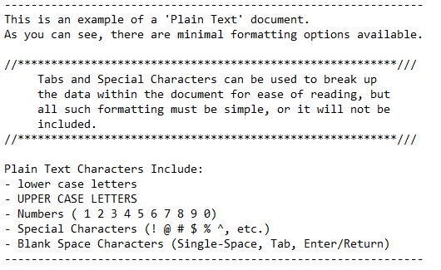

#### Formatted Text

Formatted (Or Rich) Text is the type of text where style information is included in the data characters. As such, this text can be formatted in a user-defined way so that the data can be separated or formatted for greater ease of reading.

#### Fixed Format

In fixed length text files, each field of data begins and ends at the same place in every record. Thus, all data within the field is limited to the same number of characters so that the spacing remains the same throughout the document.

This is useful when configuring a document that contains data in which the values are not completely variable. For example, Phone Numbers, Order Numbers, Customer Numbers , etc. do not vary much in the way of length, and thus are usually in no danger of being ‘cut-off’ at the end for becoming too long within their given field.

Data the contains a more variable length of characters, such as street addresses and notes, are more difficult to include in such documentation, as they have a higher likelihood of becoming too long for their designated format.

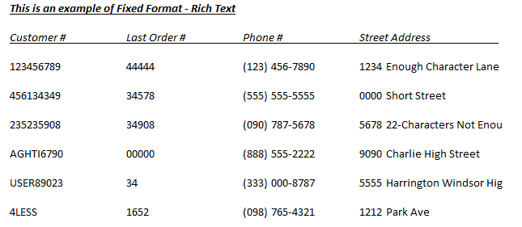  
As you can see, some data points are much shorter than the character limit placed on them, which does not affect the spacing of the document. When looking at the street addresses, however, you can see that they will be cut off after the designated number of characters has been reached.

#### Separated Format

Separated (Or Delimited) Format is where data is separated in a specific method. The data here can vary in length, and the system can understand these lengths based on a field value in between the separated character. The most common example of this is the CSV (Comma separated value) where data is separated by commas.

This works well until you have data that includes a comma ‘,’ in the data because a computer will look at that comma in the item number and assume that the comma represents the end of the item number. It is therefore important that data is entered into the systems with this in mind and avoid all special characters in codes, descriptions, users, etc.

There are ways to work around this programmatically, but these should be avoided.

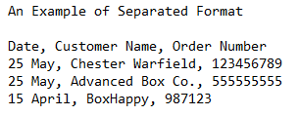

### XML Data

#### Overview

Extensible Markup Language (XML) is used to describe data. The XML standard is a flexible way to create information formats and electronically share structured data. XML data is known as ‘self-describing’ or ‘self-defining’, meaning that the structure of the data is embedded with the data itself, thus when the data arrives there is no need to pre-build a structure to store the data; it is dynamically understood within the XML. The XML format can be used by any individual or group of individuals or companies that want to share information in a consistent way.

All XML data must be entered in the proper format in order to be valid. If the XML data is not in the valid format, it cannot be read and processed by the system. S, it is important to verify your data using one of many online tools.

XML data is known as a string of characters that is both human readable and machine readable. It is comprised of tags or descriptors and values that represent the value for the tag.

#### Tag

A tag is a markup construct that begins with ‘<’ and ends with ‘>’. There are three types of tags, as follows:

|  |  |
| --- | --- |
| Start Tag | Such as: <section> |
| End Tag | Such as: </section> |
| Empty Element Tag | Such as: <line-break /> |

#### Escaping

XML provides escape facilities in order to include characters that the system deems problematic to include directly. For example, the ‘<’ symbol is used by the system to indicate a tag, but if the user needs this to print to a document or report, they will need to define it differently.

There are five predefined entities, as follows:

|  |  |
| --- | --- |
| &lt | Represents: “<” Less Than |
| &gt | Represents: “>” Greater Than |
| &amp | Represents: “&” And |
| &apos | Represents: “ ‘ ” Apostrophe |
| &quot | Represents: “ “ ” Quotation |

#### Comments

Comments may appear anywhere in a document outside other markups. Comments cannot appear before the XML declaration. Comments begin with ‘ <!-- ' and end with ‘ --> ‘.

An example of a valid comment: <!—No need to escape <code> & such in comments -->

#### Schema & Validation

In addition to being in the proper format, an XML document must be *valid*. This means that it contains a reference to a Document Type Definition (DTD), and that its elements and attributes are declared in that DTD, and follow the grammatical rules that the DTD specifies.

#### DTD

Using a Document Type Definition has the following benefits:

* + DTD support is ubiquitous due to its inclusion in the XML 1.0 standard.
  + DTDs are quite brief compared to element-based schema languages, and consequently present more information in a single screen.
  + DTDs allow the declaration of standard public entity sets for publishing characters.
  + DTDs define a *document type* rather than the types used by a namespace, thus grouping all constraints for a document in a single collection.

DTD’s have the following limitations:

* + They have no explicit support for newer features of XML, most importantly namespaces.
  + They lack expressiveness. XML DTDs are simpler than SGML DTDs and there are certain structures that cannot be expressed with regular formats. DTDs only support rudimentary datatypes.
  + They lack readability. DTD designers typically make heavy use of parameter entities (which behave essentially as textual macros). This makes it easier to define complex documents and reports, but at the expense of clarity.
  + They use a syntax based on ‘regular expression syntax’, to describe the schema. Typical XML APIs do not attempt to offer applications a structured representation of the syntax, so it is less accessible to programmers than an element-based syntax may be.

#### XML Validation

One of many free online data format validators that can be found using any browser search. Our preferred one is <https://codebeautify.org/xmlvalidator>.

### JSON Data

#### Overview

JavaScript Object Notation (JSON), is an open-standard file format that uses human-readable text to transmit data objects consisting of attribute–value pairs and array data types (or any other serializable value).

This is a very common data format, with a diverse range of applications, such as serving as replacement for XML. JSON data can be ‘beautified’ in order to show each set of data and value on a separate line. Alternatively, data may be combined into a single line, called ‘compressed’. Both function the same way as far as processing goes.

JSON’s basic data types are:

#### Number

A signed decimal number that may contain a fractional part but cannot include non-numbers such as ***NaN*** (Not a Number). This format makes no distinction between integer and floating-point numbers and JavaScript uses a double-precision floating-point format for all its numeric values, but other languages implementing JSON may encode numbers differently, so it is always best to specify decimal precision in all data.

|  |  |
| --- | --- |
| Integer | Any number that does *not* contain a decimal. (1, 00, 457, 689356) |
| Floating-Point | Any number that contains a decimal point. (23.99, 2.345, 6789.3422) |

#### String

A sequence of zero or more Unicode characters. Strings are delimited with double-quotation marks and support a backslash escaping syntax.

#### Boolean

Either of the values *‘true’* or *‘false’*.

#### Array

An ordered list of zero or more values, each of which may be of any type. Arrays use square bracket [ ] notation, with comma-separated elements.

#### Object

An unordered collection of name–value pairs where the names (also called keys) are strings. Objects are delimited with curly brackets { }, and use commas to separate each pair. Within each pair, the colon ':' character separates the key or name from its value.

#### Null

An empty value, using the word *‘null’*.

#### Multiple Records

These are repeated records under the main object, these are separated by the ‘[‘ and ‘]’ marks to indicate multiple record subsets under a main object.

### JSON Example

The following example shows a possible JSON representation describing a person.

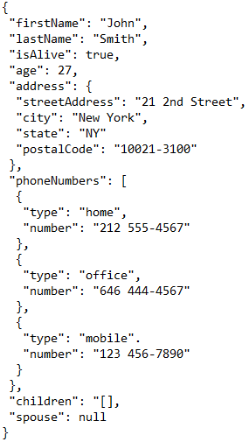

# **Inbound API**

## Overview

Inbound *API* access requires that users outside of the network or company can send data to a pre-designated location within the network and communicate with the network server. This communication requires that the system is listening to a specific port and waiting for a submission to be processed. This tool is called a node server that is then told an IP address and port to monitor for any incoming requests.

Once a request is received, with a username and password, the node service will look up the user in the Advantzware database and track their request and send back a response.

## Running Multiple Node Server Instances

### Overview

The *API* can support up to two (2) separate instances on the same physical server. The Node (Monitoring program to listen to a port) must be started when the server is started. A separate batch file can be created for each environment like TEST, PROD or TEST1, TEST2, etc. by making changes to the values as highlighted in yellow.

Please Note: The following are examples. The actual values may differ according to the environment settings – thus provided for an example assuming the CustFiles folder exists in the environment and that Node folder will be present in CustFiles folder.

### TEST Environment

#### startTEST.bat

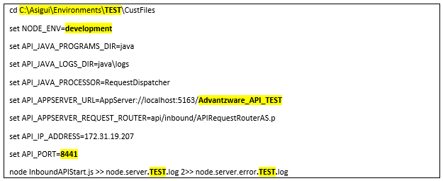

### PROD Environment

#### startPROD.bat

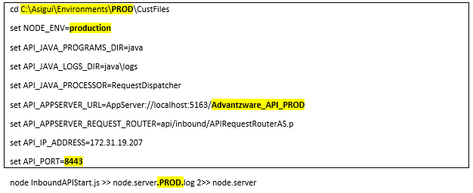

## Making Inbound API’s Public Running on Node Server

### Overview

The client can choose any of the following three methods (diagrams) to make inbound *API’s* accessible over a public or private Internet. Method 3 has the fewest points of failure, but a higher level of security related issues. This is recommended for testing purposes, but live environments should be reviewed and considered with the help of internal IT and expert sources as Advantzware cannot be responsible for network security.

Advantzware is focused on having the port accessible such that testing from outside the organization can send data using the defined URL and port with the defined username and password. If this is not received by the node, then that must be resolved before the API can function as expected. The performance of this interface can be impacted by any performance issues related to the port being verified and the login of the user into ASI for security and permission controls.

### Method 1: IP Forwarding

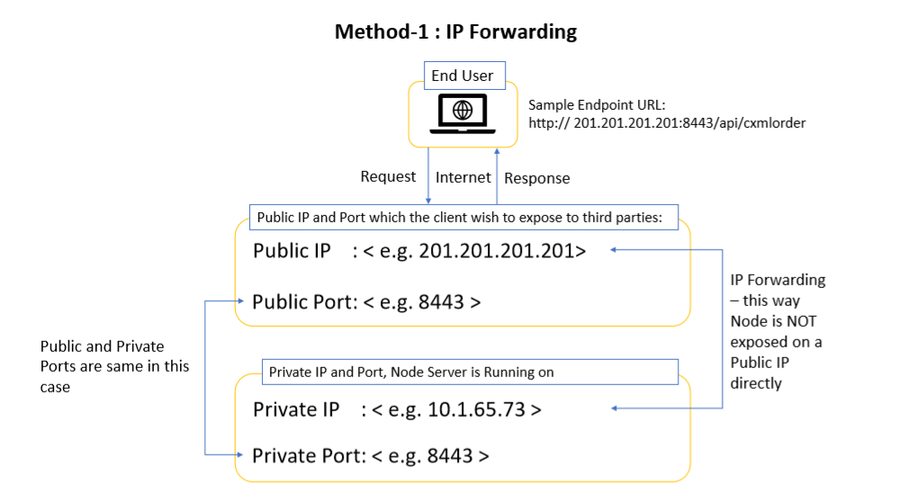

### Method 2: Proxy or Port Forwarding

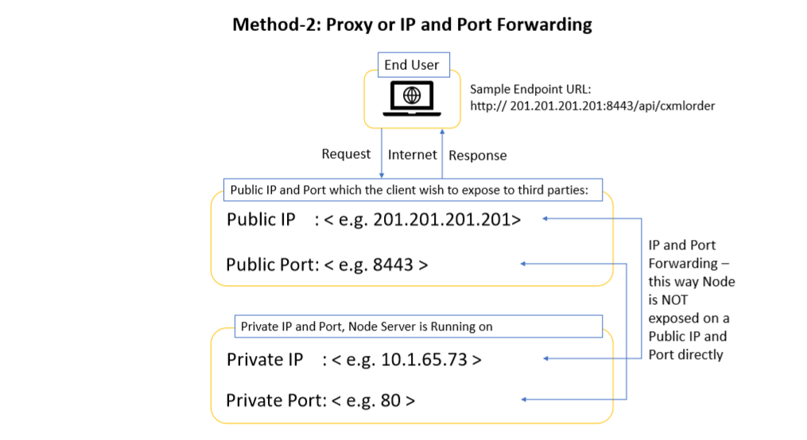

### Method 3: Node Running on Public Port

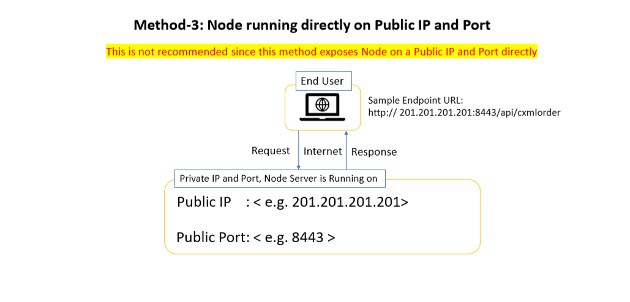

## Inbound API: Configuration Overview

An *Inbound* *API* request allows for access to the system, its data, and potentially the processing capacity of the application. It is therefore important that proper security and access control is restricted, and that it is controlled using the normal username and password controls that are available in the standard Advantzware application.

Each *Inbound* service is defined and turned on (Active = True) such that the outside party can gain access to the required details to interact with the system by calling a service that is ever present and available. This is through the Administrator providing the name of the service, the required format, and credentials to interact properly. Without this detail, the user will not be able to interact with the system and the system will not provide the results expected.

The most basic of these requirements include:

* Providing the name of the service (Like ‘GetInventory’).
* The IP address or names service (Like 123.45.67.80) or (ourEdiServer.com) or equivalent.
* The port that is being opened and awaiting a request (Like 8443).
* The authentication (Like Username = EdiUser)
* The password for that user (Like Password = EdiPassword)
  + **Caution**: This is a valid username and password, so be sure to think about password security.
* The content of the request.
  + May be the company (Company = ‘001’).
  + May be the warehouse Location (LocationID= MAIN).
  + May be the bin location (BinID = ‘Dock’).
* The format of the data (Like JSON).

The external user then sends a request in the specified format, for example:

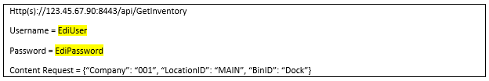

When a request is submitted, the external user will get a response from the system that will include the success or failure of the request, along with either a message or other type of response such that the user or machine knows how to respond. A normal response will include a machine-readable code and potentially a message or message of data.

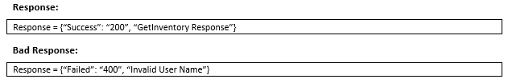

## Inbound API: Configuration

### Step 1: Database Tables and Initial Configuration Data Required

1. Ensure that the database tables APIInbound, APIInboundDetail, and APIInboundEvent are available in ASI database.
2. Ensure that the database tables APIInbound and APIInboundEvent have initial configuration data.

### Step 2: Programs Required

The latest code changes for *API Inbound* must be available in the repository and the same is required to be compiled in the targeted environment using the “fsInstaller”.

The “fsInstaller” compiles the code base and copies the compiles program to “Programs” folder.

### Step 3: Java Folder Setup

#### Java Folder Setup: Step 1

A folder named “java” (under Programs\api\node) will be created as the result of “fsInstaller” installer run.

#### Java Folder Setup: Step 2

**Open Client Java OpenAPI** is required to enable making AppServer calls and running Progress procedures from a java class. Progress provides the required libraries as part of Progress OpenEdge installation.

A java archive file named **o4glrt.jar** can be located under Progress Installation Folder as below:

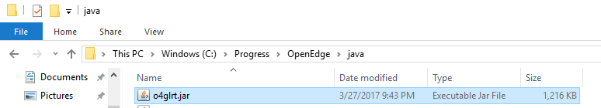

#### Java Folder Setup: Step 3

Copy the required java packages from **<Progress Installation Folder>\java** into the folder Programs\api\node\java following the below steps:

* + Go to the path **<Progress Installation Folder>\java** and extract the contents from **o4glrt.jar** into Programs\api\node\java folder and verify that the following sub-folders are available under Programs\api\node\java

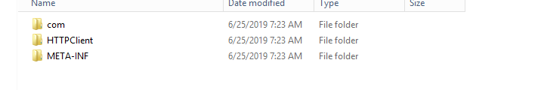

#### Java Folder Setup: Step 4

Compile java programs as per the steps given below:

* + Java programs “RequestDispatcherAS.java” and “RequestDispatcher.java” (under Programs\api\node\java) will be created as result of “fsInstaller” installer run as shown in below screenshot.  
    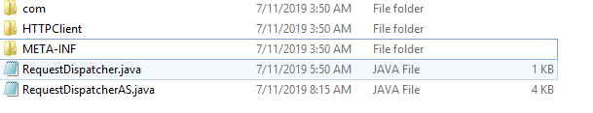
  + Open command prompt.
  + Change current directory to Programs\api\node\java
  + Execute below commands to compile java programs.
    1. **<Progress Installation Folder>**\jdk\bin\javac RequestDispatcher.java
    2. **<Progress Installation Folder>**\jdk\bin\javac RequestDispatcherAS.java

#### Java Folder Setup: Step 5

Please Note: If the java programs are compiled successfully, then files “RequestDispatcherAS.class**”** and **“**RequestDispatcher.class**”** should get generated in the same folder Programs\api\node\java as highlighted in the screen shot below:  
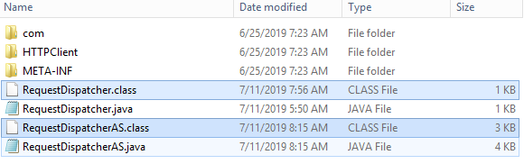

* + Once the .class files are generated, delete the .java files (“RequestDispatcherAS.java” and “RequestDispatcher.java”) from Programs\api\node\java folder.

### Step 4: AppServer Setup for Development and Test Environments

Please Note: This broker is *only* required for Development and Test Environments – this is assumed that there is an existing AppServer broker available in Prod environment and the same can be used in node start program – please refer to the steps in this document under Node Server Setup section for more details.

#### AppServer Folder Setup: Step 1

Open Management Console.

#### AppServer Folder Setup: Step 2

Create new App Server broker **Advantzware_API**, if not already available  
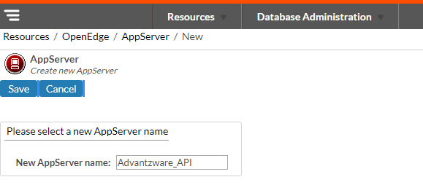

#### AppServer Folder Setup: Step 3

After creation of AppServer broker **Advantzware_API**, click on “**Configuration**” to setup the AppServer.  
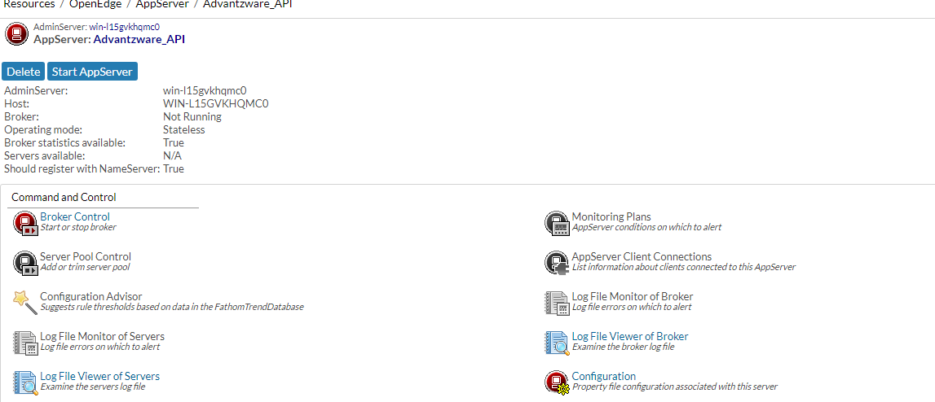

#### AppServer Folder Setup: Step 4

Create a .pf file to setup the databases (ASI and AUDIT) and server start up parameters

-s to 200 and -strictEntityResolution to 0 to setup in **Advantzware_API** broker

A Sample code for .pf file creation is shown below:

The tags <path> , <asi-db-name> and <audit-db-name> are to be replaced with the appropriate values.

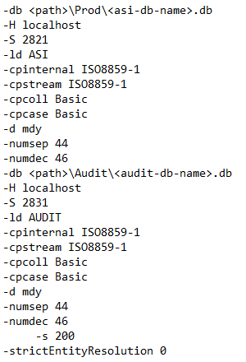

#### AppServer Folder Setup: Step 5

* Go to the **Broker** tab to setup **“Operating Mode”** as **“Stateless”** as shown below  
  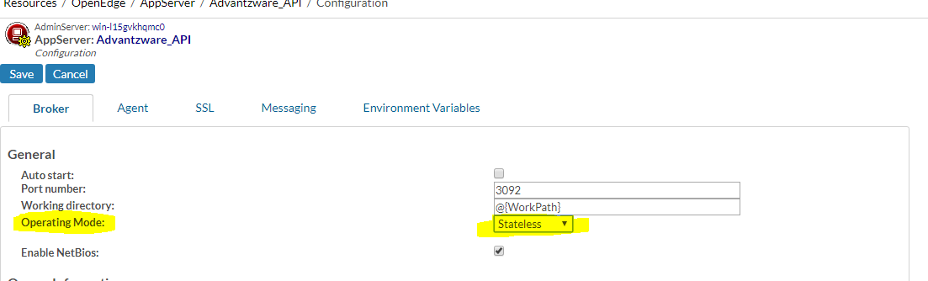
* Go to the **Agent** tab to setup the server startup parameters and the PROPATH
* Setup .pf file in the **server startup parameters** field and application’s PROPATH in the **PROPATH** field  
  Sample setup of AppServer startup parameters and the PROPATH is shown below  
  Add the below path to the PROPATH field as shown below:  
  C:\Asigui\Environments\Devel\Programs  
    
  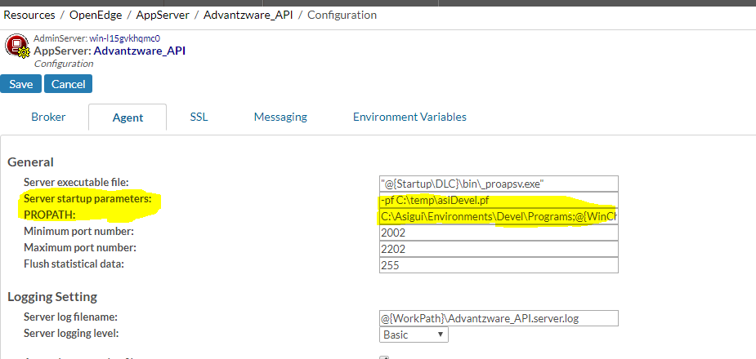
* Save the configuration

#### AppServer Folder Setup: Step 6

* Now, go to **Broker** tab and check whether any **NameServer** is registered or not.  
    
  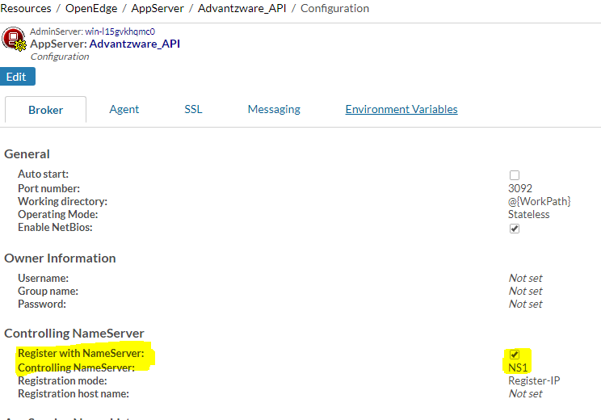
* If there is no registered NameServer,then check for any available NameServer and register it with AppServer
* If there are no available NameServers, then create new NameServer and register it with AppServer

#### AppServer Folder Setup: Step 7

* Now start registered NameServer if it is not running.
* If registered NameServer started without any issues, we can see its status as **“Running”** as shown in the screen shot below.  
    
  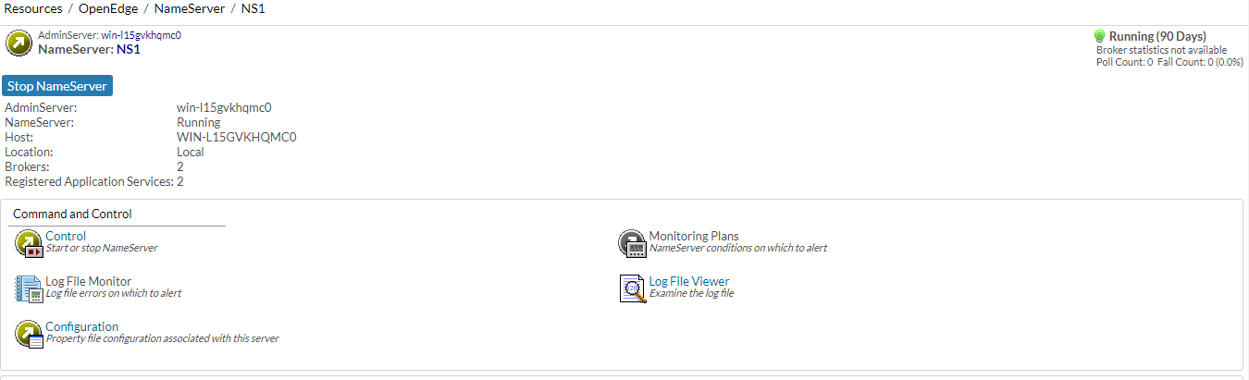  
    
  Please Note: When any AppServer is created, by default AppServer registers with the NameServer **NS1**.We can register AppServer with another NameServer if required. But, registered NameServer should be running before we start AppServer
* Now, Start the AppServer **Advantzware_API**.
* If the AppServer starts without any issues, we can see its status as **“Running”** as shown in the screen shot below.  
    
  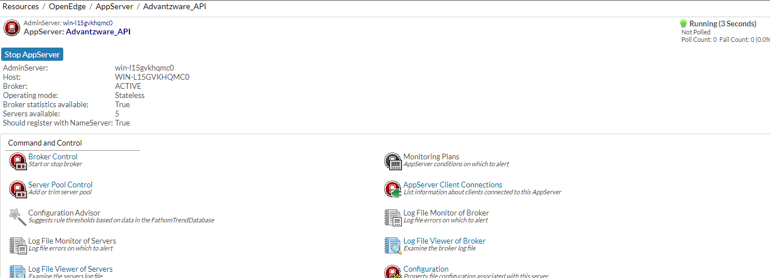

### Step 5: Progress Programs Folder Setup

A Folder named “inbound” (under Programs\api) will be created as result of “fsInstaller” installer run. This is where the Inbound API specific programs are available as compiled code.

### Step 6: Node Server Setup

#### Node Server Setup: Step 1

Install Node Server by using the following link: <https://nodejs.org/en/>  
Please Note: If Node Server is installed successfully, then its icons should appear in windows search as shown below.  
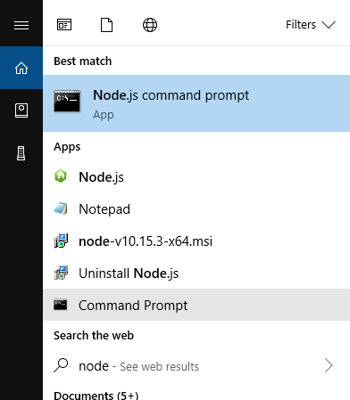

#### Node Server Setup: Step 2

Add NODE_PATH in system environment variables:

NODE_PATH: <path where node is installed>\node_modules

Example: C:\Program Files\nodejs\node_modules

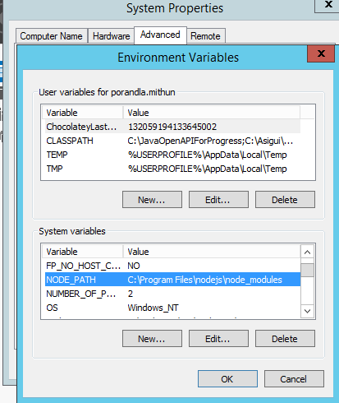

#### Node Server Setup: Step 3

Run Node.js command prompt in admin mode

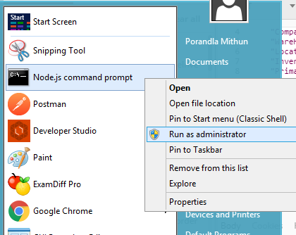

#### Node Server Setup: Step 4

Go to NODE_PATH by executing below command  
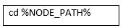

#### Node Server Setup: Step 5

Install Required Node modules:

* + Open command prompt
  + Run below commands in the same order as given below:

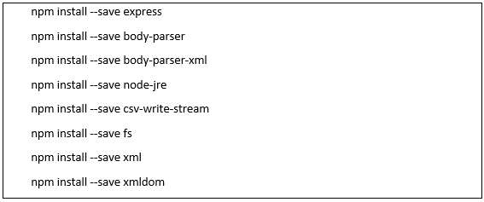

#### Node Server Setup: Step 6

Set environment variables as below:

The environment variables should not be enclosed in double quotes (“)

|  |  |  |
| --- | --- | --- |
| ***Environment Variable*** | ***Value*** | ***Purpose*** |
| NODE_ENV | Production/Development | Set “Production” for production environment and “Development” for development environment. |
| API_HAVA_PROGRAMS_DIR | Java | Path for java programs. |
| API_JAVA_LOGS_DIR | <Intended folder in which Node logs want to be created>  Preferably, it can be any folder under “CustFiles” directory. | Path where requests are logged to a CSV file when the AppServer is down. This file can be loaded using a program and such inbound API requests can be executed outside Node |
| API_JAVA_PROCESSOR | RequestDispatcher | The name of the java program which dispatches the requests from Node to AppServer |
| API_APPSERVER_URL | AppServer://<IPAddress>:<NameServer port number>/ <AppServer broker name> | URL to Progress AppServer |
| API_APPSERVER_REQUEST_ROUTER | api/inbound/APIRequestRouterAS.p | A Progress program which runs behind AppServer and makes calls to API specific process handlers |
| API_IP_ADDRESS | <IPAddress> | The IP address of the machine to be used by Node server |
| API_PORT | <PORT> | The port to be used by Node server |
| API_SSL_ENABLED | <YES/1> | To enable SSL |

Please Note:

* Value for the environment variable **API_APPSERVER_URL** should be updated with:
  + AppServer broker and NameServer port number as configured in the Step 4.
  + If AppServer and Node are running on the same machine, then update IPAddress with "localhost"
  + If AppServer and Node are running on different machines, then update “IPAddress" with "IPAddress of the machine on which AppServer is running”
* Value for the environment variable **API_IP_ADDRESS** should be updated with “IP address of the machine” on which Node needs to run.
* Value for the environment variable **API_PORT** should be updated with PORT on which Node needs to listen for incoming requests.
* Value for the environment variable **API_SSL_ENABLED** should be updated with YES/1 to run node server securely (with SSL).
* Environment variables can be set either from “Edit the system environment variables” option from Control Panel or using batch script. If Environment variables are being set using batch script, then batch script which starts the node server should be updated accordingly when a new environment variable is added/removed/updated
* If batch script which starts node servers uses .ini file to fetch environment variable values, then .ini file should be updated accordingly

#### Node Server Setup: Step 7

Start Node Server. The node server can be run using below options.

#### Using Command

* + Set Environment variables from “Edit the system environment variables” option from Control Panel.
  + Open command prompt.
  + Change current working directory to Programs\api\node folder
  + Run below command.  
    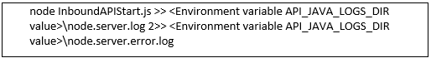

#### Using Batch Script

* + Run node server start script

#### Using Command

* + Go to **N-A-6** to run Node server from monitor.

Please Note:

* Log files “node.server.log” and “node.server.error.log” will be created under “<Environment variable API_JAVA_LOGS_DIR value>” folderIf AppServer/Progress Layer is down, a CSV file (name begins “PendingRequests*”) will be generated in the folder “<Environment variable API_JAVA_LOGS_DIR value>\” with the failed requests data, which can be later imported into APIInboundEvent table and processed further using (APIInboundEventsViewer.w / **N-A-5** screen)
* If Node starts without any errors, “node.server.log” file will have the text as shown below Here, values for the appserverURL, serverIP and serverPort will change based on the updated values in environment variables
* Multiple node servers can be run using different ports on the same IP/ hostname (**e.g.** If one node server is running on a server on port 8443, another node server can be run using another port 8444 on the same server)

#### Node Server Setup: Step 8

Below is a list of Node errors may occur if Node is not configured properly

|  |  |  |
| --- | --- | --- |
| ***S. No*** | ***Error Name*** | ***Cause*** |
| 1 | listen EADDRINUSE: address already in use hostname:port | If node is trying to start on a hostname:port where a node session is already running on the same hostname:port |
| 2 | listen EADDRNOTAVAIL: address not available hostname:port | If IP/hostname which node is trying to run is different than the server IP/hostname |

## Inbound API: Services Overview

The *inbound API* services allow for the monitoring and processing of *inbound API* requests. The inbound services required include:

|  |  |  |  |
| --- | --- | --- | --- |
| The Admin Server | The Application Server | The Name Server | The Node Server |

These services can be monitored, started and stopped using the service monitor located in ***“N”-“A”-“6”***.

This service must be run on the **server** in order to monitor them properly and to restart these services. If the server is hosted, then accessing the server should be done using Remote Desktop.

If attempting to restart or stop a service from a remote workstation, or without permissions to run the start/stop services, it will not respond as expected.

## Inbound API: Services Testing

### Initial Steps for All Testing

While testing individual *API* Services will show specialized results for each function, the following steps must be followed for all service testing.

Please Note: The *API* Service: ***“Inbound: cXMLOrder”***, which has slightly different testing steps than the bulk the other services. These are specially noted within the following steps.

#### Step One: Open API Tester

Go to screen ***“N” – “A” – “4”*** (Inbound *API* Tester / Console)

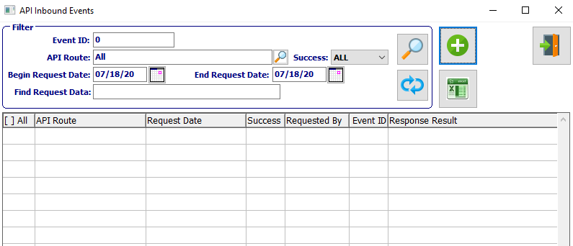

#### Step Two: Add New Event

|  |  |
| --- | --- |
|  | Click the ***“Green + Icon”*** button to add a new Inbound Event. |

#### Step Three: Tester Screen

After clicking the ***“Add Inbound Event”*** button, the follow API Inbound Tester screen will pop up.

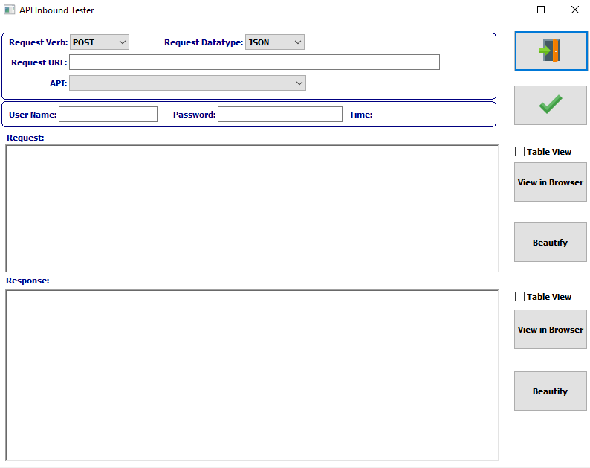

#### Step Four: Request Verb

Select the *‘Request Verb’* field as ***Post*** in the drop-down menu.

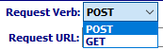

#### Step Five: Request Datatype

Select the *‘Request Datatype’* field as ***JSON*** in the drop-down menu.

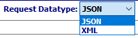

Please Note: The ***“Inbound: cXMLOrder”*** service will use the ***XML*** option instead.

#### Step Six: Request URL

Enter “http://<IPAddress>:<PORT>” as Request URL.



Please Note: This automatically saves into the database when entered for first time, thus the user will not be required to enter it further.

Here, IPAddress and PORT should be same as provided in the environment variables (Programs\api\node\config.js) in the setup.

#### Step Seven: Sign In

The user must enter their **Username** and **Password.**



#### Step Eight: Select API

Select the desired *API* Event from the drop-down list of available *API* programs.

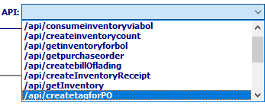

#### Step Nine: Fill all JSON Fields

The user may now fill all given JSON fields for the selected *API* program. Please check each field carefully in order to ascertain if it is **required** or ***optional.***

Please Note: Any **optional** fields may be left blank, if the user desires. Alternatively, **optional** fields may be left out of the final JSON format.

Please Note: Any **required** fields that are left blank will cause the program to throw an error, and thus will be unable to run.

#### Step Ten: Request Field Format Rules

Once the desired *API* program is selected from the list, the default *API* request data format appears in the **Request** text field.

Please Note: In the sample request data format, the field values provided are not exact values, merely rules that the user must follow for each piece of information. If these rules are not followed, it will lead to system errors, and the program being unable to run correctly.

The current different format rules are as follows:

|  |  |  |
| --- | --- | --- |
| DEC-OPT | Decimal | Optional |
| DEC-REQ | Decimal | Required |
| DECIMAL-OPT | Decimal | Optional |
| DECIMAL-REQ | Decimal | Required |
| INT-OPT | Integer | Optional |
| INT-REQ | Integer | Required |
| INTEGER-OPT | Integer | Optional |
| INTEGER-REQ | Integer | Required |
| LOG-REQ | Integer | Required |
| STR-REQ | String | Required |
| STRING-OPT | String | Optional |
| STRING-REQ | String | Required |

#### Step Eleven: JSON String Rule Reminder

In JSON strings, if a field value is enclosed with “ ” then it is a *string.* Otherwise it is a decimal or integer value.

JSON Rule examples are as Follows:

|  |  |
| --- | --- |
| Decimal | "FreightCost”:2.9525 – The FreightCost is a **decimal** so it is not enclosed in “ ”. FreightCost should be in the format (0.0) . JSON throws error If it is in the format (.0 |
| Integer | "BOLID”:9525 – The BOLID is an **integer,** so it is not enclosed in “ ”.  BOLID should be in the format (1,111,1111 etc..,) . If it is in the format (001,002 etc..,), then JSON throws error |
| String | "Company":"001"- The Company value is **string,** and it is enclosed in " " |

#### Step Twelve: Run the Program

|  |  |
| --- | --- |
|  | The user may now click the ***“Green Check Icon”*** button in order to execute the selected *API* service. |

#### Step Thirteen: Program Success vs. Program Failure

***Program Failure -*** If the selected *API* program execution call was unsuccessful, the JSON text featured in the **Response** text field will alert the user to the specific error situation. (Specific errors for the individual programs are detailed for each *API* program below.)

***Program Success -*** If the selected *API* program execution call was successful, the JSON text featured in the **Response** text field will fill with a success message specific to the current *API* program, along with any details the system has deemed necessary for the user to be alerted of. (Specific success messages for the individual programs are detailed for each *API* program below.)

### Inbound: GetInventory

#### Description

This *API* is used to get inventory details related on the given location and bin / tag / item in the input request data.

#### Default Request Data: GetInventory

* Below is the default **request data** format for the ***“GetInventory”*** *API* program.  
    
  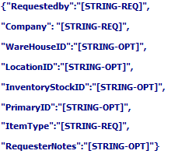
* In the above request data:
  + Field values for most fields are **optional**. However, the values for “*RequestedBy*”, “*Company*”, and “*ItemType*” are **required**.

#### Example Data: GetInventory

* Below is the sample JSON request data format for the ***“GetInventory”*** *API* program, after entering valid field values in the above request data format.  
  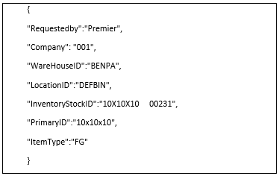
* Below is the sample screenshot in the *API* Tester for the ***“GetInventory”*** *API* program, after filling all JSON field values in the Tester Screen.  
  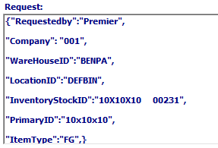

#### Successful Response

* If the *API* program “***GetInventory***” call was successful, the JSON text featured below is returned as the response in **Response** text field.  
    
  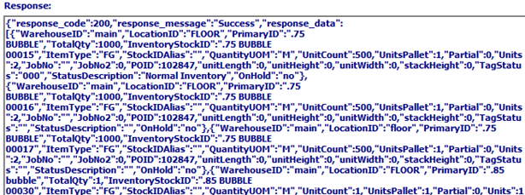

#### Test Scenarios – Invalid Scenarios

* Scenario 1 – When company is “ ” or otherwise invalid:
  + ***RESULT***: The below error text comes in the response.  
      
    
* Scenario 2 – When any of the combinations (loc & bin, tag , item number ) is not provided:
  + ***RESULT***: The below error text comes in the response.  
      
    
* Scenario 3 – When any of the combinations (loc & bin, tag, item number ) is provided:
  + ***RESULT***: Inventory details related to the above combination comes in response.  
      
    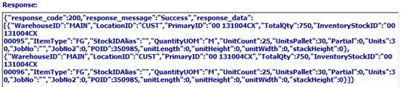
* Scenario 4 – When Item type is “ ”:
  + ***RESULT***: By default , the item type will be “FG”, and Inventory details related to “FG” comes in the response.  
      
    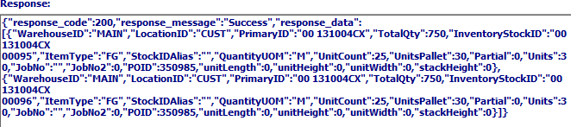
* Scenario 5 – When Item type is Invalid:
  + ***RESULT***: The below error text comes in the response.  
      
    

#### Test Scenarios – Valid Scenarios

When all Invalid scenarios are resolved, and all Input data has valid values, then the following success message along with Inventory details come in response as shown below.

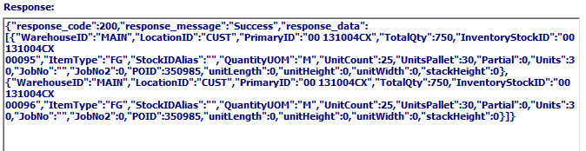

### Inbound: GetInventoryForBOL

#### Description

This *API* is used to get inventory details related on the given Bill of Lading number in the input request data.

#### Default Request Data: GetInventoryForBOL

* Below is the default **request data** format for the ***“GetInventoryForBOL”*** *API* program.  
  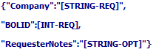
* In the above request data:
  + Field values for most fields are **required**. However, the value for “*RequesterNotes*” is **optional**.

#### Example Data: GetInventoryForBOL

* Below is the sample JSON request data format for the ***“GetInventoryForBOL”*** *API* program, after entering valid field values in the above request data format.  
  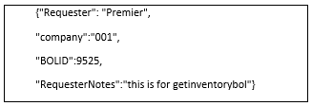
* Below is the sample screenshot in the *API* Tester for the ***“GetInventoryForBOL”*** *API* program, after filling all JSON field values in the Tester Screen.  
  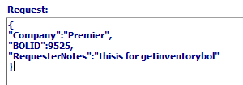

#### Successful Response

* If the *API* program “***GetInventoryForBOL***” call was successful, the JSON text featured below is returned as the response in **Response** text field.  
  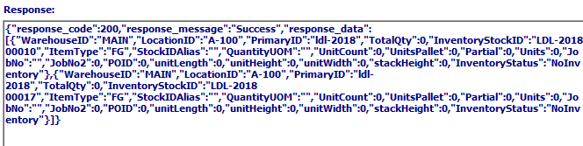

#### Test Scenarios – Invalid Scenarios

* Scenario 1 – When company is “ ” or Invalid:
  + ***RESULT***: The below error text comes in the response.  
    
* Scenario 2 – When BOLID is 0 or Invalid because it is not found:
  + ***RESULT***: The below error text comes in the response.  
    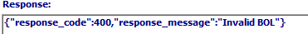

#### Test Scenarios – Valid Scenarios

* Scenario 1 – When company and BOLID values are valid and Tag value is null for a BOL Line:
  + ***RESULT***: Inventory status gets value as “TagIsEmpty”. The below screenshot shows the highlighted Inventory status.  
    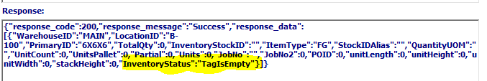
* Scenario 2 – When company and BOLID values are valid and there is no Inventory for a BOL Line:
  + ***RESULT***: Inventory status gets value as “NoInventory”. The below screenshot shows the highlighted Inventory status.  
      
    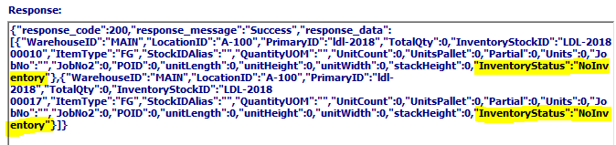
* Scenario 3 – When BOL is not posted, and inventory has a quantity that is greater than or equal to the BOL Line quantity:
  + ***RESULT***: Inventory status gets value as “OnHand”.
* Scenario 4 – When BOL is not posted, and inventory has a quantity that is less than the BOL Line quantity but greater than 0:
  + ***RESULT***: Inventory status gets value as “InsufficientInventory”.
* Scenario 5 – When BOL is posted:
  + ***RESULT***: all linked BOL Lines get Inventory status as “Shipped” irrespective of quantity.

### Inbound: GetPurchaseOrder

#### Description

This *API* is used to get purchase orders for the given Purchase Order ID.

#### Default Request Data: GetPurchaseOrder

* Below is the default **request data** format for the ***“GetPurchaseOrder”*** *API* program.  
  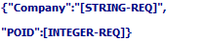
* In the above request data:
  + Field values for all fields are **required**.

#### Example Data: GetPurchaseOrder

* Below is the sample JSON request data format for the ***“GetPurchaseOrder”*** *API* program, after entering valid field values in the above request data format.  
  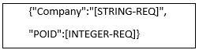
* Below is the sample screenshot in the *API* Tester for the ***“GetPurchaseOrder”*** *API* program, after filling all JSON field values in the Tester Screen.  
  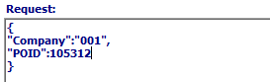

#### Successful Response

* If the API program “**GetPurchaseOrder**” call was successful, the JSON text featured below is returned as the response in **Response** text field.  
  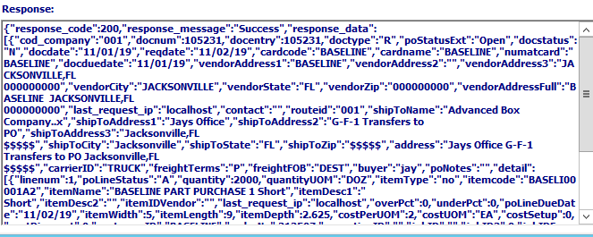

#### Test Scenarios – Invalid Scenarios

* Scenario 1 – When company is “” or Invalid:
  + ***RESULT***: The below error text comes in the response.  
      
    
* Scenario 2 – When POIID is 0 or Invalid:
  + ***RESULT***: The below error text comes in the response.  
      
    

#### Test Scenarios – Valid Scenarios

* Scenario 1 – When company and POID values are valid:
  + ***RESULT***: PO details along with PO line details will come in response.  
      
    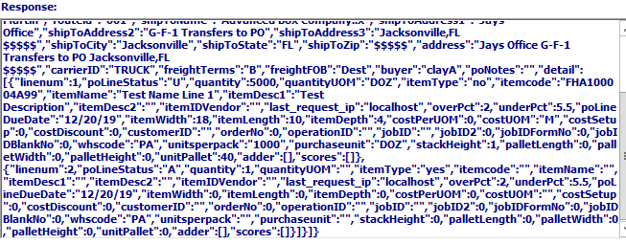

### Inbound: CreateInventoryTransfer

#### Description

This *API* is used to transfer inventory to new warehouse location and bin.

#### Default Request Data: CreateInventoryTransfer

* Below is the default **request data** format for the ***“CreateInventoryTransfer”*** *API* program.  
  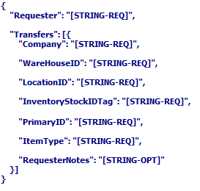
* In the above request data:
  + Field values for most fields are **required**. However, the value for “*RequesterNotes*” is **optional**.

#### Example Data: CreateInventoryTransfer

* Below is the sample JSON request data format for the ***“CreateInventoryTransfer”*** *API* program, after entering valid field values in the above request data format.  
  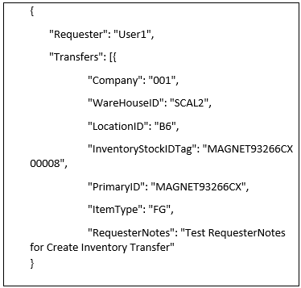
* Below is the sample screenshot in the *API* Tester for the ***“CreateInventoryTransfer”*** *API* program, after filling all JSON field values in the Tester Screen.  
  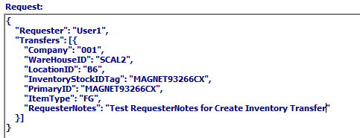

#### Successful Response

* If the *API* program “***CreateInventoryTransfer***” call was successful, the JSON text featured below is returned as the response in **Response** text field.  
  

#### Test Scenarios – Invalid Scenarios

* Scenario 1 – When company is “” or Invalid:
  + ***RESULT***: The below error text comes in the response.  
    
* Scenario 2 – When WarehouseID is empty or Invalid:
* ***RESULT***: The below error text comes in the response.  
  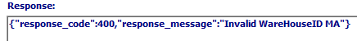  
  Scenario 3 – When LocationID is empty or Invalid:
  + ***RESULT***: The below error text comes in the response.  
    
* Scenario 4 – When Tag is Invalid:
  + ***RESULT***: The below error text comes in the response.  
    
* Scenario 5 – When Tag is empty:
  + ***RESULT***: The below error text comes in the response.  
    
* Scenario 6 – When Item is empty:
  + ***RESULT***: The below error text comes in the response.  
    
* Scenario 7 – When Item is Invalid:
  + ***RESULT***: The below error text comes in the response.  
    
* Scenario 8 – When Item Type is empty:
  + ***RESULT***: The below error text comes in the response  
    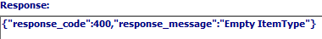
* Scenario 9 - When current loc & bin are same as loc & bin to be transferred:
  + ***RESULT***: The below error text comes in the response  
      
    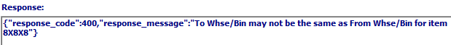

#### Test Scenarios – Valid Scenarios

* Scenario 1 - When all Invalid scenarios are resolved, or request data has valid data then:
  + Success response comes in response
  + Inventory will be transferred to new loc & bin.

#### Check Inventory Transfer:

* Inventory transfer can be checked in **“Finished Goods Item Inventory/History” (Located at *“I”-“F”-“1”*)**, as show below.  
  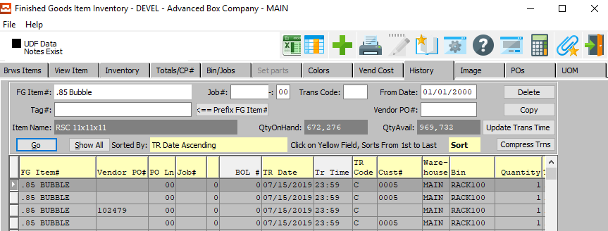

### Inbound: CreateTagForPO

#### Description

This *API* does the following:

* + Creates a tag for the given Purchase Order number, PO Line, and Item details.
  + Creates receipt for the created tag, if needed.
  + Returns created tag number along with PO Lines in the response.
  + Supports multiple requests and responses.

#### Default Request Data: CreateTagForPO

* Below is the default **request data** format for the ***“CreateTagForPO”*** *API* program.  
  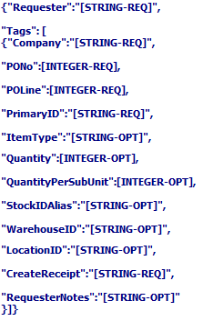
* In the above request data:
  + Field values for most fields are **optional**. However, the values for “*Requester*”, “*Company*”, “*PONo*”, “*POLine*” , “*PrimaryID*”, and “*CreateReceipt*” are **required**.

#### Example Data: CreateTagForPO

* Below is the sample JSON request data format for the ***“CreateTagForPO”*** *API* program, after entering valid field values in the above request data format.  
  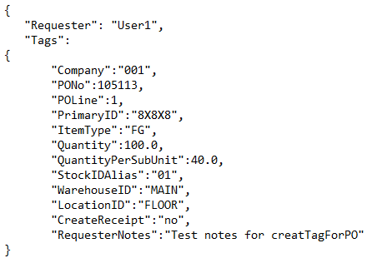
* Below is the sample screenshot in the *API* Tester for the ***“CreateTagForPO”*** *API* program, after filling all JSON field values in the Tester Screen.  
  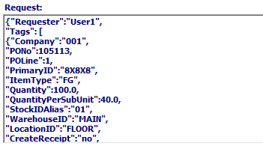
* Please Note: The “*CreateReceipt”* field in the ***“CreateTagForPO”*** *API* program, is a Boolean value. This means that the user has two choices in how this field is handled. Options for this field are as follows:

|  |  |
| --- | --- |
| yes | A receipt will be created. |
| no | A receipt will not be created. |
| Anything Else | The response will be an error message, as nothing but a ‘yes’ or ‘no’ answer is valid. |

#### Successful Response

* If the *API* program “***CreateTagForPO***” call was successful, the JSON text featured below is returned as the response in **Response** text field.  
  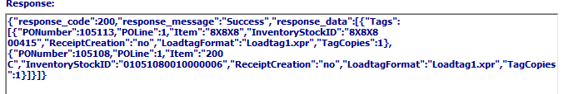

#### Test Scenarios – Invalid Scenarios

* Scenario 1 – When company is “” or Invalid
  + ***RESULT***: The below error text comes in the response  
      
    
* Scenario 2 – When Po Number is 0 or Invalid:
  + ***RESULT***: The below error text comes in the response.  
      
    
* Scenario 3 – When Po Line is 0 or does not exists on the PO number:
  + ***RESULT***: The below error text comes in the response.  
      
    
* Scenario 4 – When Item is “ ” or Invalid:
  + ***RESULT***: The below error text comes in the response.  
      
    
* Scenario 5 – When Item type is “ ” or Invalid. By default, Item type will be “FG” and FG tag will be created:
  + ***RESULT***: Tag details will come in response.  
      
    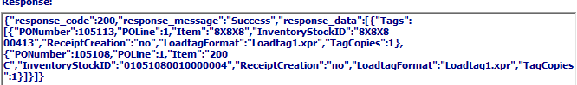
* Scenario 6 – When Item is “ ” or Invalid:
  + ***RESULT***: The below error text comes in the response.  
      
    
* Scenario 7 – When Item is “ ” or Invalid:
  + ***RESULT***: The below error text comes in the response.  
      
    
* Scenario 8 – When WarehouseID or LocationID are empty:
  + ***RESULT***: Tag will be created with item’s WarehouseID and LocationID
* Scenario 9 – When WarehouseID and LocationID are non-empty and WarehouseID is Invalid:
  + ***RESULT***: The below error text comes in the response.  
      
    
* Scenario 10 – When WarehouseID and LocationID are non-empty and LocationID is Invalid:
  + ***RESULT***: The below error text comes in the response.  
      
    
* Scenario 11 – When CreateReceipt is other than yes/no:
  + ***RESULT***: The below error text comes in the response.  
      
    

#### Test Scenarios – Valid Scenarios

* Scenario 1 – When all values are Valid:
  + ***RESULT***: Then Tags will be created and returns in the response along with “LoadtagFormat” and “TagCopies” values.  
    

#### Check Receipt Creation:

* Finished Good Receipt creation can be checked in **“Finished Goods Item Inventory/History” (Located at *“I”-“F”-“1”*)**, as shown below.  
  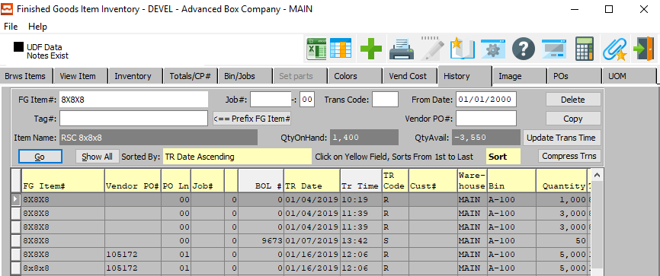
* Raw Material Receipt creation can be checked in **“RM History” (Located at *“M”-“F”-“1”*)**, as shown below.  
  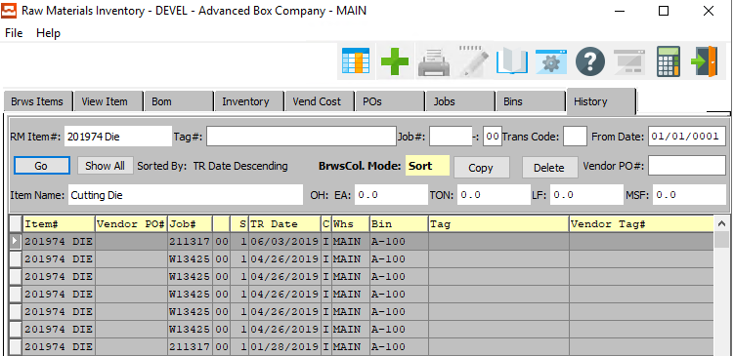

### Inbound: CreateInventoryReceipt

#### Description

This *API* does the following:

* Creates a Receipt for the given Tag.
* Creates Finished Good receipts for both positive and negative quantities.
* Creates Raw Material receipts for positive quantities.
* Supports multiple requests and responses.

#### Default Request Data: CreateInventoryReceipt

* Below is the default **request data** format for the ***“CreateInventoryReceipt”*** *API* program.  
  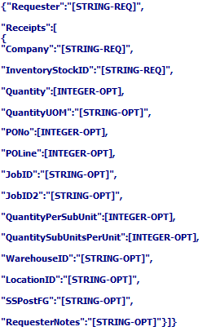
* In the above request data:
  + Field values for most fields are **optional**. However, the values for “*Requester*”, “*Company*”, and “*InventoryStockID*” are **required**.

#### Example Data: CreateInventoryReceipt

* Below is the sample JSON request data format for the ***“CreateInventoryReceipt”*** *API* program, after entering valid field values in the above request data format.  
    
  Please Note: This example shows the user sending multiple receipts for the same requester on the same *API* program execution.  
  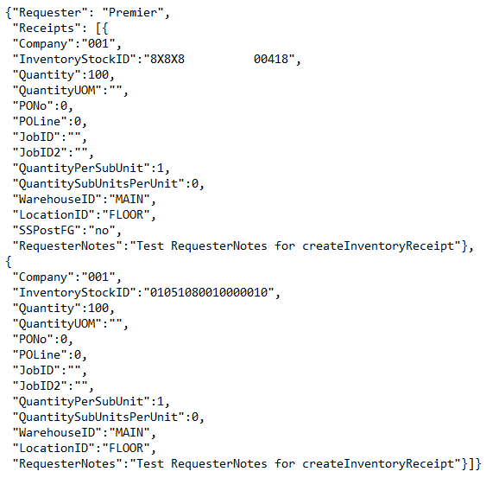
* Below is the sample screenshot in the *API* Tester for the ***“CreateInventoryReceipt”*** *API* program, after filling all JSON field values in the Tester Screen.  
  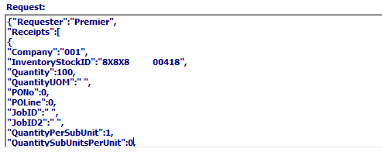
* Please Note: The “*SSPostFG”* field in the ***“CreateInventoryReceipt”*** *API* program, is a Boolean value. This means that the user has two choices in how this field is handled. Options for this field are as follows:

|  |  |
| --- | --- |
| yes | A receipt will be created. |
| no | A receipt will not be created. |
| Anything Else | The response will be an error message, as nothing but a ‘yes’ or ‘no’ answer is valid. |

#### Successful Response

* If the *API* program “***CreateInventoryReceipt***” call was successful, the JSON text featured below is returned as the response in **Response** text field.  
  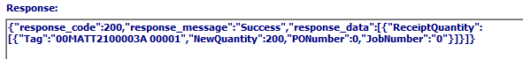

#### Test Scenarios – Invalid Scenarios

* Scenario 1 – When company is empty or Invalid:
  + ***RESULT***: The below error text comes in the response.  
      
    
* Scenario 2 – When Tag is empty:
  + ***RESULT***: The below error text comes in the response.  
      
    
* Scenario 3 – When WarehouseID is non-empty and Invalid:
  + ***RESULT***: The below error text comes in the response.  
      
    
* Scenario 4 – When LocationID is non-empty and Invalid:
  + ***RESULT***: Below error text comes in the response.  
      
    
* Scenario 5 – When both PO details and Job details are entered:
  + ***RESULT***: The below error text comes in the response.  
      
    
* Scenario 6 – When POID is non-empty and Invalid:
  + ***RESULT***: The below error text comes in the response.  
      
    
* Scenario 7 – When POLine is non-empty and Invalid for the unregistered tag / POID & POLine combination does not exists for the given registered tag:
  + ***RESULT***: The below error text comes in the response.  
      
    
* Scenario 8A – When Job number1 is non-empty for registered tags:
  + ***RESULT***: Job number1 is Invalid. Both Job number1 and Job number2 defaults to zero.
  + ***RESULT***: Job number1 is Valid and Job number2 is Invalid. Below shown error comes in response.  
      
    
* Scenario 8B – When Job number1 is non-empty for un-registered tags”
  + ***RESULT***: Job number1 is Invalid. Below shown error comes in response.  
      
      
      
    ***RESULT***: Job number2 is Invalid. Below shown error comes in response.  
      
    
* Scenario 9 – When quantity is empty for un-registered tag:
  + ***RESULT***: The below error text comes in the response.  
      
    
* Scenario 10 – When QuantityPerSubUnit is empty for un-registered tag:
  + ***RESULT***: The below error text comes in the response.  
      
    
* Scenario 11 - When QuantityUOM empty or Invalid:
  + ***RESULT***: QuantityUOM defaults to “EA”
* Scenario 12 - When Quantity is positive, and receipt is already created for the given tag:
  + ***RESULT***: The below error text comes in the response.  
      
    
* Scenario 13 – When Quantity is negative for the FG Tags:
  + ***RESULT***: Receipt does not exist on the given tag. Below error text comes in the response.  
      
    
  + ***RESULT***: Negative quantity is greater than receipt quantity. Below error text comes in the response.  
      
    
* Scenario 14 - When Quantity is negative for the RM Tags, below error comes in the response:
  + ***RESULT***: The below error text comes in the response.  
      
    
* Scenario 15 – When WarehouseID / LocationID is empty:
  + ***RESULT***: Defaults to item’s values.

#### Test Scenarios – Valid Scenarios

This API retrieves the Item number based on the given tag

* If Tag is registered, then Item type comes from loadtag
* If Tag is un-registered and PO number is provided, then Item type comes from given PO
* If Tag is un-registered and Job number is provided, then Item type is RM
* Scenario 1 – When Tag is registered:
  + POID / Job number not provided, and all quantities are empty  
    ***RESULT***: Receipt will be created with loadtag values except loc & bin
  + PO details (POID & POLine) are non-empty and valid and all quantities are empty  
    ***RESULT***: Receipt will be created with PO values except loc & bin
  + Job details (Job number1 & Job number2) are non-empty and valid and all quantities are empty  
    ***RESULT***: Receipt will be created with Job number values except loc & bin
* Scenario 2 – When Tag is un-registered:
  + PO details (POID & POLine) are non-empty and valid  
    ***RESULT***: Receipt will be created with given PO details and quantities
  + Job details (Job number1 & Job number2) are non-empty  
    ***RESULT***: Receipt will be created with given Job number and quantities
* Scenario 3 – When receipt creation and posting is success:  
  ***RESULT***: Success message comes along with Receipt quantities, Job number, PO number and Tag numbers as shown below  
    
  

#### Check Receipt Creation:

* Finished Good Receipt creation can be checked in **“Finished Goods Item Inventory/History” (Located at *“I”-“F”-“1”*)**, as shown below.  
  
* Raw Material Receipt creation can be checked in **“RM History” (Located at *“M”-“F”-“1”*)**, as shown below.  
  

### Inbound: CreateBillOfLading

#### Description

This *API* creates and returns a Bill of Lading ID for the given Release ID.

#### Default Request Data: CreateBillOfLading

* Below is the default **request data** format for the ***“CreateBillOfLading”*** *API* program.  
  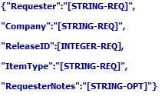
* In the above request data:
  + Field values for most fields are **required**. However, the value for “*RequesterNotes*” is **optional**.

#### Example Data: CreateBillOfLading

* Below is the sample JSON request data format for the ***“CreateBillOfLading”*** *API* program, after entering valid field values in the above request data format.  
  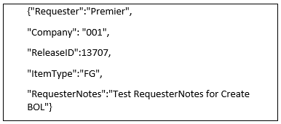
* Below is the sample screenshot in the *API* Tester for the ***“CreateBillOfLading”*** *API* program, after filling all JSON field values in the Tester Screen.  
  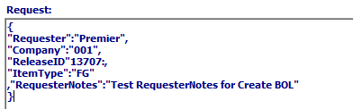

#### Successful Response

* If the *API* program “***CreateBillOfLading***” call was successful, the JSON text featured below is returned as the response in **Response** text field.  
  

#### Test Scenarios – Invalid Scenarios

* Scenario 1 – When company is empty or Invalid:
  + ***RESULT***: The below error text comes in the response.  
    
* Scenario 2 – When ReleaseID is 0 or Invalid:
  + ***RESULT***: The below error text comes in the response.  
    
* Scenario 3 – When ReleaseID is already Posted:
  + ***RESULT***: The below error text comes in the response.  
    

#### Test Scenarios – Valid Scenarios

* Scenario 1 – When all Invalid scenarios are resolved / Request data has valid data:
  + Created BOLID comes in the response with success message as shown below  
    
  + Release ID will be posted  
    Check screen **“Order Release” (*“O”-“T”-“1”*)** whether release ID is posted or not as shown below  
    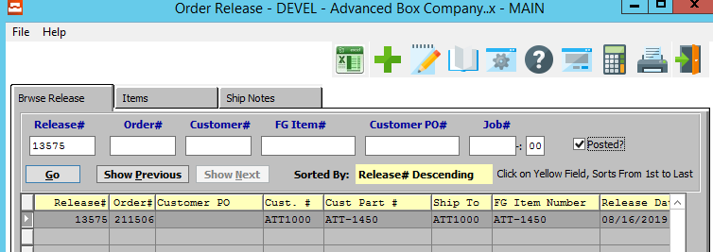
  + BOL will be created and it can be checked in screen **“Bill of Lading Maintenance” (*“O”-“S”-“1”*)** as shown below  
    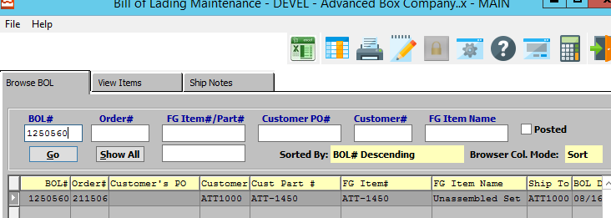

### Inbound: ConsumeInventoryviaBOL

#### Description

This *API* consumes inventory and posts for a given Bill of Lading.

#### Default Request Data: ConsumeInventoryviaBOL

* Below is the default **request data** format for the ***“ConsumeInventoryviaBOL”*** *API* program.  
  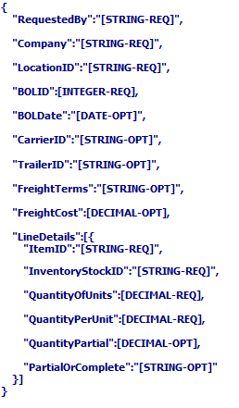
* In the above request data:
  + Field values for most fields are **required**. However, the values for “*BOLDate*”, “*CarrierID*”, “*TrailerID*”, “*FreightTerms*”, “*FreightCost*”, “*QuantityPartial*”, and “*PartialOrComplete*” are **optional**.

#### Example Data: ConsumeInventoryviaBOL

* Below is the sample JSON request data format for the ***“ConsumeInventoryviaBOL”*** *API* program, after entering valid field values in the above request data format.  
  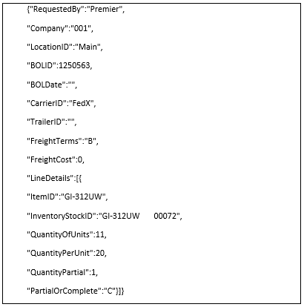
* Below is the sample screenshot in the *API* Tester for the ***“ConsumeInventoryviaBOL”*** *API* program, after filling all JSON field values in the Tester Screen.  
  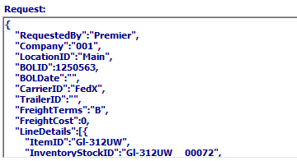

#### Successful Response

* If the *API* program “***ConsumeInventoryviaBOL***” call was successful, the JSON text featured below is returned as the response in **Response** text field.  
  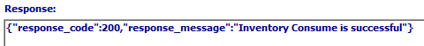

#### Test Scenarios – Invalid Scenarios

* Scenario 1 – When company is “” or Invalid:
  + ***RESULT***: The below error text comes in the response.  
      
    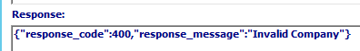
* Scenario 2 – When BOLID is 0 or Invalid:
  + ***RESULT***: The below error text comes in the response.  
      
    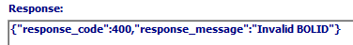
* Scenario 3 – When BOL date is non-empty and Invalid:
  + ***RESULT***: The below error text comes in the response.  
      
    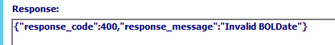
* Scenario 4 – When CarrierID is non-empty and Invalid:
  + ***RESULT***: The below error text comes in the response.  
      
    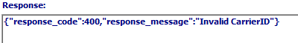
* Scenario 5 – When BOL Item quantity is less than input quantity:
  + ***RESULT***: The below error text comes in the response.  
      
    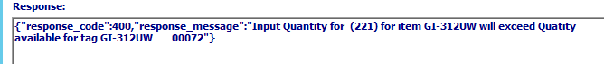
* Scenario 6 – When FreightTerms is empty or Invalid:
  + ***RESULT***: The below error text comes in the response.  
      
    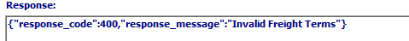
* Scenario 7 – When Item does not exist for the given BOL:
  + ***RESULT***: The below error text comes in the response.  
      
    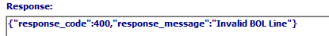

#### Test Scenarios – Valid Scenarios

* Scenario 1 – When all Invalid scenarios are resolved / Input data has valid values:
  + ***Result:*** Success message comes in response.
  + BOL will be posted.

#### Check BOL Posting:

* The posted Bill of Lading can be checked in **“Order Processing/Bill of Lading” (Located at *“O”-“S”-“1”*)**, as shown below.  
  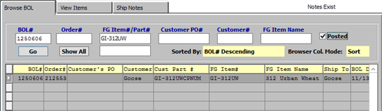

### Inbound: CreateInventoryCount

#### Description

This *API* does the following:

* Creates and posts count for the given Tag.
* Supports multiple requests and responses.

#### Default Request Data: CreateInventoryCount

* Below is the default **request data** format for the ***“CreateInventoryCount”*** *API* program.  
  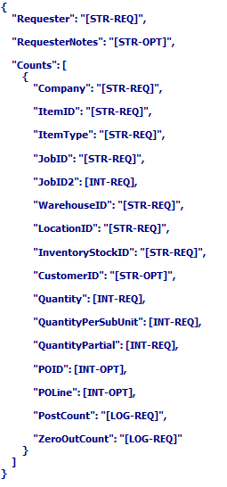
* In the above request data:
  + Field values for most fields are **required**. However, the values for “*RequesterNotes*”, “*CustomerID*”, “*POID*”, and “*POLine*” are **optional**.

#### Example Data: CreateInventoryCount

* Below is the sample JSON request data format for the ***“CreateInventoryCount”*** *API* program, after entering valid field values in the above request data format.  
  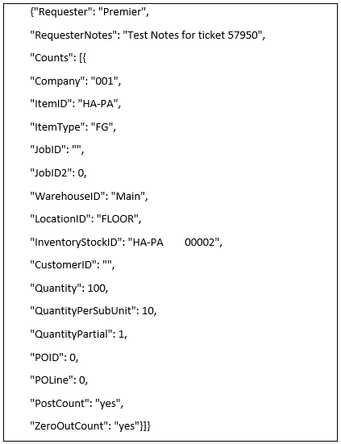
* Below is the sample screenshot in the *API* Tester for the ***“CreateInventoryCount”*** *API* program, after filling all JSON field values in the Tester Screen.  
  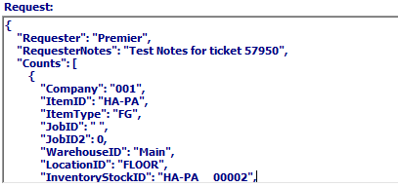
* Please Note: The “PostCount*”* field in the ***“CreateInventoryCount”*** *API* program, is a Boolean value. This means that the user has two choices in how this field is handled. Options for this field are as follows:

|  |  |
| --- | --- |
| yes | The count will be posted. |
| no | The count will not be posted. |
| Anything Else | The response will be an error message, as nothing but a ‘yes’ or ‘no’ answer is valid. |

* Please Note: The “*ZeroOutCount”* field in the ***“CreateInventoryCount”*** *API* program, is a Boolean value. This means that the user has two choices in how this field is handled. Options for this field are as follows:

|  |  |
| --- | --- |
| yes | Other bins will zero out. |
| no | Other bins do not zero out. |
| Anything Else | The response will be an error message, as nothing but a ‘yes’ or ‘no’ answer is valid. |

#### Successful Response

* If the *API* program “***CreateInventoryCount***” call was successful, the JSON text featured below is returned as the response in **Response** text field.  
  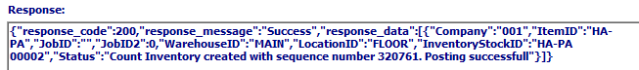

#### Test Scenarios – Invalid Scenarios

* Scenario 1 – When company is empty or Invalid:
  + ***RESULT***: The below error text comes in the response.  
      
    
* Scenario 2 – When ItemID is empty:
  + ***RESULT***: The below error text comes in the response.  
      
    
* Scenario 3 – When ItemID is Invalid:
  + ***RESULT***: The below error text comes in the response.  
      
    
* Scenario 4 – When ItemType is empty or Invalid:
  + ***RESULT***: The below error text comes in the response.  
      
    
* Scenario 5 – When WarehouseID is empty:
  + ***RESULT***: The below error text comes in the response.  
      
    
* Scenario 6 – When WarehouseID is Invalid:
  + ***RESULT***: The below error text comes in the response.  
      
    
* Scenario 7 – When LocationID is empty:
  + ***RESULT***: The below error text comes in the response.  
      
    
* Scenario 8 – When LocationID is Invalid:
  + ***RESULT***: The below error text comes in the response.  
      
    
* Scenario 9 – When Tag is empty:
  + ***RESULT***: The below error text comes in the response.  
      
    
* Scenario 10 – When Quantity is empty:
  + ***RESULT***: The below error text comes in the response.  
      
    
* Scenario 11 – When Tag is Invalid:
  + ***RESULT***: The below error text comes in the response.  
      
    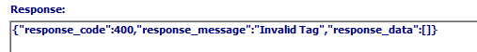

#### Test Scenarios – Valid Scenarios

* Scenario 1 – When all Invalid cases are resolved:
  + ***RESULT***: Success message along with sequence number comes in response.  
      
    

#### Check Finished Good Counts:

* The Finished Good counts can be checked in **Finished Goods Item Inventory/History” (Located at *“I”-“F”-“1”*)**, as shown below.  
  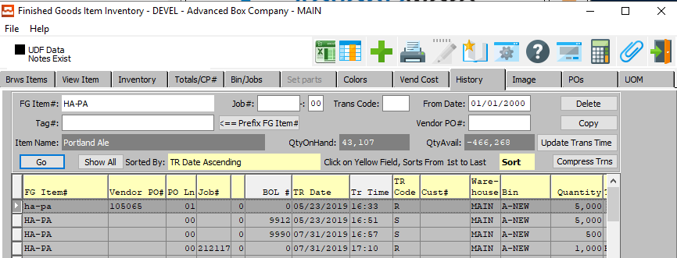

### Inbound: CreateVendorInvoice

#### Description

This *API* provides the option to submit invoices electronically to their vendors.

#### Default Request Data: CreateVendorInvoice

* Below is the default **request data** format for the ***“CreateVendorInvoice”*** *API* program.  
  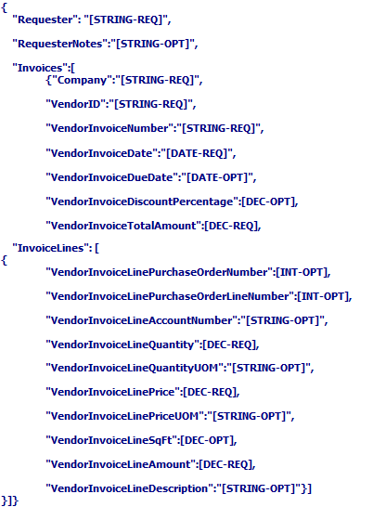
* In the above request data:
  + Field values for most fields are **optional**. However, quite a few values are **required**, so the user should exercise extreme caution when filling out their desired fields.

#### Example Data: CreateVendorInvoice

* Below is the sample JSON request data format for the ***“CreateVendorInvoice”*** *API* program, after entering valid field values in the above request data format.  
  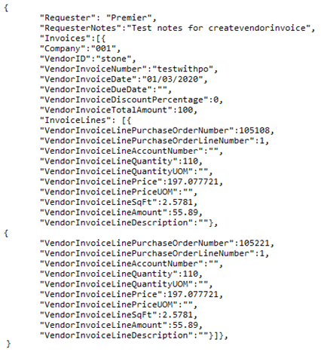
* Below is the sample screenshot in the *API* Tester for the ***“CreateVendorInvoice”*** *API* program, after filling all JSON field values in the Tester Screen.  
  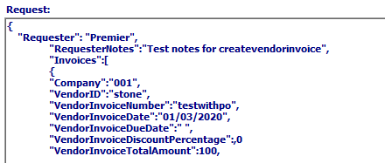

#### Successful Response

* If the *API* program “***CreateVendorInvoice***” call was successful, the JSON text featured below is returned as the response in **Response** text field.  
  

#### Test Scenarios – Invalid Scenarios

* Scenario 1 – When company is empty or Invalid:
  + ***RESULT***: The below error text comes in the response.  
      
    
* Scenario 2 – When VendorID is empty or Invalid:
  + ***RESULT***: The below error text comes in the response.  
      
    
* Scenario 3 – When Invoice number is empty:
  + ***RESULT***: The below error text comes in the response.  
      
    
* Scenario 4 – When Invoice date is empty or Invalid:
  + ***RESULT***: The below error text comes in the response.  
      
    
* Scenario 5 – When Invoice total amount is empty:
  + ***RESULT***: The below error text comes in the response.  
      
    
* Scenario 6 – When Invoice line PO number is non-empty and Invalid:
  + ***RESULT***: The below error text comes in the response.  
    
* Scenario 7 – When Invoice line PO line is non-empty and Invalid:
  + ***RESULT***: The below error text comes in the response.  
    
* Scenario 8 – When Invoice line quantity is empty:
  + ***RESULT***: The below error text comes in the response.  
    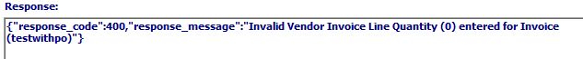
* Scenario 9 – When Invoice line price is empty:
  + ***RESULT***: The below error text comes in the response.  
    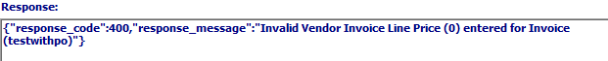
* Scenario 10 – When Invoice line amount is empty:
  + ***RESULT***: The below error text comes in the response.  
    

#### Test Scenarios – Valid Scenarios

* Scenario 1 – When all Invalid cases are resolved:
  + Invoices will be created, and success message comes in the response  
    

#### Check Invoices:

* The Created Invoices can be checked in **Accounts Payable/Vendor Invoices” (Located at *“V”-“U”-“1”*)**, as shown below.  
  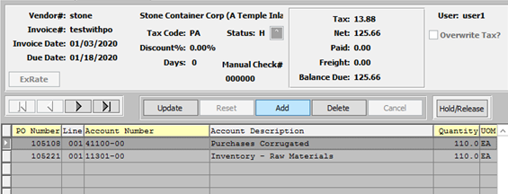

### Inbound: UpdateItem

#### Description

This *API* provides a chance to update an item’s dimensions.

#### Default Request Data: UpdateItem

* Below is the default **request data** format for the ***“UpdateItem”*** *API* program.  
  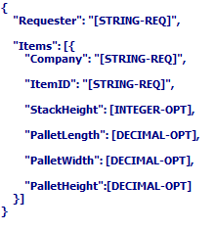
* In the above request data:
  + Field values for most fields are **optional**. However, the values for “*Requester*”, “*Company*”, and “*ItemID*” are **required**.

#### Example Data: UpdateItem

* Below is the sample JSON request data format for the ***“UpdateItem”*** *API* program, after entering valid field values in the above request data format.  
  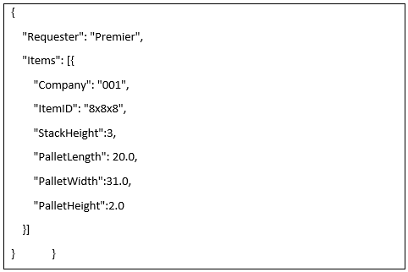
* Below is the sample screenshot in the *API* Tester for the ***“UpdateItem”*** *API* program, after filling all JSON field values in the Tester Screen.  
  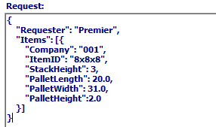

#### Successful Response

* If the *API* program “***UpdateItem***” call was successful, the JSON text featured below is returned as the response in **Response** text field.  
  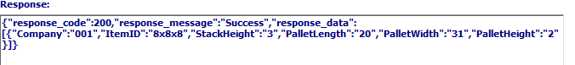

#### Test Scenarios – Invalid Scenarios

* Scenario 1 – When company is empty or Invalid:
  + ***RESULT***: The below error text comes in the response.  
      
    
* Scenario 2 – When ItemID is empty or Invalid:
  + ***RESULT***: The below error text comes in the response.  
      
    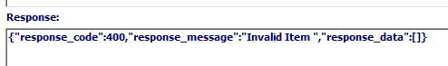
* Scenario 3 – When StackHeight is not in the range of 1 and 4 for non-zero values:
  + ***RESULT***: The below error text comes in the response.  
      
    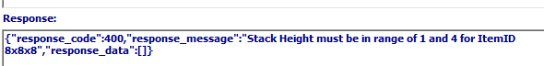

#### Test Scenarios – Valid Scenarios

* Scenario 1 – When all Invalid cases are resolved:
  + Item dimensions update to new value and success message comes in the response along with updates values  
    

#### Check Dimension Updates:

* The Finished Good Item Dimensions can be checked in **Finished Goods Item Inventory/Item Detail” (Located at *“I”-“F”-“1”*)**, as shown below.  
  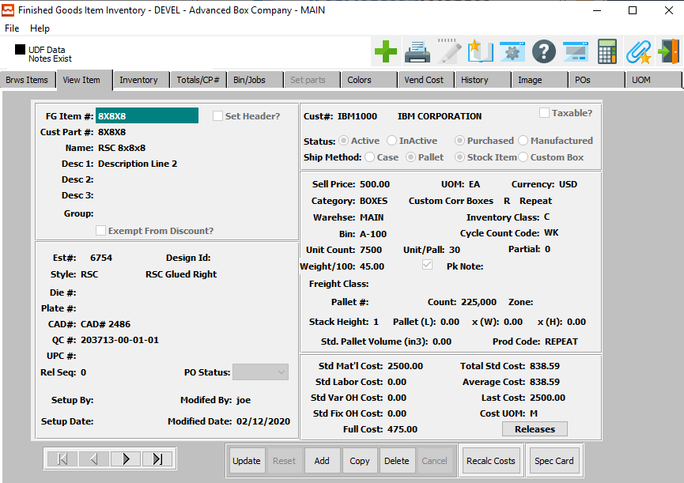  
    
  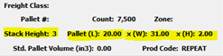

### Inbound: SplitTag

#### Description

This *API* splits a tag quantity and transfers it to a new tag.

#### Default Request Data: SplitTag

* Below is the default **request data** format for the ***“SplitTag”*** *API* program.  
  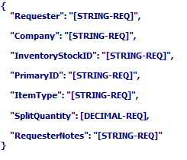
* In the above request data:
  + Field values for all fields are **required**.

#### Example Data: SplitTag

* Below is the sample JSON request data format for the ***“SplitTag”*** *API* program, after entering valid field values in the above request data format.  
  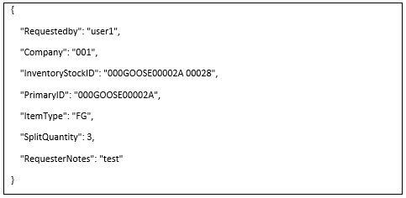
* Below is the sample screenshot in the *API* Tester for the ***“SplitTag”*** *API* program, after filling all JSON field values in the Tester Screen.  
  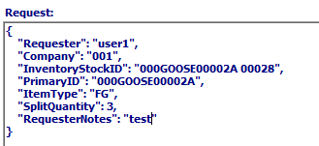

#### Successful Response

* If the *API* program “***SplitTag***” call was successful, the JSON text featured below is returned as the response in **Response** text field.  
  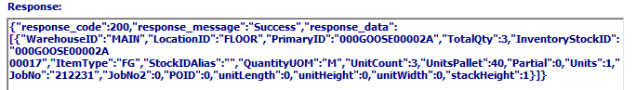

#### Test Scenarios – Invalid Scenarios

* Scenario 1 – When company is empty or Invalid:
  + ***RESULT***: The below error text comes in the response.  
      
    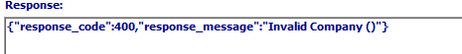
* Scenario 2 – When Tag is empty or Invalid:
  + ***RESULT***: The below error text comes in the response.  
      
    
* Scenario 3 – When Item is empty or Invalid:
  + ***RESULT***: The below error text comes in the response.  
      
    
* Scenario 4 – When bin don’t have on-hand quantity for the given tag:
  + ***RESULT***: The below error text comes in the response.  
      
    
* Scenario 5 – When on-hand quantity is less than split quantity:
  + ***RESULT***: The below error text comes in the response.  
      
    
* Scenario 6 – When tag item is not same as given item:
  + ***RESULT***: The below error text comes in the response.  
    
* Scenario 7 – When new tag is not posted successfully because of any issue:
  + ***RESULT***: The below error text comes in the response.  
    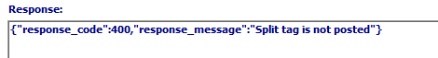
* Scenario 8 – When Item type is Invalid or Empty:
  + ***RESULT***: The below error text comes in the response.  
    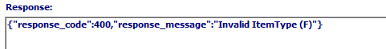

#### Test Scenarios – Valid Scenarios

* Scenario 1 – When all Invalid cases are resolved:
  + New tag number along with inventory details come in the response  
    
  + Split quantity transfers from given tag to new tag.

#### Check Tags:

* The Finished Good Tags can be checked in **Finished Goods Item Inventory/History” (Located at *“I”-“F”-“1”*)**, as shown below.  
  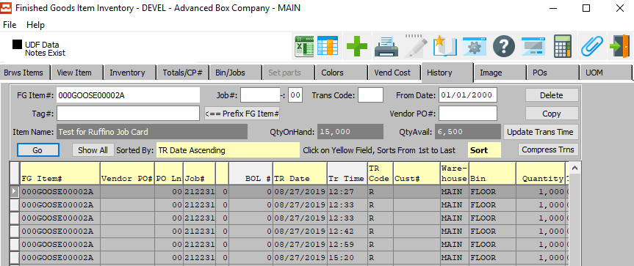

### Inbound: UpdateTagStatus

#### Description

This *API* updates a tag status.

#### Default Request Data: UpdateTagStatus

* Below is the default **request data** format for the ***“UpdateTagStatus”*** *API* program.  
  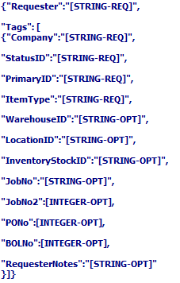
* In the above request data:
  + Field values for most fields are **optional**. However, the values for “*Requester*”, “*Company*”, “*StatusID*”, “*PrimaryID*” and “*ItemType*” are **required**.

#### Example Data: UpdateTagStatus

* Below is the sample JSON request data format for the ***“UpdateTagStatus”*** *API* program, after entering valid field values in the above request data format.  
  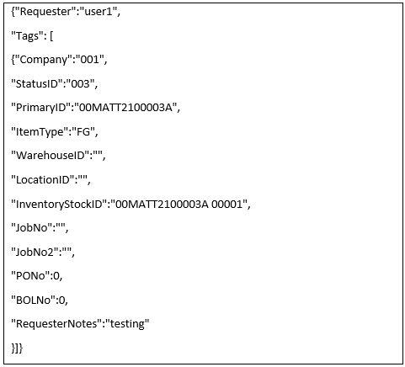
* Below is the sample screenshot in the *API* Tester for the ***“UpdateTagStatus”*** *API* program, after filling all JSON field values in the Tester Screen.  
  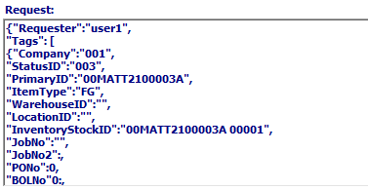

#### Successful Response

* If the *API* program “***UpdateTagStatus***” call was successful, the JSON text featured below is returned as the response in **Response** text field.  
  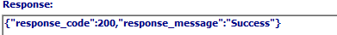

#### Test Scenarios – Invalid Scenarios

* Scenario 1 – When company is empty or Invalid:
  + ***RESULT***: The below error text comes in the response.  
      
    
* Scenario 2 – When Tag is empty or Invalid:
  + ***RESULT***: The below error text comes in the response.  
      
    
* Scenario 3 – When Item is empty or Invalid:
  + ***RESULT***: The below error text comes in the response.  
      
    
* Scenario 4 – When Status ID is empty or Invalid:
  + ***RESULT***: The below error text comes in the response.  
      
    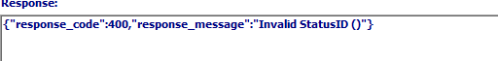
* Scenario 5 – When Item type is empty or Invalid:
  + ***RESULT***: The below error text comes in the response.  
      
    
* Scenario 6 – When WarehouseID is non-empty or Invalid:
  + ***RESULT***: The below error text comes in the response.  
      
    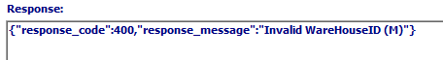
* Scenario 7 – When LocationID is non-empty or Invalid:
  + ***RESULT***: The below error text comes in the response.  
      
    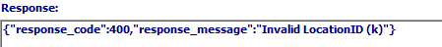
* Scenario 8 – When FG item is not found for the given combination:
  + ***RESULT***: The below error text comes in the response.  
      
    

#### Test Scenarios – Valid Scenarios

* Scenario 1 – When all Invalid cases are resolved:  
  
  + Tag status updates with the given status ID.

#### Check Tag Status:

The new Tag Status can be checked in **Finished Goods/Bin Inquiry” (Located at *“I”-“Q”-“3”*)**, as shown below.  
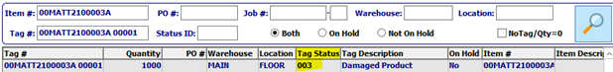

### Inbound: DeleteBillOfLading

#### Description

This *API* deletes a user-specified Bill of Lading and un-posts the related release ID.

#### Default Request Data: DeleteBillOfLading

* Below is the default **request data** format for the ***“DeleteBillOfLading”*** *API* program.  
  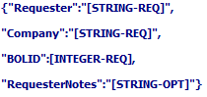
* In the above request data:
  + Field values for most fields are **required**. However, the value for “*RequesterNotes*” is **required**.

#### Example Data: DeleteBillOfLading

* Below is the sample JSON request data format for the ***“DeleteBillOfLading”*** *API* program, after entering valid field values in the above request data format.  
  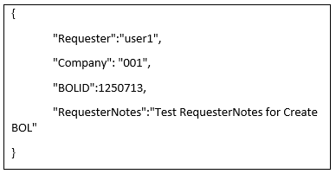
* Below is the sample screenshot in the *API* Tester for the ***“DeleteBillOfLading”*** *API* program, after filling all JSON field values in the Tester Screen.  
  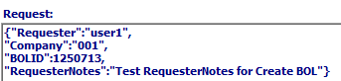

#### Successful Response

* If the *API* program “***DeleteBillOfLading***” call was successful, the JSON text featured below is returned as the response in **Response** text field.  
  

#### Test Scenarios – Invalid Scenarios

* Scenario 1 – When company is empty or Invalid:
  + ***RESULT***: The below error text comes in the response.  
      
    
* Scenario 2 – When BOLID is 0 or Invalid:
  + ***RESULT***: The below error text comes in the response.  
      
    

#### Test Scenarios – Valid Scenarios

* Scenario 1 – When all Invalid scenarios are resolved / Request data has valid data:
  + Response comes with success message as shown below  
    
  + Release ID will be posted  
    Check screen **“Order Release” (O-T-1)** whether release ID is unposted or not
  + BOL will be deleted and it can be checked in screen **“Bill of Lading Maintenance” (O-S-1)**

### Inbound: getPriceInUOM

#### Description

This *API* does the following:

* Returns the price in after converting to targeted Unit of Measure.
* Supports multiple requests and responses.

#### Default Request Data: getPriceInUOM

* Below is the default **request data** format for the ***“getPriceInUOM”*** *API* program.  
  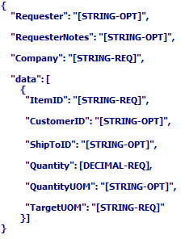
* In the above request data:
  + Field values for most fields are **optional**. However, the values for “*Company*”, “*ItemID*”, “*Quantity*” and “*TargetUOM*” are **required**.

#### Example Data: getPriceInUOM

* Below is the sample JSON request data format for the ***“getPriceInUOM”*** *API* program, after entering valid field values in the above request data format.  
  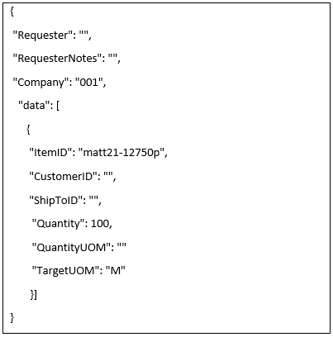
* Below is the sample screenshot in the *API* Tester for the ***“getPriceInUOM”*** *API* program, after filling all JSON field values in the Tester Screen.  
  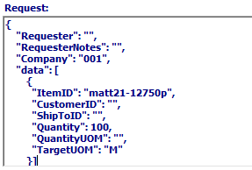

#### Successful Response

* If the *API* program “***getPriceInUOM***” call was successful, the JSON text featured below is returned as the response in **Response** text field.  
  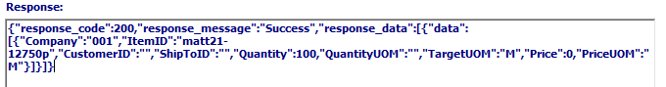

#### Test Scenarios – Invalid Scenarios

* Scenario 1 – When company is empty or Invalid:
  + ***RESULT***: The below error text comes in the response.  
      
    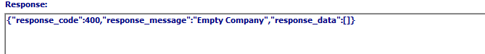
* Scenario 2 – When itemID is blank:
  + ***RESULT***: The below error text comes in the response.  
      
    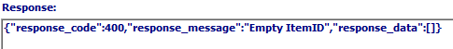
* Scenario 3 – When Quantity is 0:
  + ***RESULT***: The below error text comes in the response.  
      
    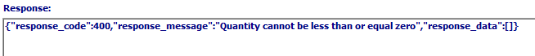

### Inbound: getPrice

#### Description

This *API* does the following:

* Returns the price for an Item ID.
* Supports multiple requests and response.

#### Default Request Data: getPrice

* Below is the default **request data** format for the ***“getPrice”*** *API* program.  
  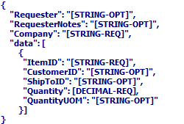
* In the above request data:
  + Field values for most fields are **optional**. However, the values for “*Company*”, “*ItemID*”, and “*Quantity*” are **required**.

#### Example Data: getPrice

* Below is the sample JSON request data format for the ***“getPrice”*** *API* program, after entering valid field values in the above request data format.  
  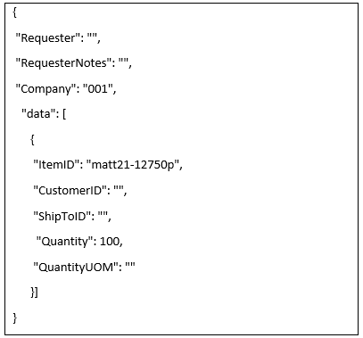
* Below is the sample screenshot in the *API* Tester for the ***“getPrice”*** *API* program, after filling all JSON field values in the Tester Screen.  
  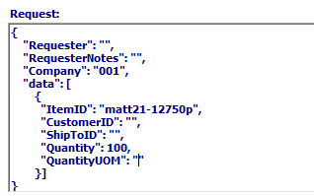

#### Successful Response

* If the *API* program “***getPrice***” call was successful, the JSON text featured below is returned as the response in **Response** text field.  
  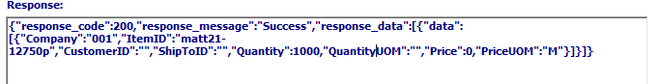

#### Test Scenarios – Invalid Scenarios

* Scenario 1 – When company is empty or Invalid:
  + ***RESULT***: The below error text comes in the response  
      
    
* Scenario 2 – When itemID is blank:
  + ***RESULT***: The below error text comes in the response.  
      
    
* Scenario 3 – When Quantity is 0:
  + ***RESULT***: The below error text comes in the response  
      
    

### Inbound: getPriceMatrix

#### Description

This *API* does the following:

* Returns the price matrix for an Item ID and customer.
* Supports multiple requests and responses.

#### Default Request Data: getPriceMatrix

* Below is the default **request data** format for the ***“getPriceMatrix”*** *API* program.  
  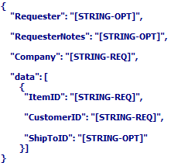
* In the above request data:
  + Field values for most fields are **optional**. However, the values for “*Company*”, “*ItemID*”, and “*CustomerID*” are **required**.

#### Example Data: getPriceMatrix

* Below is the sample JSON request data format for the ***“getPriceMatrix”*** *API* program, after entering valid field values in the above request data format.  
  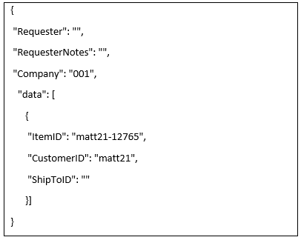
* Below is the sample screenshot in the *API* Tester for the ***“getPriceMatrix”*** *API* program, after filling all JSON field values in the Tester Screen.  
  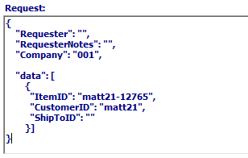

#### Successful Response

* If the *API* program “***getPriceMatrix***” call was successful, the JSON text featured below is returned as the response in **Response** text field.  
  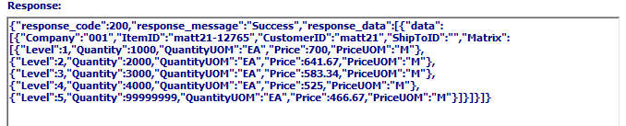

#### Test Scenarios – Invalid Scenarios

* Scenario 1 – When company is empty or Invalid:
  + ***RESULT***: The below error text comes in the response.  
    
* Scenario 2 – When itemID is blank:
  + ***RESULT***: The below error text comes in the response.  
    
* Scenario 3 – When CustomerID is “ ”:
  + ***RESULT***: The below error text comes in the response.  
    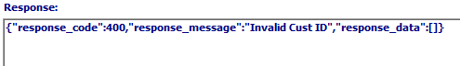

### Inbound: cXMLOrder

#### Description

This *API* is used to create cXML orders.

#### How to Test:

* Enter the cXML request data into the *Request* field.
* Below is the sample screenshot for the ***“cXMLOrder”*** *API* program, after entering valid field values in the tester screen.  
  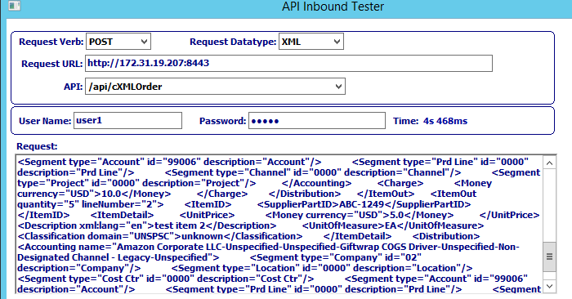

|  |  |
| --- | --- |
|  | The user may now click the ***“Green Check Icon”*** button in order to execute the selected *API* service. |

* If the *API* “cxmlorder” call is successful, then below XML text is returned as the response in **Response** text field.  
  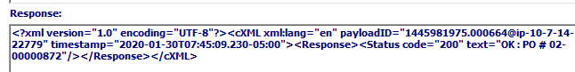

#### Test Scenarios – Invalid Scenarios

Below text comes in response irrespective of invalid cXML data / Internal exceptions



To verify internal exceptions, go to screen ***“N”-“A”-“4”*** and check field “*Success*” to know whether the *API* program call has been successful. Check the “Response Result” field in order to verify the error name as shown below.

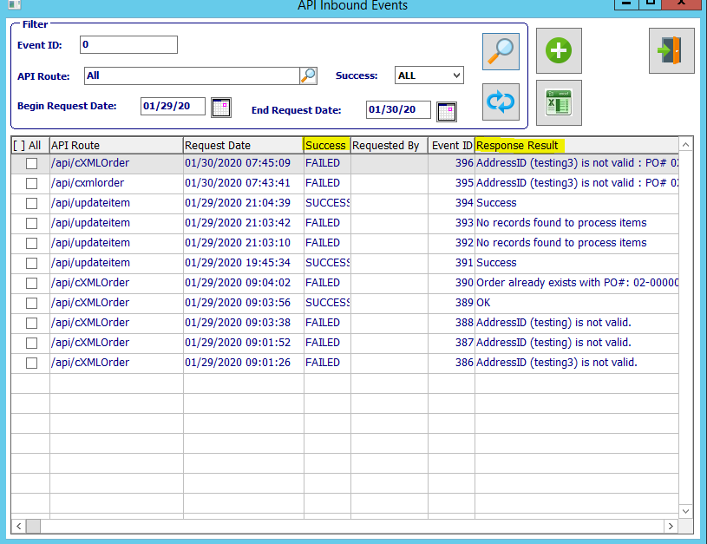

In the following invalid scenarios, an internal exception occurs.

* Scenario 1 – When “*orderID”* is already exists:
  + ***RESULT***: The below error text comes in the response result.  
    
* Scenario 2 – When “*orderID”* is empty:
  + ***RESULT***: The below error text comes in the response result.  
    
* Scenario 3 – When “*orderDate”* is empty:
  + ***RESULT***: The below error text comes in the response result.  
    
* Scenario 4 – When “*PayloadID”* is empty:
  + ***RESULT***: The below error text comes in the response result.  
    
* Scenario 5 – When “*AddressID”* is empty:
  + ***RESULT***: The below error text comes in the response result.  
    
* Scenario 6 – When *“Identity Tag”* present under the *“From Tag”* is empty:
  + ***RESULT***: The below error text comes in the response result.  
    
* Scenario 7 – When *“DTD Tag”* value is invalid:
  + ***RESULT***: The below error text comes in the response result.  
    
* Scenario 8 – When “*SupplierPartID”* value is empty:
  + ***RESULT***: The below error text comes in the response result.  
    
* Scenario 9 – When “*AddressID”* value is Invalid:
  + ***RESULT***: The below error text comes in the response result.  
      
    
* Scenario 10 – When “*SupplierPartID”* value is Invalid:
  + ***RESULT***: The below error text comes in the response result.  
      
    

#### Test Scenarios – Valid Scenarios

* Scenario 1 - When all invalid scenarios are resolved:
  + ***RESULT:*** The below text comes in the response result.  
      
    

## Inbound API Services Re-Trigger

### Overview

If a request is submitted and any failure occurs, it is possible to retrigger that failed event again after entering valid data into system.

### Steps to Re-Trigger Event

#### Step One: Open API Tester

Go to screen ***“N” – “A” – “4”*** (Inbound *API* Tester / Console)

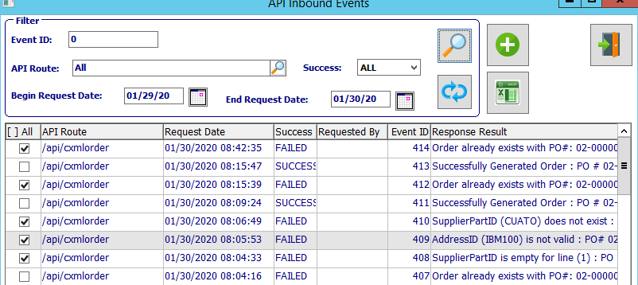

#### Step Two: Select Failed Events

Select the failed events which need to be re-triggered. In order to select an event, make sure that the toggle box next to the desired event is check marked.

Please Note: The user can quickly see if an event was failed or successful by looking in the “*Success”* column on the Inbound Events screen.

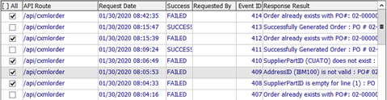

#### Step Three: Re-Trigger Event

|  |  |
| --- | --- |
|  | Click the ***“Blue Refresh Icon”*** button to re-trigger the selected Inbound Event(s). |

#### Step Four: Updated Information Popup

A message box popup will then appear, which briefly shows the user the current total number of success events, failed events, and re-triggered events.

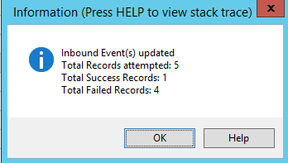

Click the ***“Okay”*** button to exit this popup window.

#### Step Five: Refresh Inbound Events.

|  |  |
| --- | --- |
|  | Click the ***“Magnifying Glass Icon”*** button to refresh the Inbound Event(s) page. |

#### Step Six: Review Events

The user may now check the fields labeled “*Success*” and “*Response Result*” for each listed *API* event in order to verify the updated status for all re-triggered events.

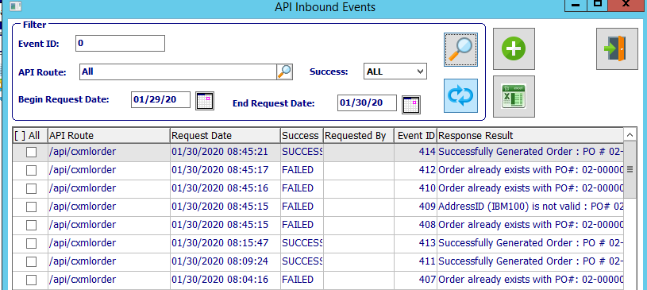

## Inbound API: Loader

### Overview

If a request is submitted, and the service is not operational or otherwise cannot process the request, the system allows for requests to be queued and processed later. Advantzware supports a log of requests received when the service is not available, and these will be tracked in a log in the format submitted to be processed at a later time.

This process allows for requests to be placed in a log and loaded later (Once the service is restored) and loaded. This is a manual process, but no requests will be processed at the time they are entered. Rather, they will be tracked in a log file that can be loaded and processed afterwards in the order they were submitted. This is a safeguard in order to prevent losing the data, and should be processed as quickly as possible once service is restored since they are the basis for any future requests.

These files are stored in the system, and there is a system utility located in ***“N”-“M”*** called ‘*DataLoader’* that can load this file and process them in accordance with normal rules.

## Monitor Screen

### Overview

The *API* Monitor screen is used to monitor resources in order to verify the status of the services and to allow notification to users when these services are no longer available. This service can monitor any desired *API* Services, including the Node Server (Monitoring the ports), Web Server (Connection to the database), Name Server what will track which service is connected to which database instance, Database Server, and the Admin Server.

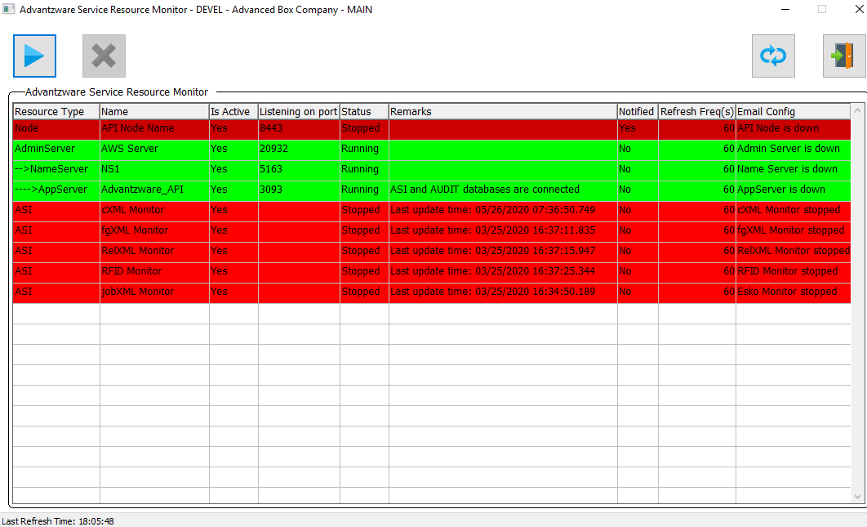

The following database table will be created.

### Table: serverResource

This table stores configuration required for resources.

|  |  |  |  |  |  |
| --- | --- | --- | --- | --- | --- |
| ***S. No*** | ***Fieldname*** | ***Datatype*** | ***Format*** | ***Purpose*** | ***Index Field*** |
| 1 | rec_key | Character | X(21) | Unique identifier for a record | Yes |
| 2 | company | Character | X(3) | This stores company code |  |
| 3 | resourceID | INT64 | ->,>>>,>>9 | Primary unique identifier for a resource | Yes |
| 4 | environment | Character | x(16) | This stores environment of the machine | Yes |
| 5 | resourceType | Character | x(16) | This stores resource type  (e.g. Node Server, Database Server, etc..,) | Yes |
| 6 | Name | Character | x(32) | This stores name of the resource | Yes |
| 7 | isActive | Logical | Yes/no | Used to indicate if this service is active | Yes |
| 8 | createTime | Datetime | 99/99/9999 HH:MM:SS.SSS | This stores record creation date time | Yes |
| 9 | createBy | Character | X(24) | This stores the user id of the logged in user | Yes |
| 10 | Port | Character | X(8) | This stores port on which resource is running if applicable | Yes |
| 11 | startService | Character | X(200) | The command to start or re-start a resource |  |
| 12 | stopService | Character | X(200) | This command to stop a resource |  |

Theconfiguration table “serverResource” will not store Name Server configuration, because Name Server configuration will be retrieved from Web Server configuration (the controlling Name Server property).

### Monitor Programs

#### api/AdvantzwareMonitorProcs.p

This program contains procedures and functions to check the status of resources, and returns the required details as an output parameter. It also controls the ‘Send Email’ notification procedure for notification purposes if any of the resources are not running.

#### api/AdvantzwareMonitor.w

This program is the screen display that will be used to monitor the resources and to start/stop the same.

### How Advantzware Monitor Works

#### If a Resource is Running

* ***“Start”*** (Play Icon) button will be disabled.
* ***“Stop”*** (Cross Icon) button will be enabled.
* ***“Notified”*** field in the browser will be set to *“No”.*

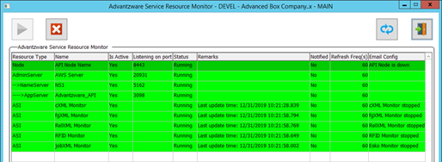

#### If Any Resource Needs to be Stopped

* Click on **stop** (cross icon) button to stop
* Click **Refresh** button OR wait till timer refreshes monitor to view latest status in the browser.

#### If a Resource is Stopped Because of any Issue/Anyone Stopped It

* **start** (play icon) button will be enabled
* **stop** (cross icon) button will be disabled
* **Notified** field in the browse will be “yes”

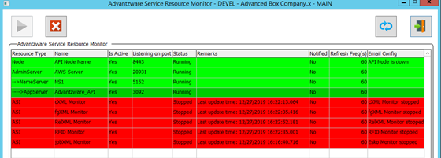

Further, email notifications will be not be sent once **Notified** field updates to “yes”.

* If any resource needs to be Re-started then ,
  + Click on **start** (play icon) button to start.
  + Click Refreshbutton OR wait till timer refreshes monitor to view latest status in the browser.
* Once, a resource is re-started then **Notified** field updates to “no”.

# **Outbound API**

## Outbound API Configuration

### Overview

Outbound *API* access requires that users outside of the network or company can provide and receive data to a pre-designated location outside the network and communicate with the outbound network server.

This communication requires that the external system is listening to a specific port and waiting for a submission to be processed. This tool may be any number of options that are ready to receive data from Advantzware once it is told an IP address and port to send data for any responses.

### Configuration

#### Schema

Make sure the following tables are available in the database. As of 29th May 2020, the updated schema (.df files) for the below tables can be taken from AWS Server.

|  |  |
| --- | --- |
| APIOutbound | This table holds configuration required for Outbound APIs |
| APIOutboundDetail | This table is an extension to APIOutbound table and holds configuration required for Outbound APIs, when request data has nested JSON |
| APIOutboundEvent | This table keeps track of all Outbound events and serves as a log as well |
| APIClient | This tables holds the client configuration such as client name and share secrets/tokens |
| APIClientXref | This table holds the scopes and scope types (customer/vendor/shipto/etc.) for which API should be made active/inactive |

#### API Configuration Data

Make sure the following tables have the required configuration data.

* APIOutbound
* APIOutboundDetail

#### cURL Utility

Make sure the executable of the cURL (32-bit) utility is available in the PROPATH preferably under “Resources” directory.

#### sys-ctrl Configuration

Make sure to create the following sys-ctrl records using System Control Parameter Maitenance (***“N”-“K”-“1”***) as shown below.

Please Note that these sys-ctrl records will be automatically created if one does not exist.

* This is required to validate the request and response handler codes with the program names available in APIOutbound configuration.  
    
  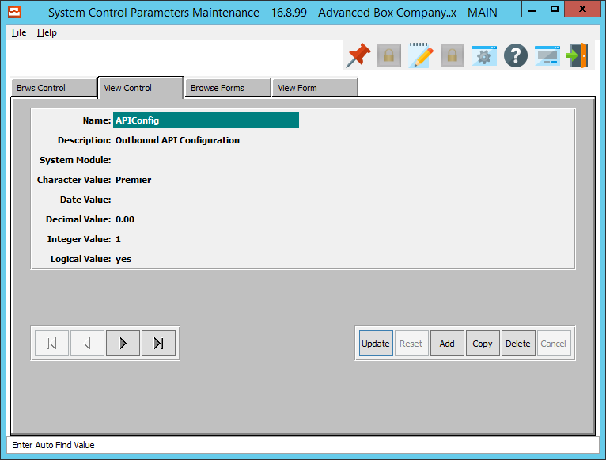
* This is required to fetch the directory to which data needs to be exported from the API Outbound Events Viewer screen.  
    
  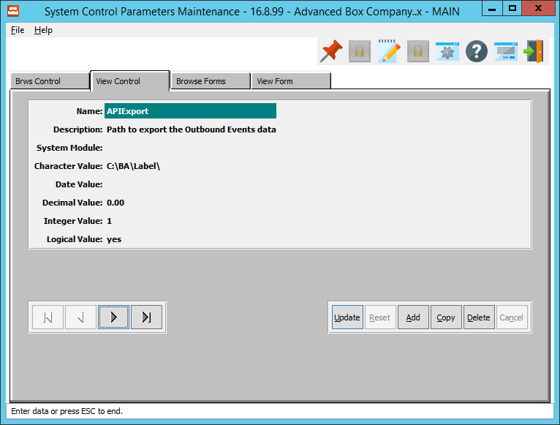

## Outbound API Triggers Configuration

An outbound *API* can have multiple trigger points. Based on the customer requirements, trigger points can be enabled / disabled for an *API*.

### How to Enable a Trigger Point

* Open screen ***“N”-“A”-“1”***
* Go to tab “*Outbound*”  
  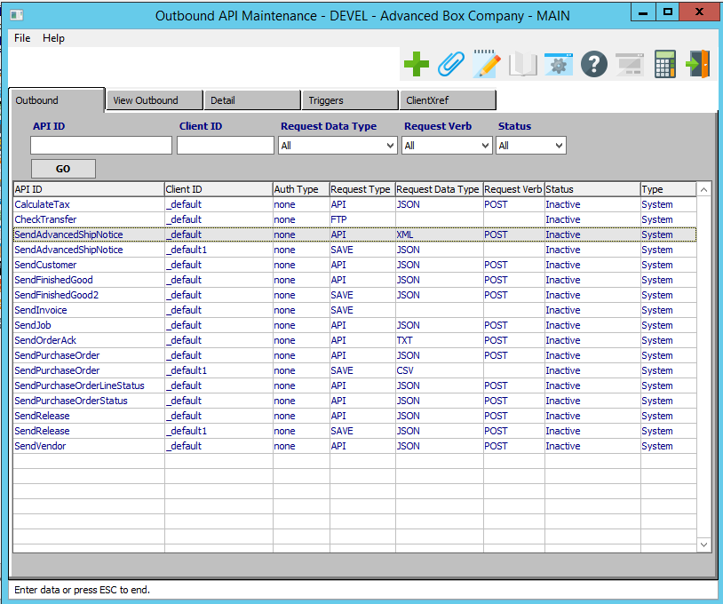
* Select required Outbound *API*
* Go to tab “*Triggers*”  
  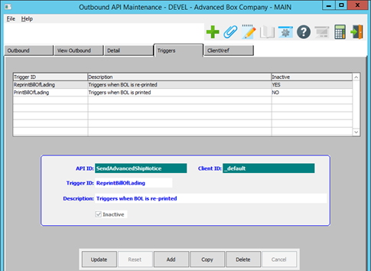
* Select required Trigger.
* Click the ***“Update”*** button.
* Make sure that the *“Inactive”* toggle box is not checked.  
  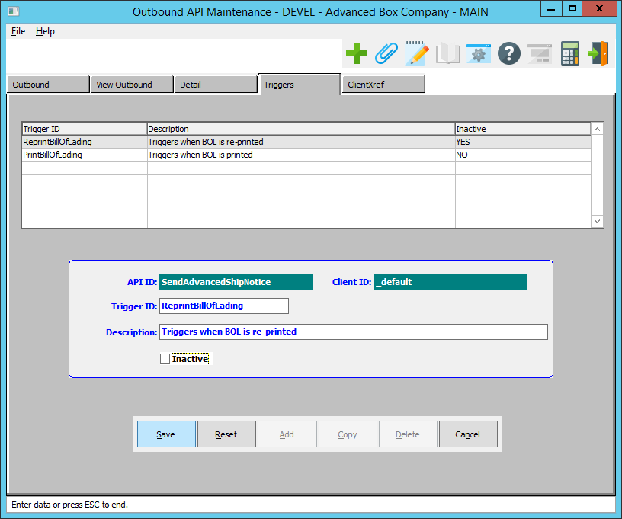
* Click the ***“Save”*** button.

### How to Disable a Trigger Point

* Open screen ***“N”-“A”-“1”***
* Go to tab “*Outbound*”  
  
* Select required Outbound *API*
* Go to tab “*Triggers*”  
  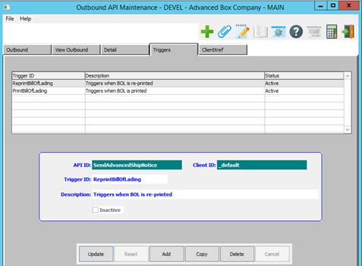
* Select required Trigger
* Click the “***Update***” button.
* Make sure that the *“Inactive”* toggle box is checked.  
  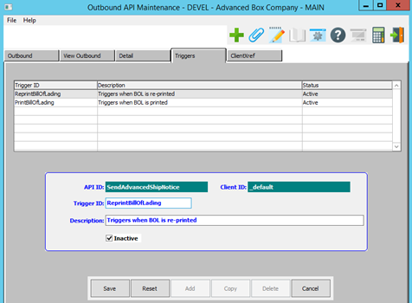
* Click the “***Save***” button.

## Outbound API Triggers Testing

### Outbound API SendPurchaseOrder Triggers

These triggers call outbound *API* “***SendPurchaseOrder***” when a purchase order is printed, reprinted, deleted, closed, or the status is updated.

Please Note: These steps are the same for the ***“Westrock”*** system.

#### PrintPurchaseOrder and ReprintPurchaseOrder

In order to test these triggers: First, open screen ***“P”-“U”-“1”*** and click on the “***Print***” icon. Alternatively, open screen *“****P”-“U”-“3”*** to get to the below screen.

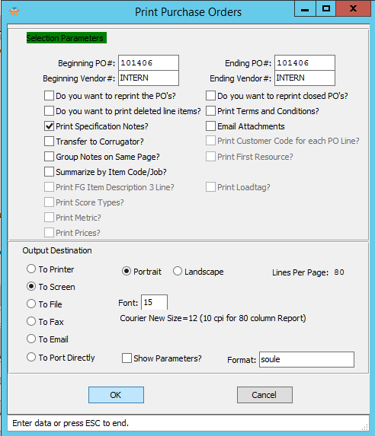

1. The user must enter their preferred values into the “*Beginning PO#*” and “*Ending PO#*” fields.
2. To choose the destination where the document should be printed, please make sure that desired output destination choice bubble is toggled.
3. The user may also choose any other specifications for the Purchase Orders that they wish using the Selection Parameters section of this screen.
4. In order to reprint Purchase Orders that have already been printed within the desired order parameters, the user should make sure that the ‘*Do you want to reprint the PO’s’* toggle box is checked.  
     
   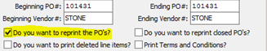
5. Click the ***“Okay”*** button.
6. The user may now check whether the Outbound *API* “*SendPurchaseOrder*” has been called or not. In order to do so, the user should open the Outbound Event screen located at ***“N”-“A”-“3”.***   
     
   If the Outbound *API* was called, then the Outbound event will be created as shown below.  
     
   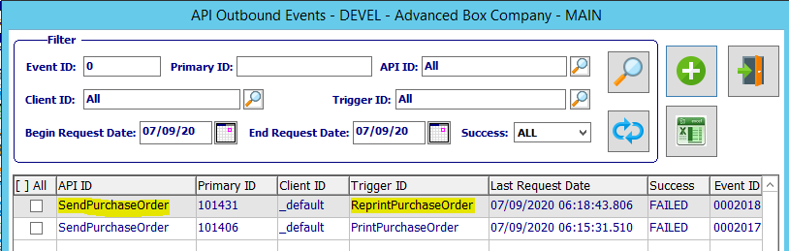  
     
   Please Note: In this example, you can see that there is one call for the *PrintPurchaseOrder* (Which is the initial printing of any user-selected Purchase Orders), and one call for the *ReprintPurchaseOrder* (Which is the reprinting of any previously-printed orders within the user-selected parameters.)

#### DeletePurchaseOrder

In order to test this trigger: First, open screen ***“P”-“U”-“1”***.

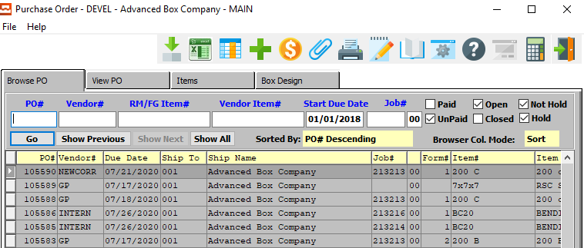

1. The user may then search for the Purchase Order that they wish to delete using the provided search fields on the *Browse PO* screen. In order to select the desired Purchase Order within this list, the user should click on the PO line to highlight it. The highlighted PO line will be the Purchase Order that the subsequent tabs will detail for the user.
2. The user may then go to the *“View PO”* tab.  
     
   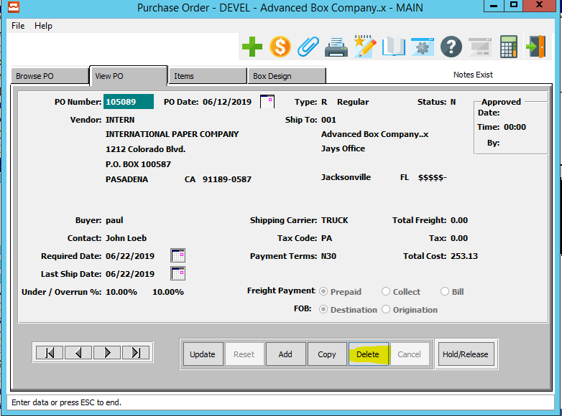
3. To delete this Purchase Order, click the ***“Delete”*** button.  
     
   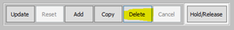
4. A popup window will now open for the user. This is a security measure in order to make sure that the user has not pressed the ***“Delete”*** button by accident. In order to confirm the deletion of this Purchase Order, the user may now press the ***“Yes”*** button.  
     
   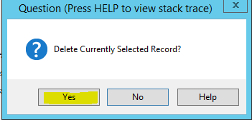
5. The user may now check whether the Outbound *API* “*SendPurchaseOrder*” has been called or not. In order to do so, the user should open the Outbound Event screen located at ***“N”-“A”-“3”.***   
     
   If the Outbound *API* was called, then the Outbound event will be created as shown below.  
     
   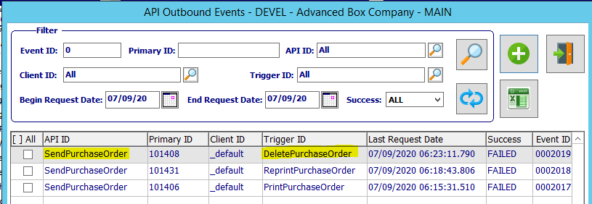

#### UpdatePurchaseOrder

In order to test this trigger: First, open screen ***“P”-“U”-“1”***.



1. The user may then search for the Purchase Order that they wish to update using the provided search fields on the *Browse PO* screen. In order to select the desired Purchase Order within this list, the user should click on the PO line to highlight it. The highlighted PO line will be the Purchase Order that the subsequent tabs will detail for the user.
2. The user may then go to the *“View PO”* tab.  
   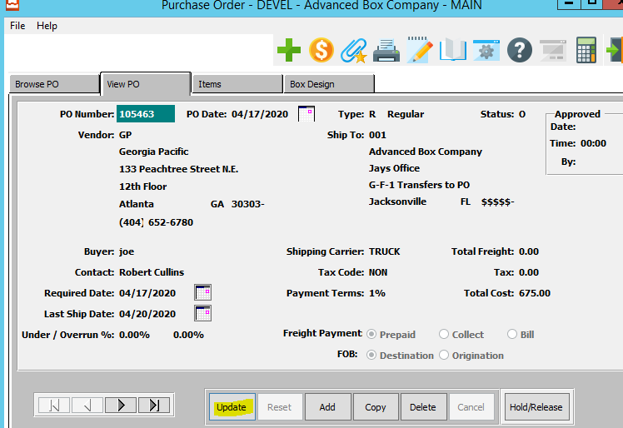
3. The update this Purchase Order, click the ***“Update”*** button.  
   
4. The user may now update their desired information within the available update fields.  
   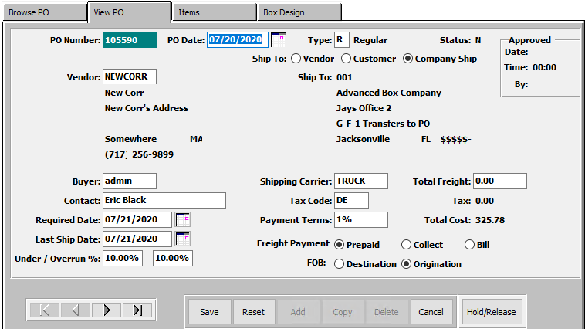  
     
   Please Note: If the user needs further information for the details of these fields, please refer to the *“Purchasing”* user manual.
5. The user may now confirm their updates by clicking the ***“Save”*** button.  
   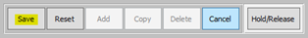
6. The user may now check whether the Outbound *API* “*SendPurchaseOrder*” has been called or not. In order to do so, the user should open the Outbound Event screen located at ***“N”-“A”-“3”.***   
     
   If the Outbound *API* was called, then the Outbound event will be created as shown below.  
     
   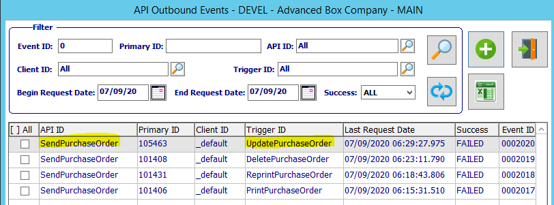

#### ReleasePurchaseOrder and HoldPurchaseOrder

In order to test this trigger: First, open screen ***“P”-“U”-“1”***.



1. The user may then search for the Purchase Order that they wish to change the Status for using the provided search fields on the *Browse PO* screen. In order to select the desired Purchase Order within this list, the user should click on the PO line to highlight it. The highlighted PO line will be the Purchase Order that the subsequent tabs will detail for the user.
2. The user may then go to the *“View PO”* tab.  
     
   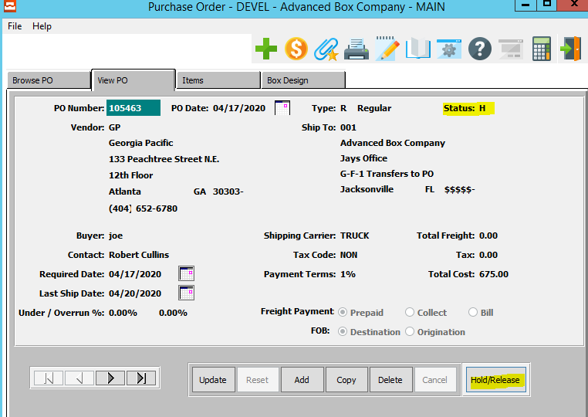
3. To change the current status of this Purchase Order, the user may click on the ***“Hold/Release”*** button.  
     
   Please Note: If the current Status is *“H” (Hold)*, then clicking this button will Release the Purchase Order. Alternatively, if the current Status is *“R” (Released)*, then clicking this button will Hold the Purchase Order.  
     
   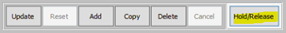
4. A popup window will now open for the user. This is a security measure in order to make sure that the user has not pressed the ***“Hold/Release”*** button by accident. In order to confirm the status change of this Purchase Order, the user may now press the ***“Yes”*** button.  
     
   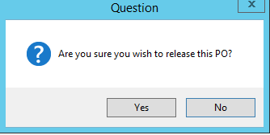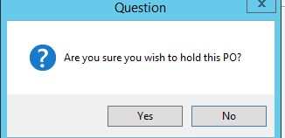  
     
   Please Note: This popup window question will differ based on the current status of the Purchase Order.
5. The user may now check whether the Outbound *API* “*SendPurchaseOrder*” has been called or not. In order to do so, the user should open the Outbound Event screen located at ***“N”-“A”-“3”.***   
     
   If the Outbound *API* was called, then the Outbound event will be created as shown below.  
     
     
     
   Please Note: In this example, you can see that there is one call for the *ReleasePurchaseOrder* (Which is the trigger for Releasing a Purchase Order who’s status was previously *On-Hold*), and one call for the *HoldPurchaseOrder* (Which is the trigger for Holding a Purchase Order who’s status was previously *Released*).

#### ClosePurchaseOrder

In order to test this trigger: First, open screen ***“P”-“U”-“4”***.

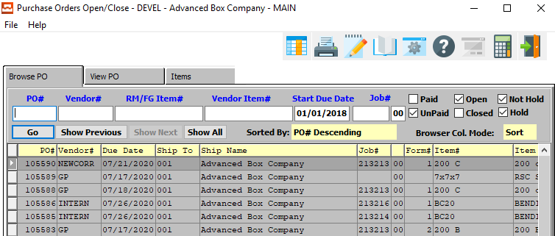

1. The user may then search for the Purchase Order that they wish to close by using the provided search fields on the *Browse PO* screen. In order to select the desired Purchase Order within this list, the user should click on the PO line to highlight it. The highlighted PO line will be the Purchase Order that the subsequent tabs will detail for the user.  
     
   Please Note: The user does not have to choose a single PO to close, as the subsequent *Close PO’s* window will allow the user to choose a sequence of Purchase Orders to close at the same time. However, choosing one from the browse screen will allow for quicker parameter selection.
2. The user may then go to the *“View PO”* tab.  
   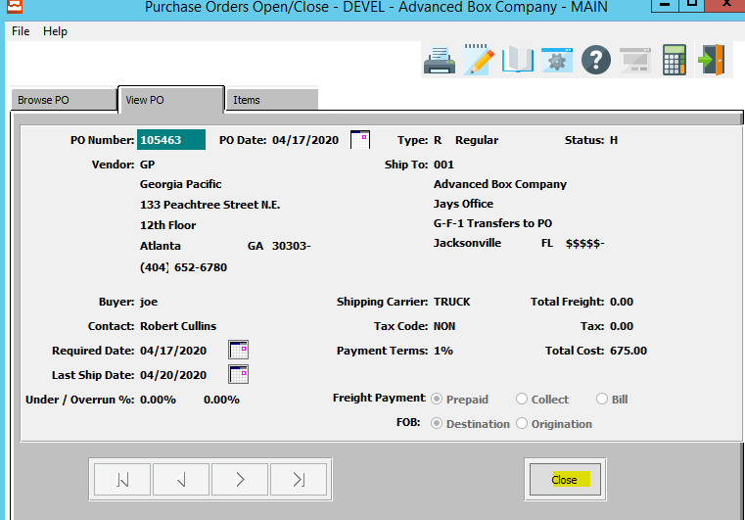
3. To delete this Purchase Order, click the ***“Close”*** button.  
     
   
4. A popup window will now open for the user. This is a security measure in order to make sure that the user has not pressed the ***“Close”*** button by accident.   
     
   The user must enter their preferred values into the selection parameter fields. By default, the selected Purchase Order that the user has chosen in the *Browse* tab will be the first and last PO# in this window. However, the user may enter any prior or subsequent PO numbers in these fields in order to close multiple orders at once.  
     
   In order to confirm closing all the Purchase Orders within the selected parameters, the user may now press the ***“Okay”*** button.  
     
   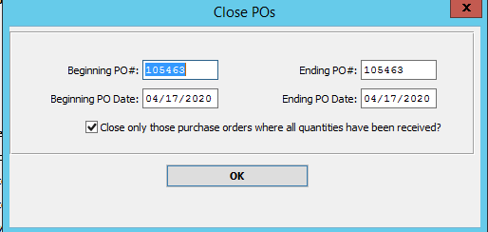
5. A popup window will now open for the user. This is a security measure in order to make sure that the user has not pressed the ***“Close”*** or ***“Okay”*** buttons by accident. In order to confirm the closing of these Purchase Orders, the user may now press the ***“Yes”*** button.  
     
   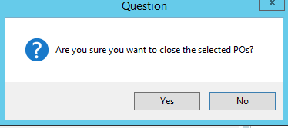
6. The user may now check whether the Outbound *API* “*SendPurchaseOrder*” has been called or not. In order to do so, the user should open the Outbound Event screen located at ***“N”-“A”-“3”.***   
     
   If the Outbound *API* was called, then the Outbound event will be created as shown below.  
     
   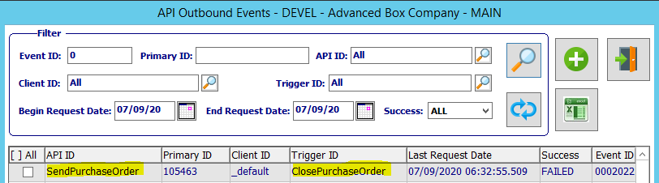

### Outbound API SendVendor Triggers

These triggers call outbound *API* “***SendVendor***” when a purchase order is printed or reprinted.

#### PrintPurchaseOrder and ReprintPurchaseOrder

In order to test these triggers: First, open screen ***“P”-“U”-“1”*** and click on the “***Print***” icon. Alternatively, open screen *“****P”-“U”-“3”*** to get to the below screen.

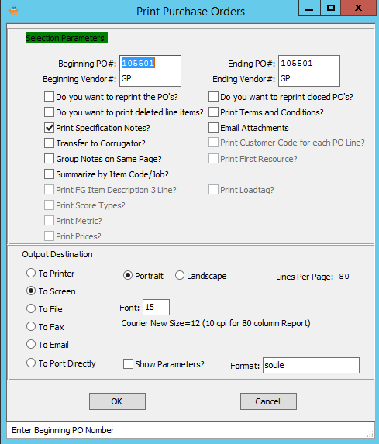

1. The user must enter their preferred values into the “*Beginning Vendor#*” and “*Ending Vendor#*” fields.
2. To choose the destination where the document should be printed, please make sure that desired output destination choice bubble is toggled.
3. The user may also choose any other specifications for the Purchase Orders that they wish using the Selection Parameters section of this screen.
4. In order to reprint Purchase Orders that have already been printed within the desired order parameters, the user should make sure that the ‘*Do you want to reprint the PO’s’* toggle box is checked.  
     
   
5. Click the ***“Okay”*** button.
6. The user may now check whether the Outbound *API* “*SendVendor*” has been called or not. In order to do so, the user should open the Outbound Event screen located at ***“N”-“A”-“3”.***   
     
   If the Outbound *API* was called, then the Outbound event will be created as shown below.  
     
   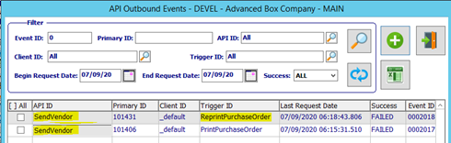  
     
   Please Note: In this example, you can see that there is one call for the *PrintPurchaseOrder* (Which is the initial printing of any user-selected Purchase Orders), and one call for the *ReprintPurchaseOrder* (Which is the reprinting of any previously-printed orders within the user-selected parameters.)

### Outbound API SendFinishedGood Triggers

These triggers call outbound *API* “***SendFinishedGood***” when a release is printed or reprinted.

#### PrintRelease and ReprintRelease

In order to test these triggers: First, open screen ***“O”-“T”-“1”*** and click on the “***Print***” icon. Alternatively, open screen *“****O”-“T”-“3”*** to get to the below screen.

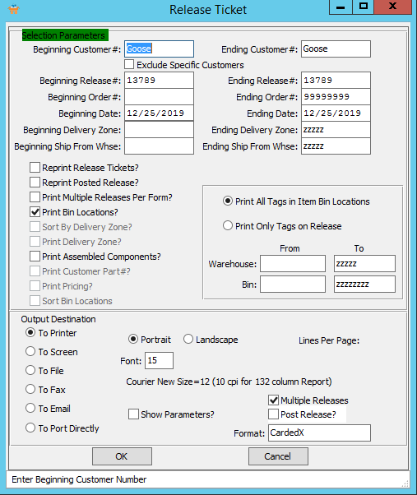

1. The user must enter their preferred values into the “*Beginning Release#*” and “*Ending Release#*” fields.
2. To choose the destination where the document should be printed, please make sure that desired output destination choice bubble is toggled.
3. The user may also choose any other specifications for the Releases that they wish using the Selection Parameters section of this screen.

1. In order to reprint Releases that have already been printed within the desired order parameters, the user should make sure that the ‘*Reprint Release Tickets’* toggle box is checked.  
     
   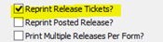
2. Click the ***“Okay”*** button.
3. The user may now check whether the Outbound *API* “*SendFinishedGood*” has been called or not. In order to do so, the user should open the Outbound Event screen located at ***“N”-“A”-“3”.***   
     
   If the Outbound *API* was called, then the Outbound event will be created as shown below.  
     
   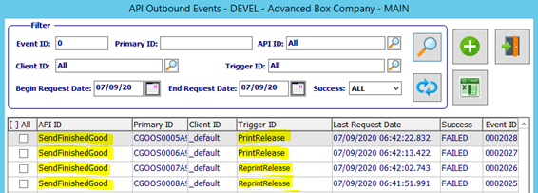  
     
   Please Note: In this example, you can see that there is one call for the *PrintRelease* (Which is the initial printing of any user-selected Releases), and one call for the *ReprintRelease* (Which is the reprinting of any previously-printed releases within the user-selected parameters.)

### Outbound API SendCustomer Triggers

These triggers call outbound *API* “***SendCustomer***” when a release is printed or reprinted.

#### PrintRelease and ReprintRelease

In order to test these triggers: First, open screen ***“O”-“T”-“1”*** and click on the “***Print***” icon. Alternatively, open screen *“****O”-“T”-“3”*** to get to the below screen.



1. The user must enter their preferred values into the “*Beginning Customer#*” and “*Ending Customer#*” fields.
2. To choose the destination where the document should be printed, please make sure that desired output destination choice bubble is toggled.
3. The user may also choose any other specifications for the Releases that they wish using the Selection Parameters section of this screen.

1. In order to reprint Releases that have already been printed within the desired order parameters, the user should make sure that the ‘*Reprint Release Tickets’* toggle box is checked.  
     
   
2. Click the ***“Okay”*** button.
3. The user may now check whether the Outbound *API* “*SendCustomer*” has been called or not. In order to do so, the user should open the Outbound Event screen located at ***“N”-“A”-“3”.***   
     
   If the Outbound *API* was called, then the Outbound event will be created as shown below.  
     
   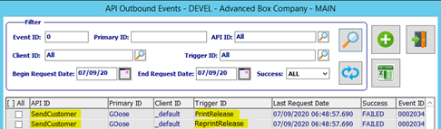  
     
   Please Note: In this example, you can see that there is one call for the *PrintRelease* (Which is the initial printing of any user-selected Releases), and one call for the *ReprintRelease* (Which is the reprinting of any previously-printed releases within the user-selected parameters.)

### Outbound API SendRelease Triggers

These triggers call outbound *API* “***SendRelease***” when a release is printed, reprinted, updated, created, deleted, or the status is updated.

#### PrintRelease and ReprintRelease

In order to test these triggers: First, open screen ***“O”-“T”-“1”*** and click on the “***Print***” icon. Alternatively, open screen *“****O”-“T”-“3”*** to get to the below screen.



1. The user must enter their preferred values into the “*Beginning Release#*” and “*Ending Release#*” fields.
2. To choose the destination where the document should be printed, please make sure that desired output destination choice bubble is toggled.
3. The user may also choose any other specifications for the Releases that they wish using the Selection Parameters section of this screen.
4. In order to reprint Releases that have already been printed within the desired order parameters, the user should make sure that the ‘*Reprint Release Tickets’* toggle box is checked.  
     
   
5. Click the ***“Okay”*** button.
6. The user may now check whether the Outbound *API* “*SendRelease*” has been called or not. In order to do so, the user should open the Outbound Event screen located at ***“N”-“A”-“3”.***   
     
   If the Outbound *API* was called, then the Outbound event will be created as shown below.  
     
   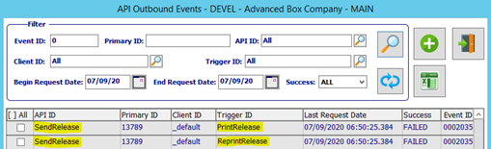  
     
   Please Note: In this example, you can see that there is one call for the *PrintRelease* (Which is the initial printing of any user-selected Releases), and one call for the *ReprintRelease* (Which is the reprinting of any previously-printed releases within the user-selected parameters.)

#### UpdateRelease

In order to test this trigger: First, open screen ***“O”-“T”-“1”***.

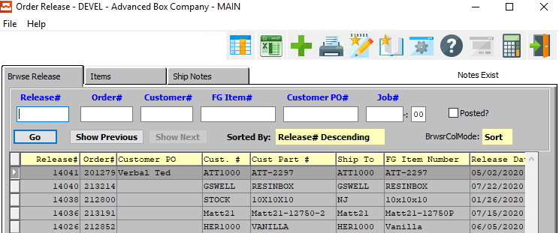

1. The user may then search for the Order Release that they wish to update using the provided search fields on the *Browse Release* screen. In order to select the desired Release within this list, the user should click on the Release Number line to highlight it. The highlighted Release line will be the Order Release that the subsequent tabs will detail for the user.
2. The user may then go to the *“Items”* tab.  
     
   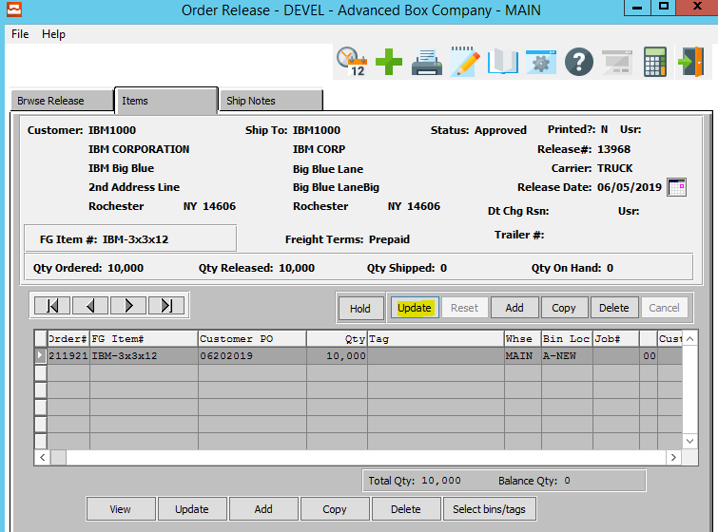
3. The update this Release, click the ***“Update”*** button under the Item Detail section.  
     
   
4. The user may now update their desired information within the available update fields.  
     
   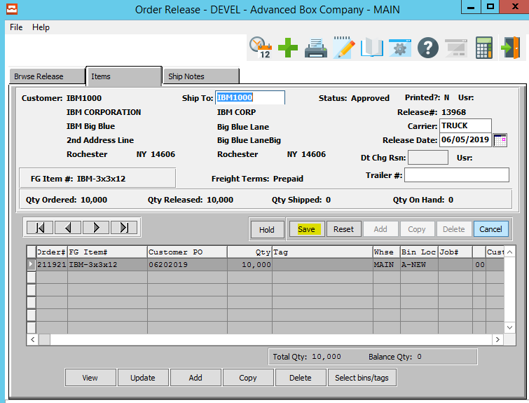  
     
   Please Note: If the user needs further information for the details of these fields, please refer to the *“Order Processing”* user manual.
5. The user may now confirm their updates by clicking the ***“Save”*** button.  
     
   
6. The user may now check whether the Outbound *API* “*SendRelease*” has been called or not. In order to do so, the user should open the Outbound Event screen located at ***“N”-“A”-“3”.***   
     
   If the Outbound *API* was called, then the Outbound event will be created as shown below.  
     
   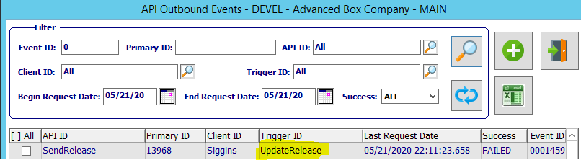

#### ApproveRelease and HoldRelease

In order to test this trigger: First, open screen ***“O”-“T”-“1”***.



1. The user may then search for the Order Release that they wish to change the status for using the provided search fields on the *Browse Release* screen. In order to select the desired Release within this list, the user should click on the Release Number line to highlight it. The highlighted Release line will be the Order Release that the subsequent tabs will detail for the user.
2. The user may then go to the *“Items”* tab.  
     
   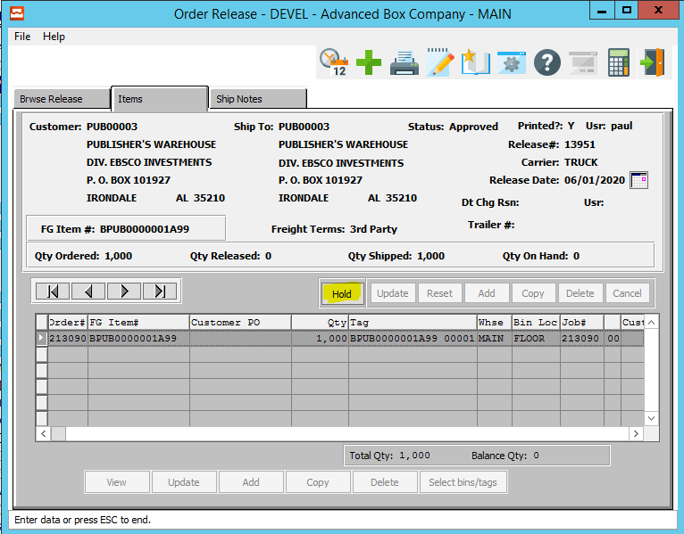
3. To change the current status of this Release, the user may click on the ***“Hold”*** button, or the ***“Release”*** button.  
     
   Please Note: If the current Status is *“On Hold”*, then this button will say ***“Release”***, and clicking this button will Approve the Order. Alternatively, if the current Status is *“Approved” (Released)*, then this button will say ***“Hold”***, and clicking this button will place this order On Hold.  
     
     
   
4. The user may now check whether the Outbound *API* “*SendRelease*” has been called or not. In order to do so, the user should open the Outbound Event screen located at ***“N”-“A”-“3”.***   
     
   If the Outbound *API* was called, then the Outbound event will be created as shown below.  
     
   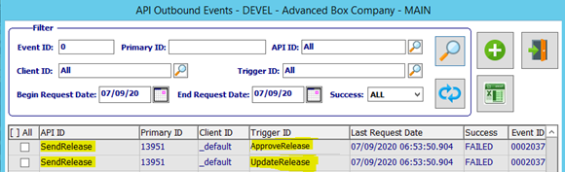  
     
   Please Note: In this example, you can see that there is one call for the *ApproveRelease* (Which is the trigger for Releasing an Order who’s status was previously *On-Hold*), and one call for the *UpdateRelease* (Which is the trigger for Holding an Order who’s status was previously *Approved/Released*).

#### DeleteRelease

In order to test this trigger: First, open screen ***“O”-“T”-“1”***.



1. The user may then search for the Order Release that they wish to delete using the provided search fields on the *Browse Release* screen. In order to select the desired Release within this list, the user should click on the Release Number line to highlight it. The highlighted Release line will be the Order Release that the subsequent tabs will detail for the user.
2. The user may then go to the *“Items”* tab.  
   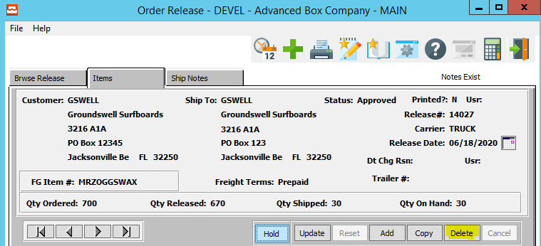
3. To delete this Purchase Order, click the ***“Delete”*** button under the Item Detail section.  
   
4. A popup window will now open for the user. This is a security measure in order to make sure that the user has not pressed the ***“Delete”*** button by accident. In order to confirm the deletion of this Release, the user may now press the ***“Yes”*** button.  
   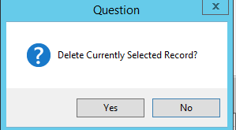
5. The user may now check whether the Outbound *API* “*SendRelease*” has been called or not. In order to do so, the user should open the Outbound Event screen located at ***“N”-“A”-“3”.***   
     
   If the Outbound *API* was called, then the Outbound event will be created as shown below.  
   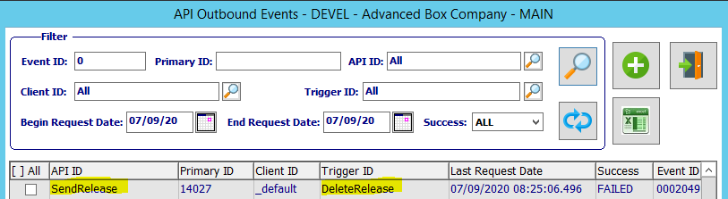

#### CreateRelease

In order to test this trigger: First, open screen ***“O”-“U”-“1”***.

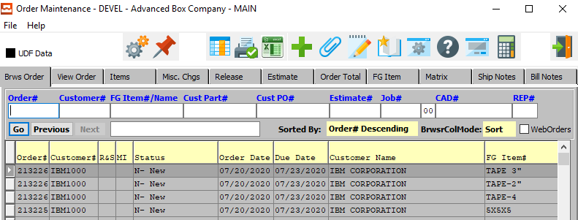

1. The user may then search for the Order that they wish to create a Release for by using the provided search fields on the *Browse Order* screen. In order to select the desired Order within this list, the user should click on the Order Number line to highlight it. The highlighted Order line will be the Order that the subsequent tabs will detail for the user.
2. The user may then go to the *“Items”* tab.  
     
   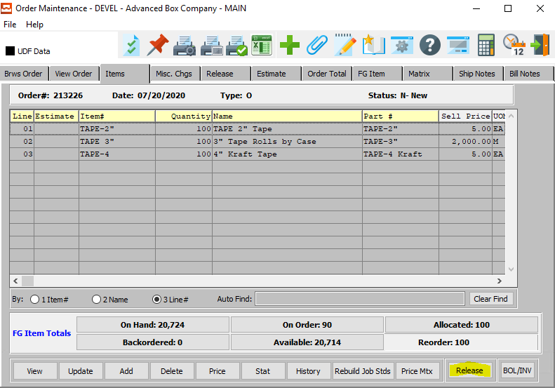
3. To release this Order, click the ***“Release”*** button.  
     
   
4. The user may now check whether the Outbound *API* “*SendRelease*” has been called or not. In order to do so, the user should open the Outbound Event screen located at ***“N”-“A”-“3”.***   
     
   If the Outbound *API* was called, then the Outbound event will be created as shown below.  
     
   

### Outbound API SendAdvancedShipNotice Triggers

#### PrintBillOfLading and ReprintBillOfLading

In order to test these triggers: First, open screen ***“O”-“S”-“1”*** and click on the “***Print***” icon. Alternatively, open screen *“****O”-“S”-“3”*** to get to the below screen.

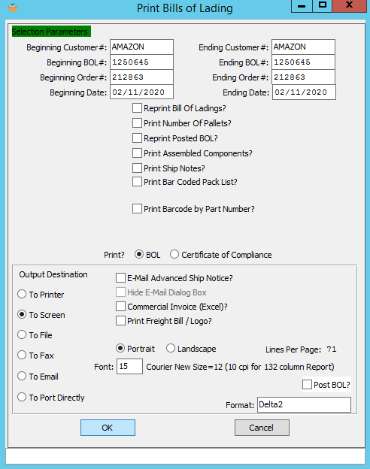

1. The user must enter their preferred values into the “*Beginning BOL#*” and “*Ending BOL#*” fields.
2. To choose the destination where the document should be printed, please make sure that desired output destination choice bubble is toggled.
3. The user may also choose any other specifications for the Bills of Lading that they wish using the Selection Parameters section of this screen.
4. In order to reprint BOL’s that have already been printed within the desired order parameters, the user should make sure that the ‘*Reprint Bill Of Ladings’* toggle box is checked.  
     
   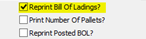
5. Click the ***“Okay”*** button.

1. The user may now check whether the Outbound *API* “*SendAdvancedShipNotice*” has been called or not. In order to do so, the user should open the Outbound Event screen located at ***“N”-“A”-“3”.***   
     
   If the Outbound *API* was called, then the Outbound event will be created as shown below.  
     
   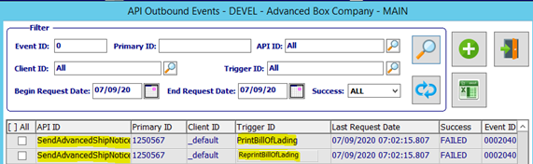  
     
   Please Note: In this example, you can see that there is one call for the *PrintBillOfLading* (Which is the initial printing of any user-selected Bills of Lading), and one call for the *ReprintBillOfLading* (Which is the reprinting of any previously-printed BOL’s within the user-selected parameters.)

### Outbound API SendPurchaseOrderLineStatus Triggers

These triggers call outbound *API* “***SendPurchaseOrderLineStatus***” when a Purchase Order Line is closed.

#### ClosePurchaseOrderLine

In order to test this trigger: First, open screen ***“P”-“U”-“4”***.



1. The user may then search for the Purchase Order that they wish to close a line for by using the provided search fields on the *Browse PO* screen. In order to select the desired Purchase Order within this list, the user should click on the PO line to highlight it. The highlighted PO number line will be the Purchase Order that the subsequent tabs will detail for the user.
2. The user may then go to the *“Items”* tab.  
     
   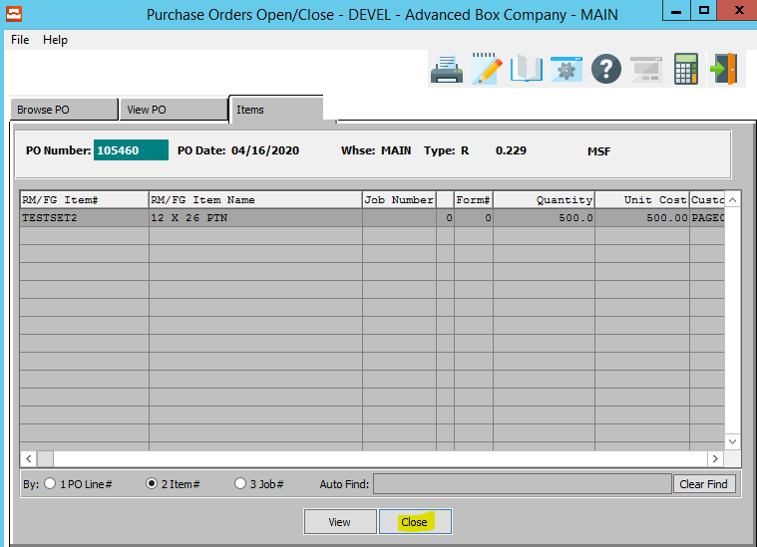
3. In order to select the desired Purchase Order Line within this list, the user should click on the PO line to highlight it. The highlighted PO line will be the Item that will be closed.
4. To delete this Purchase Order Line, click the ***“Close”*** button.  
     
   
5. A popup window will now open for the user. This is a security measure in order to make sure that the user has not pressed the ***“Close”*** button by accident. In order to confirm the closing of this Purchase Order Line Item, the user may now press the ***“Yes”*** button.  
     
   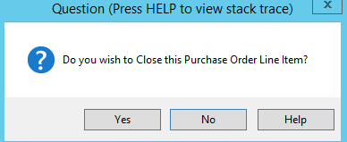
6. The user may now check whether the Outbound *API* “*SendPurchaseOrderLineStatus*” has been called or not. In order to do so, the user should open the Outbound Event screen located at ***“N”-“A”-“3”.***   
     
   If the Outbound *API* was called, then the Outbound event will be created as shown below.  
     
   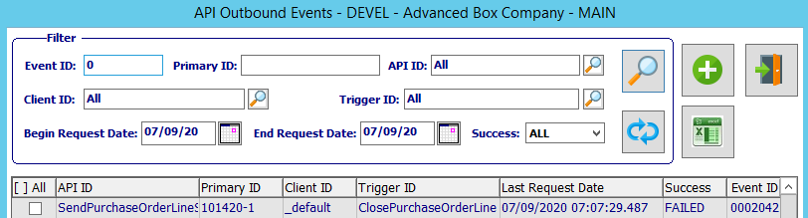

### Outbound API SendPurchaseOrderStatus Triggers

These triggers call outbound *API* “***SendPurchaseOrderStatus***” when a Purchase Order is closed.

#### ClosePurchaseOrder

In order to test this trigger: First, open screen ***“P”-“U”-“4”***.



1. The user may then search for the Purchase Order that they wish to close by using the provided search fields on the *Browse PO* screen. In order to select the desired Purchase Order within this list, the user should click on the PO line to highlight it. The highlighted PO line will be the Purchase Order that the subsequent tabs will detail for the user.  
     
   Please Note: The user does not have to choose a single PO to close, as the subsequent *Close PO’s* window will allow the user to choose a sequence of Purchase Orders to close at the same time. However, choosing one from the browse screen will allow for quicker parameter selection.
2. The user may then go to the *“View PO”* tab.  
   
3. To delete this Purchase Order, click the ***“Close”*** button.  
     
   
4. A popup window will now open for the user. This is a security measure in order to make sure that the user has not pressed the ***“Close”*** button by accident.   
     
   The user must enter their preferred values into the selection parameter fields. By default, the selected Purchase Order that the user has chosen in the *Browse* tab will be the first and last PO# in this window. However, the user may enter any prior or subsequent PO numbers in these fields in order to close multiple orders at once.  
     
   In order to confirm closing all the Purchase Orders within the selected parameters, the user may now press the ***“Okay”*** button.  
     
   
5. A popup window will now open for the user. This is a security measure in order to make sure that the user has not pressed the ***“Close”*** or ***“Okay”*** buttons by accident. In order to confirm the closing of these Purchase Orders, the user may now press the ***“Yes”*** button.  
     
   
6. The user may now check whether the Outbound *API* “*SendPurchaseOrderStatus*” has been called or not. In order to do so, the user should open the Outbound Event screen located at ***“N”-“A”-“3”.***   
     
   If the Outbound *API* was called, then the Outbound event will be created as shown below.  
     
   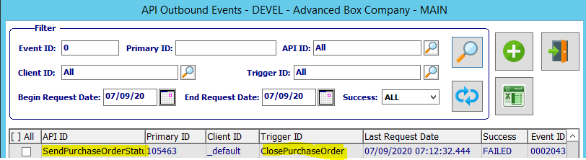

### Outbound API SendJob Triggers

These triggers call outbound *API* “***SendJob***” when a Job is printed or reprinted.

#### PrintJob and ReprintJob

In order to test these triggers: First, open screen ***“J”-“U”-“1”*** and click on the “***Print***” icon. Alternatively, open screen *“****O”-“U”-“5”*** to get to the below screen.

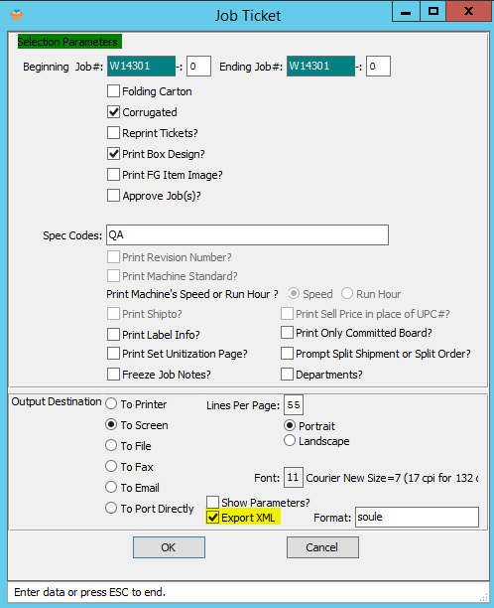

1. The user must enter their preferred values into the “*Beginning Job#*” and “*Ending Job#*” fields.
2. To choose the destination where the document should be printed, please make sure that desired output destination choice bubble is toggled.
3. The user ***must*** ensure that the *“Export XML”* toggle box is checked.  
     
   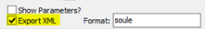
4. The user may also choose any other specifications for the Job Tickets that they wish using the Selection Parameters section of this screen.
5. In order to reprint Job Tickets that have already been printed within the desired job ticket parameters, the user should make sure that the ‘*Reprint Tickets’* toggle box is checked.  
     
   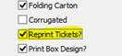
6. Click the ***“Okay”*** button.
7. The user may now check whether the Outbound *API* “*SendJob*” has been called or not. In order to do so, the user should open the Outbound Event screen located at ***“N”-“A”-“3”.***   
     
   If the Outbound *API* was called, then the Outbound event will be created as shown below.  
     
   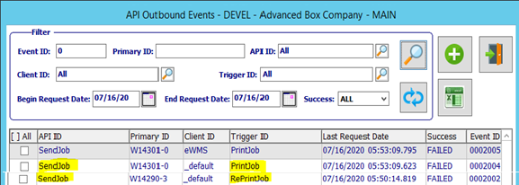  
     
   Please Note: In this example, you can see that there is one call for the *PrintJob* (Which is the initial printing of any user-selected Job Tickets), and one call for the *ReprintJob* (Which is the reprinting of any previously-printed Job Tickets within the user-selected parameters.)

### Outbound API SendOrderAck Triggers

These triggers call outbound *API* “***SendOrderAck***” when an Acknowledgement is printed or reprinted.

#### PrintOrderAck and ReprintOrderAck

In order to test these triggers: First, open screen ***“O”-“U”-“1”*** and click on the “***Print***” icon. Alternatively, open screen *“****O”-“U”-“4”*** to get to the below screen.

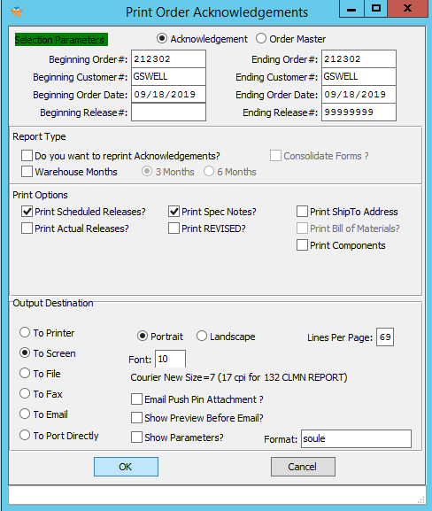

1. The user must enter their preferred values into the “*Beginning Order#*” and “*Ending Order#*” fields.
2. To choose the destination where the document should be printed, please make sure that desired output destination choice bubble is toggled.
3. The user may also choose any other specifications for the Order Acknowledgements that they wish using the Selection Parameters section of this screen.
4. In order to reprint Order Acknowledgements that have already been printed within the desired job ticket parameters, the user should make sure that the ‘*Do you want to reprint Acknowledgements’* toggle box is checked.  
     
   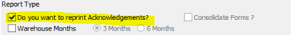
5. Click the ***“Okay”*** button.
6. The user may now check whether the Outbound *API* “*SendOrderAck*” has been called or not. In order to do so, the user should open the Outbound Event screen located at ***“N”-“A”-“3”.***   
     
   If the Outbound *API* was called, then the Outbound event will be created as shown below.  
     
   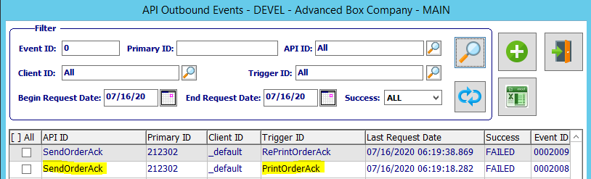  
     
   Please Note: In this example, you can see that there is one call for the *PrintOrderAck* (Which is the initial printing of any user-selected Order Acknowledgements), and one call for the *ReprintOrderAck* (Which is the reprinting of any previously-printed Order Acknowledgements within the user-selected parameters.)

## Outbound API Services Testing

### Initial Steps for All Testing

While testing individual *API* Services will show specialized results for each function, the following steps must be followed for all service testing.

#### Step One: Open API Tester

Go to screen ***“N” – “A” – “3”*** (Outbound *API* Tester / Console)

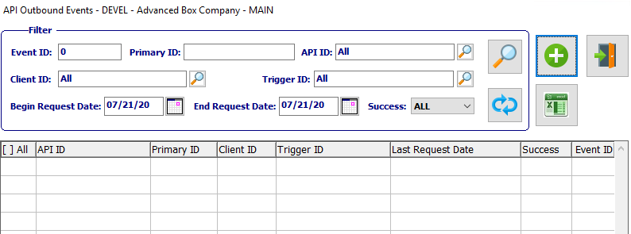

#### Step Two: Add New Event

|  |  |
| --- | --- |
|  | Click the ***“Green + Icon”*** button to add a new Outbound Event. |

#### Step Three: Tester Screen

After clicking the ***“Add Outbound Event”*** button, the follow API Outbound Tester screen will pop up.

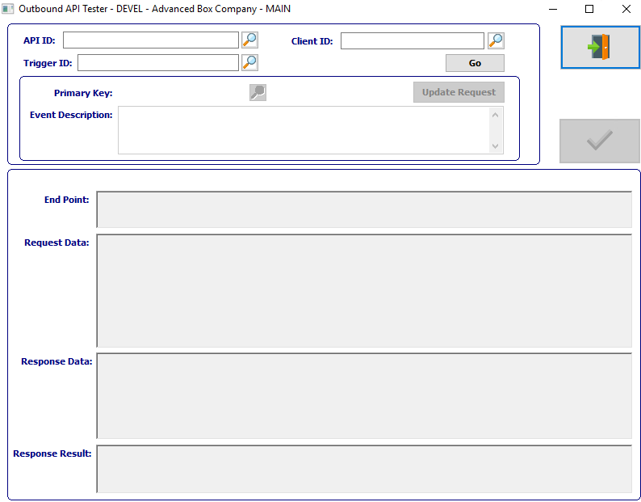

#### Step Four: Fill API ID Field

The user may now enter their desired *API* ID code in the *“API ID”* field. Alternatively, the user may select their desired ID code from the list of available *API* ID’s by pressing the ***“F1”*** key, or clicking the ***“Magnifying Glass Icon”*** button to look it up.

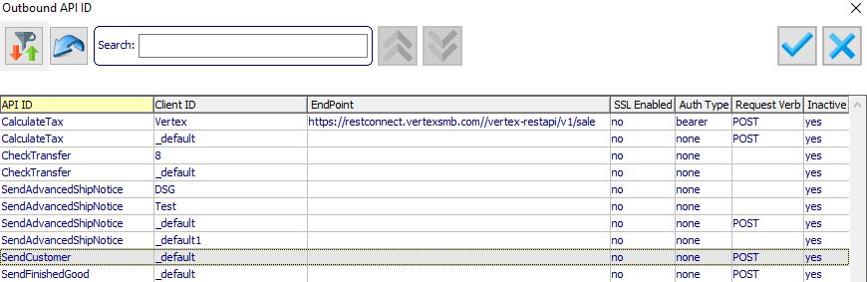

Please Note: The “*Client ID”* field will automatically populate with the default value for the selected *API* program. However, this may be modified by the user.



#### Step Five: Fill Trigger ID Field

The user may now enter their desired Trigger ID code in the *“Trigger ID”* field. Alternatively, the user may select their desired ID code from the list of available Trigger ID’s by pressing the ***“F1”*** key, or clicking the ***“Magnifying Glass Icon”*** button to look it up.

In order to narrow down the list to only Triggers for the desired *API*, the user may enter their desired search criteria in the Search Box.

Please Note: The user must pay attention to the *“API ID”* column in the “*Outbound API Triggers”* screen, as the Trigger ID that they choose must match the currently selected *API* ID.

#### Step Six: Approve Selections

|  |  |
| --- | --- |
|  | The user may now click the ***“Go”*** button in order to approve all the selected *API* service ID fields. |

#### Step Seven: End Point and Request Data Fields

Providing the user has selected ID fields that are active, both the *“End Point”* and *“Request Data”* fields will automatically populate with their default values by the system.

The user may now enter their desired information into the *“Primary Key”* field. Alternatively, the user may select their desired information from the list of available selections by pressing the ***“F1”*** key, or clicking the ***“Magnifying Glass Icon”*** button to look it up.

Once the user has entered or selected valid data within this field, the system will populate the request data for the selected record. The user can further modify the request data manually before calling the endpoint.

#### Step Eight: Run the Program

|  |  |
| --- | --- |
|  | The user may now click the ***“Green Check Icon”*** button in order to execute the selected *API* service. |

#### Step Nine: Program Success vs. Program Failure

***Program Failure -*** If the selected *API* program execution call was unsuccessful, the JSON text featured in the **Response** text field will alert the user to the specific error situation. (Specific errors for the individual programs are detailed for each *API* program below.)

***Program Success -*** If the selected *API* program execution call was successful, the JSON text featured in the **Response** text field will fill with a success message specific to the current *API* program, along with any details the system has deemed necessary for the user to be alerted of. (Specific success messages for the individual programs are detailed for each *API* program below.)

### Outbound SendCustomer

#### API ID Code

The user may now enter “***SendCustomer***” in the *“API ID”* field. Alternatively, the user may select it from the list of available API ID’s by pressing the ***“F1”*** key, or clicking the ***“Magnifying Glass Icon”*** button to look it up.



#### Trigger ID Field

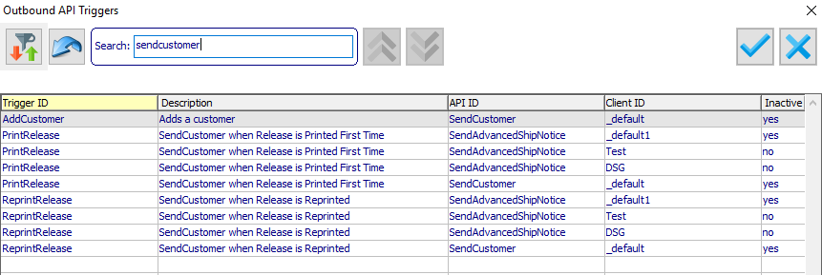

Please Note: The user must pay attention to the *“API ID”* column in the “*Outbound API Triggers”* screen, as the Trigger ID that they choose must match the currently selected *API* ID.

#### Primary Key

The user may now enter their desired Customer ID Number in the *“Primary Key”* field. Alternatively, the user may select their desired Customer ID Number from the list of available Customers by pressing the ***“F1”*** key, or clicking the ***“Magnifying Glass Icon”*** button to look it up.

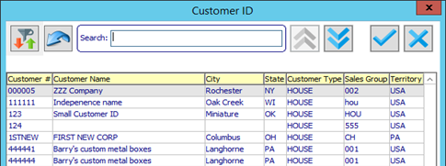

#### Request Data

Selecting a row from the “*Customer*” lookup screen will populate the request data for the selected record. The user can further modify the request data manually before calling the endpoint.

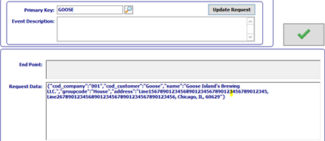

#### Successful Response

If the *API* program “***SendCustomer***” call was successful, the text featured below is returned as the response in **Response** text field.

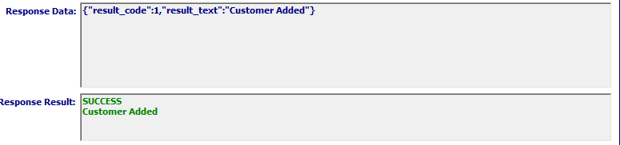

### Outbound SendVendor

#### API ID Code

The user may now enter “***SendVendor***” in the *“API ID”* field. Alternatively, the user may select it from the list of available API ID’s by pressing the ***“F1”*** key, or clicking the ***“Magnifying Glass Icon”*** button to look it up.



#### Trigger ID Field

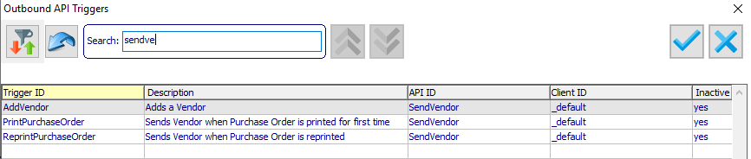

#### Primary Key

The user may now enter their desired Vendor ID Number in the *“Primary Key”* field. Alternatively, the user may select their desired Vendor ID Number from the list of available Vendors by pressing the ***“F1”*** key, or clicking the ***“Magnifying Glass Icon”*** button to look it up.

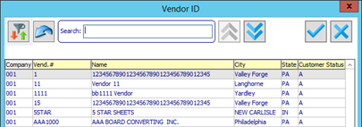

#### Request Data

Selecting a row from the “*Vendor ID*” lookup screen will populate the request data for the selected record. The user can further modify the request data manually before calling the endpoint.

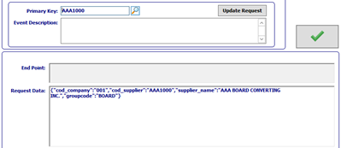

#### Successful Response

If the *API* program “***SendVendor***” call was successful, the text featured below is returned as the response in **Response** text field.

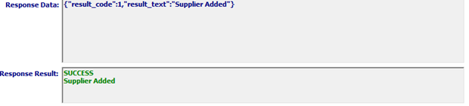

### Outbound SendFinishedGood

#### API ID Code

The user may now enter “***SendFinishedGood***” in the *“API ID”* field. Alternatively, the user may select it from the list of available API ID’s by pressing the ***“F1”*** key, or clicking the ***“Magnifying Glass Icon”*** button to look it up.



#### Trigger ID Field

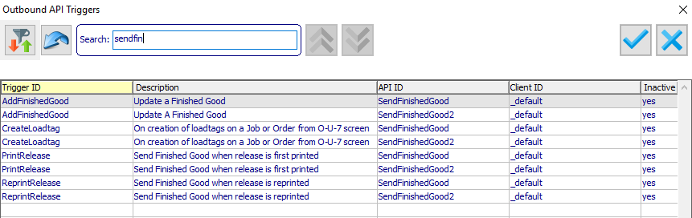

Please Note: The user must pay attention to the *“API ID”* column in the “*Outbound API Triggers”* screen, as the Trigger ID that they choose must match the currently selected *API* ID.

#### Primary Key

The user may now enter their desired Finished Good Item Number in the *“Primary Key”* field. Alternatively, the user may select their desired FG Item Number from the list of available Finished Good Items by pressing the ***“F1”*** key, or clicking the ***“Magnifying Glass Icon”*** button to look it up.

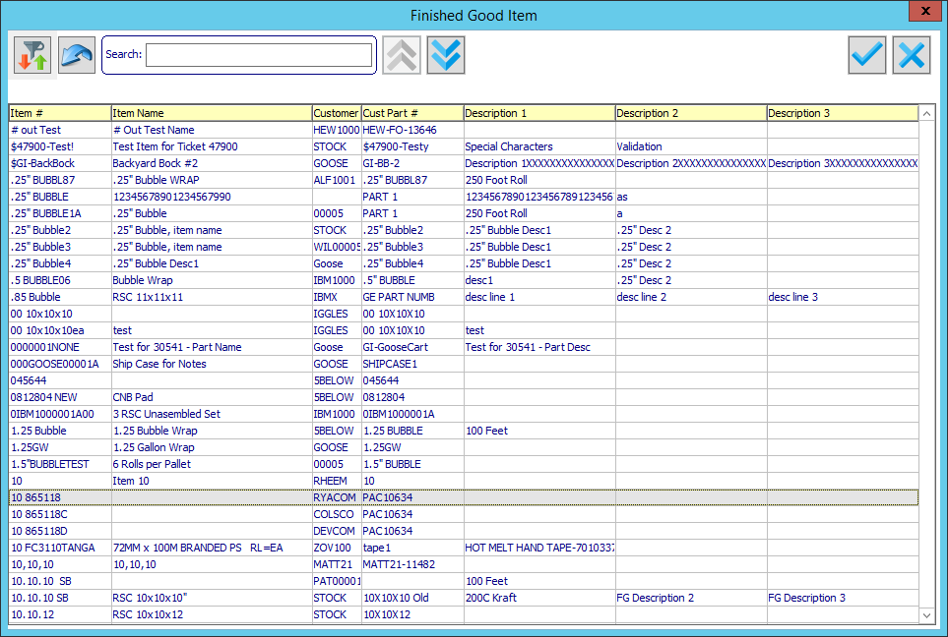

#### Request Data

Selecting a row from the “*Finished Good Item*” lookup screen will populate the request data for the selected record. The user can further modify the request data manually before calling the endpoint.

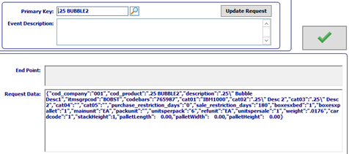

#### Successful Response

If the *API* program “***SendFinishedGood***” call was successful, the text featured below is returned as the response in **Response** text field.

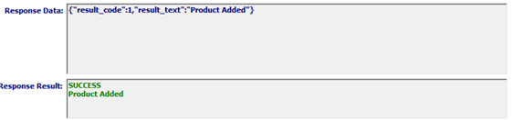

### Outbound SendRelease (Siggins)

Please Note: The ***“SendRelease”*** *API* Service works the same for both ***“Siggins”*** and ***“GSWELL***” systems.

#### API ID Code

The user may now enter “***SendRelease***” in the *“API ID”* field. Alternatively, the user may select it from the list of available API ID’s by pressing the ***“F1”*** key, or clicking the ***“Magnifying Glass Icon”*** button to look it up.



#### Trigger ID Field

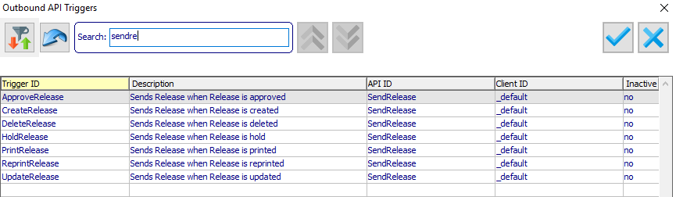

Please Note: The user must pay attention to the *“API ID”* column in the “*Outbound API Triggers”* screen, as the Trigger ID that they choose must match the currently selected *API* ID.

#### Primary Key

The user may now enter their desired Release ID Number in the *“Primary Key”* field. Alternatively, the user may select their desired Release ID Number from the list of available Releases by pressing the ***“F1”*** key, or clicking the ***“Magnifying Glass Icon”*** button to look it up.

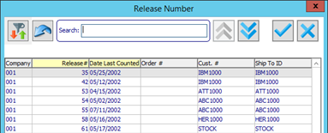

#### Request Data

Selecting a row from the “*Release Number*” lookup screen will populate the request data for the selected record. The user can further modify the request data manually before calling the endpoint.

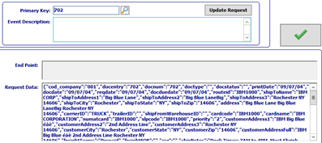

#### Successful Response

If the *API* program “***SendRelease***” call was successful, the text featured below is returned as the response in **Response** text field.

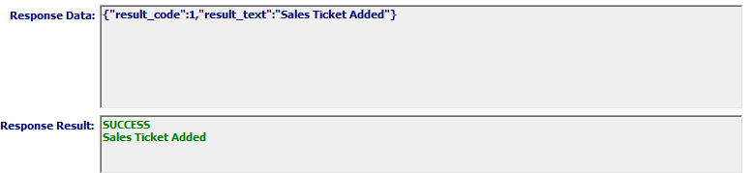

### Outbound SendPurchaseOrder

Please Note: The ***“SendPurchaseOrder”*** *API* Service works the same for both ***“Siggins”*** and ***“CSC***” systems.

#### API ID Code

The user may now enter “***SendPurchaseOrder***” in the *“API ID”* field. Alternatively, the user may select it from the list of available API ID’s by pressing the ***“F1”*** key, or clicking the ***“Magnifying Glass Icon”*** button to look it up.



#### Trigger ID Field

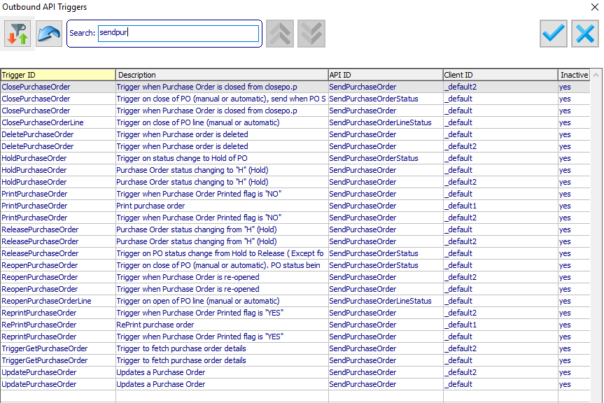

Please Note: The user must pay attention to the *“API ID”* column in the “*Outbound API Triggers”* screen, as the Trigger ID that they choose must match the currently selected *API* ID.

#### Primary Key

The user may now enter their desired Purchase Order ID Number in the *“Primary Key”* field. Alternatively, the user may select their desired PO ID from the list of available Purchase Orders by pressing the ***“F1”*** key, or clicking the ***“Magnifying Glass Icon”*** button to look it up.

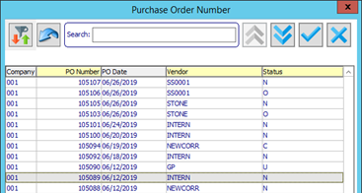

#### Request Data

Selecting a row from the “*Purchase Order Number*” lookup screen will populate the request data for the selected record. The user can further modify the request data manually before calling the endpoint.

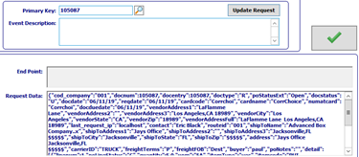

#### Successful Response

If the *API* program “***SendPurchaseOrder***” call was successful, the text featured below is returned as the response in **Response** text field.

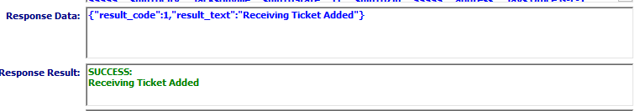

### Outbound SendAdvancedShipNotice

Please Note: The ***“SendAdvancedShipNotice”*** *API* Service works the same for both ***“Amazon”*** and ***“Target124***” systems.

#### API ID Code

The user may now enter “***SendAdvancedShipNotice***” in the *“API ID”* field. Alternatively, the user may select it from the list of available API ID’s by pressing the ***“F1”*** key, or clicking the ***“Magnifying Glass Icon”*** button to look it up.



#### Trigger ID Field

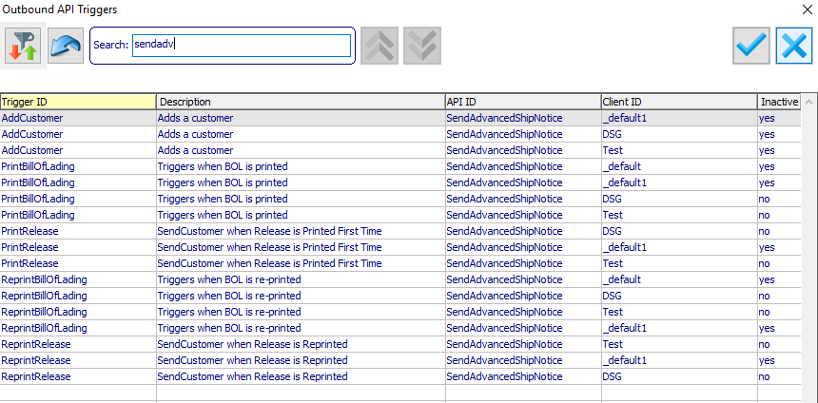

Please Note: The user must pay attention to the *“API ID”* column in the “*Outbound API Triggers”* screen, as the Trigger ID that they choose must match the currently selected *API* ID.

#### Primary Key

The user may now enter their desired Bill of Lading in the *“Primary Key”* field. Alternatively, the user may select their desired BOL from the list of available Bills of Lading by pressing the ***“F1”*** key, or clicking the ***“Magnifying Glass Icon”*** button to look it up.

#### Request Data

Selecting a row from the “*Bill of Lading*” lookup screen will populate the request data for the selected record. The user can further modify the request data manually before calling the endpoint.

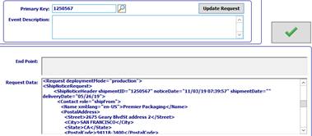

#### Failure Response

If the *API* program “***SendAdvancedShipNotice***” call was unsuccessful, the text featured below is returned as the response in **Response** text field.

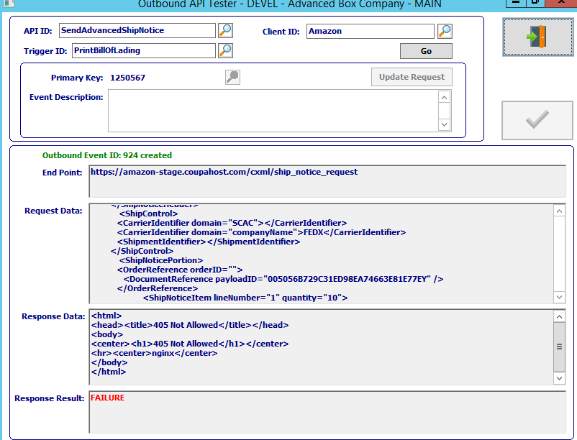

### Outbound SendFinishedGood2 (GSWELL)

#### API ID Code

The user may now enter “***SendFinishedGood2***” in the *“API ID”* field. Alternatively, the user may select it from the list of available API ID’s by pressing the ***“F1”*** key, or clicking the ***“Magnifying Glass Icon”*** button to look it up.



#### Trigger ID Field

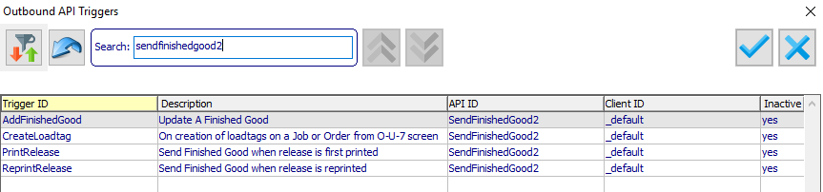

Please Note: The user must pay attention to the *“API ID”* column in the “*Outbound API Triggers”* screen, as the Trigger ID that they choose must match the currently selected *API* ID.

#### Primary Key

The user may now enter their desired Finished Good Item Number in the *“Primary Key”* field. Alternatively, the user may select their desired FG Item Number from the list of available Finished Good Items by pressing the ***“F1”*** key, or clicking the ***“Magnifying Glass Icon”*** button to look it up.



#### Request Data

Selecting a row from the “*Finished Good Item*” lookup screen will populate the request data for the selected record. The user can further modify the request data manually before calling the endpoint.

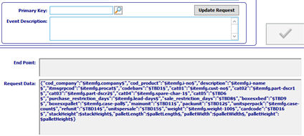

#### Successful Response

If the *API* program “***SendFinishedGood2***” call was successful, the text featured below is returned as the response in **Response** text field.



### Outbound SendInvoice

#### API ID Code

The user may now enter “***SendInvoice***” in the *“API ID”* field. Alternatively, the user may select it from the list of available API ID’s by pressing the ***“F1”*** key, or clicking the ***“Magnifying Glass Icon”*** button to look it up.



#### Trigger ID Field

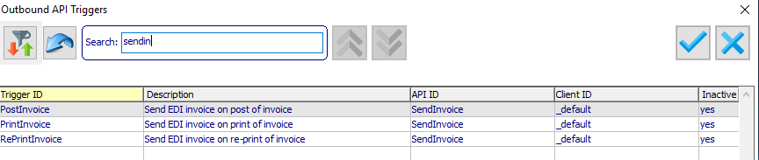

Please Note: The user must pay attention to the *“API ID”* column in the “*Outbound API Triggers”* screen, as the Trigger ID that they choose must match the currently selected *API* ID.

#### Primary Key

The user may now enter their desired Invoice ID Number in the *“Primary Key”* field. Alternatively, the user may select their desired Invoice ID Number from the list of available Invoices by pressing the ***“F1”*** key, or clicking the ***“Magnifying Glass Icon”*** button to look it up.

#### Request Data

Selecting a row from the “*Invoice ID*” lookup screen will populate the request data for the selected record. The user can further modify the request data manually before calling the endpoint.

### Outbound SendJob

#### API ID Code

The user may now enter “***SendJob***” in the *“API ID”* field. Alternatively, the user may select it from the list of available API ID’s by pressing the ***“F1”*** key, or clicking the ***“Magnifying Glass Icon”*** button to look it up.



#### Trigger ID Field

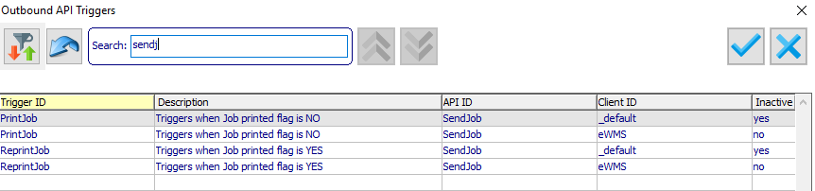

Please Note: The user must pay attention to the *“API ID”* column in the “*Outbound API Triggers”* screen, as the Trigger ID that they choose must match the currently selected *API* ID.

#### Primary Key

The user may now enter their desired Job ID Number in the *“Primary Key”* field. Alternatively, the user may select their desired Job ID Number from the list of available Jobs by pressing the ***“F1”*** key, or clicking the ***“Magnifying Glass Icon”*** button to look it up.

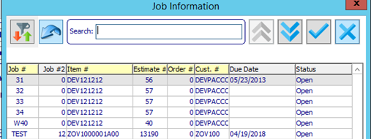

#### Request Data

Selecting a row from the “*Job Information*” lookup screen will populate the request data for the selected record. The user can further modify the request data manually before calling the endpoint.

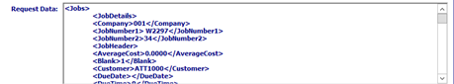

### Outbound SendOrderAck

#### API ID Code

The user may now enter “***SendOrderAck***” in the *“API ID”* field. Alternatively, the user may select it from the list of available API ID’s by pressing the ***“F1”*** key, or clicking the ***“Magnifying Glass Icon”*** button to look it up.



#### Trigger ID Field

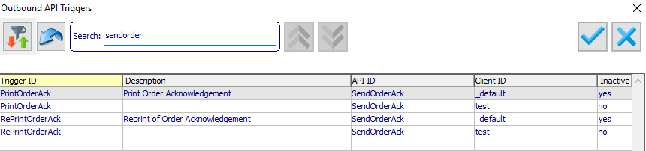

Please Note: The user must pay attention to the *“API ID”* column in the “*Outbound API Triggers”* screen, as the Trigger ID that they choose must match the currently selected *API* ID.

#### Primary Key

The user may now enter their desired Order ID Number in the *“Primary Key”* field. Alternatively, the user may select their desired Order ID from the list of available Orders by pressing the ***“F1”*** key, or clicking the ***“Magnifying Glass Icon”*** button to look it up.

#### Request Data

Selecting a row from the “*Order ID*” lookup screen will populate the request data for the selected record. The user can further modify the request data manually before calling the endpoint.

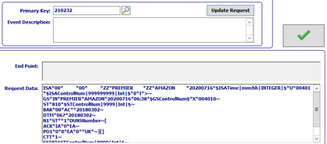

### Outbound SendPurchaseOrderLineStatus

#### API ID Code

The user may now enter “***SendPurchaseOrderLineStatus***” in the *“API ID”* field. Alternatively, the user may select it from the list of available API ID’s by pressing the ***“F1”*** key, or clicking the ***“Magnifying Glass Icon”*** button to look it up.



#### Trigger ID Field

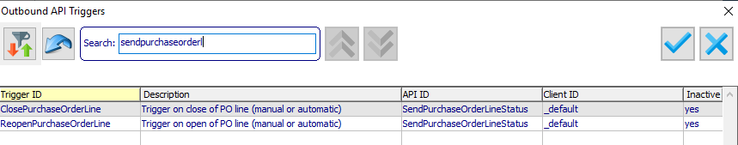

Please Note: The user must pay attention to the *“API ID”* column in the “*Outbound API Triggers”* screen, as the Trigger ID that they choose must match the currently selected *API* ID.

#### Primary Key

The user may now enter their desired Purchase Order Line Number in the *“Primary Key”* field. Alternatively, the user may select their desired Purchase Order Line Number ID from the list of available Purchase Order Lines by pressing the ***“F1”*** key, or clicking the ***“Magnifying Glass Icon”*** button to look it up.

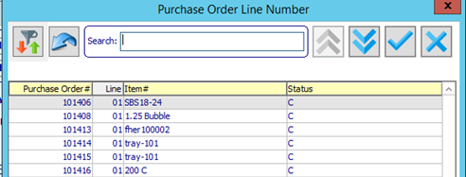

#### Request Data

Selecting a row from the “*Purchase Order Line Number*” lookup screen will populate the request data for the selected record. The user can further modify the request data manually before calling the endpoint.



### Outbound SendPurchaseOrderStatus

#### API ID Code

The user may now enter “***SendPurchaseOrderStatus***” in the *“API ID”* field. Alternatively, the user may select it from the list of available API ID’s by pressing the ***“F1”*** key, or clicking the ***“Magnifying Glass Icon”*** button to look it up.



#### Trigger ID Field

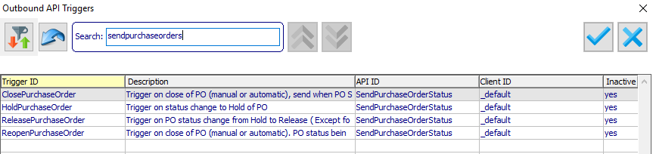

Please Note: The user must pay attention to the *“API ID”* column in the “*Outbound API Triggers”* screen, as the Trigger ID that they choose must match the currently selected *API* ID.

#### Primary Key

The user may now enter their desired Purchase Order ID Number in the *“Primary Key”* field. Alternatively, the user may select their desired Purchase Order Number from the list of available Purchase Orders by pressing the ***“F1”*** key, or clicking the ***“Magnifying Glass Icon”*** button to look it up.

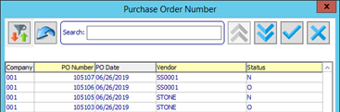

#### Request Data

Selecting a row from the “*Purchase Order Number*” lookup screen will populate the request data for the selected record. The user can further modify the request data manually before calling the endpoint.

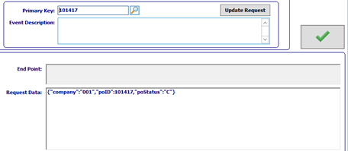

## Outbound PurchaseOrder Triggers

### Trigger Events (Customized by Customer)

* Print PO button (Normally on ***“P”-“U”-“1”***) Print function needs to execute - Status = Open
* Modified P/O – Any change in any item on P/O upon print – Status = Open
* If PO is on hold – Status = Closed
* Delete of Purchase Order – Send entire Purchase Order with status = Closed
* Change of Address to a ship to location that is different
  + Delete if other location is not API enabled, changed if new location is also API enabled
  + Delete if P/O is put on hold. See my comment below. What do we delete from
  + Delete if P/O is closed (***“P”-“U”-“4”***) Don’t understand this case, It says below that closed is sent as status closed. Where are we deleting from?
* Upon status change to Closed – Send full PO with status = Closed

#### Selection Criteria

* Location is API Enabled (for now LOUDC is the only one)
* All purchase orders approved, released and shipping to an API enabled location

#### Trigger Results

* SendPurchaseOrder event recorded
* Content = Send all purchase order data every time as it is upon trigger event

### API OutboundPurchaseOrder Data

#### Unique Identifier

* Purchase Order Number
* PO Type (Regular, Drop Ship)
* Status (New/Update/Delete)
* P/O Date

#### Purchase Order Information

|  |  |  |
| --- | --- | --- |
| Vendor Code | Ship-To Code (Will be one of the eWMS locations) | Ship-To Zip |
| Vendor Address 1 | Ship-To Name | Carrier |
| Vendor Address 2 | Ship-To Address 1 | Freight Terms |
| Vendor City | Ship-To Address 2 | FOB |
| Vendor State | Ship-To City | Buyer |
| Vendor Contact | Ship-To State |  |

#### Order Line Information

|  |  |  |  |
| --- | --- | --- | --- |
| Line Number | Order Quantity | Order UOM | Quantity Received |
| Received UOM | Item Type (RM/FG/NA) | Vendor Part # | Item Number |
| Item Name | Item Description 1 | Item Description 2 | PO Due Date |
| Item Width | Item Length | Item Depth | Stack Height (FG Only) |
| Count | Units/Pallet | Job Number | Sub Jon Number |
| Overrun % | Underrun % | Line Item Notes |  |

Quantity Per Pallet (Count x Units/Pallet)

### Exhibit of Fields Sent Over

#### Figure 2: P/O Header

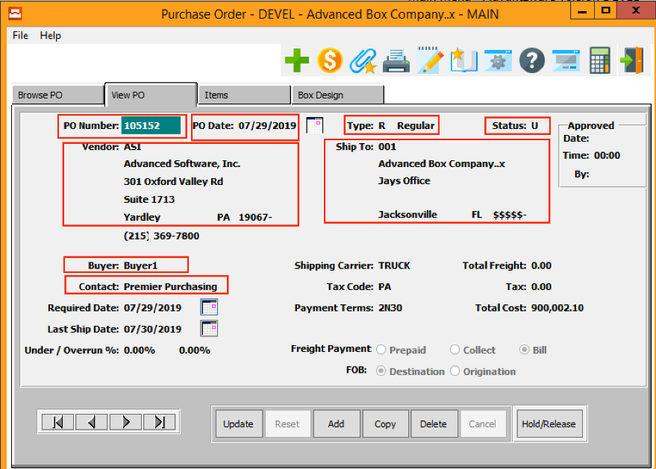

#### Figure 3: P/O Line Summary

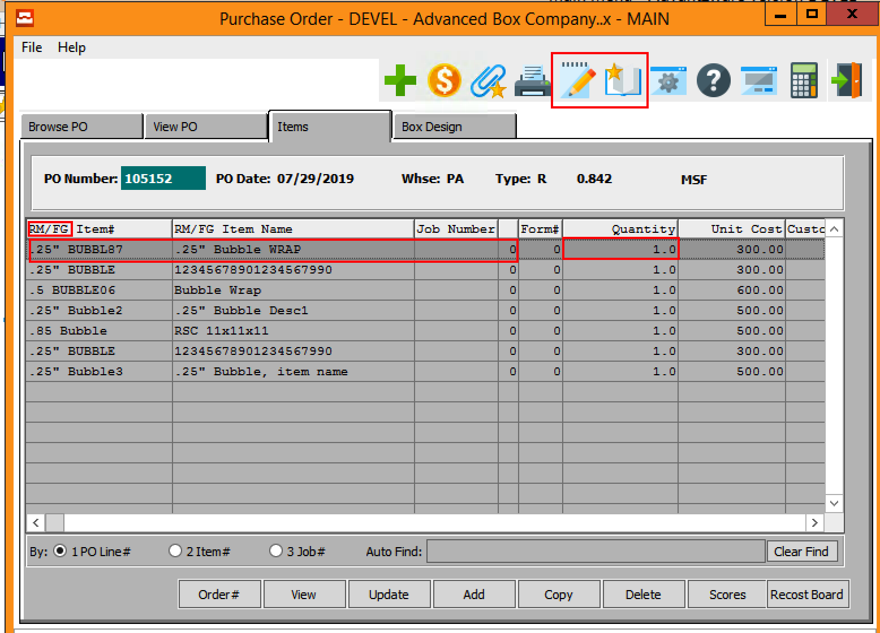

#### Figure 4: P/O Line Details

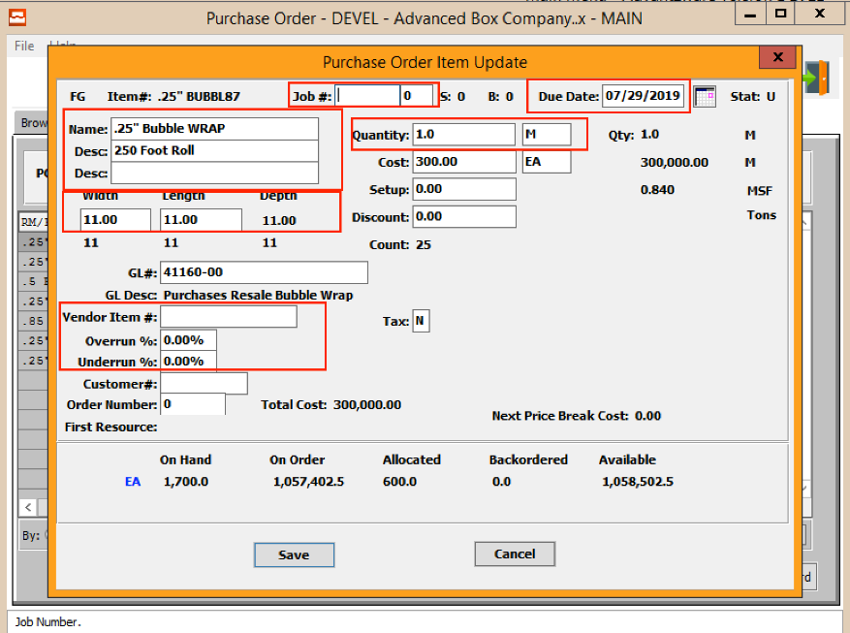

#### Figure 5: P/O Notes

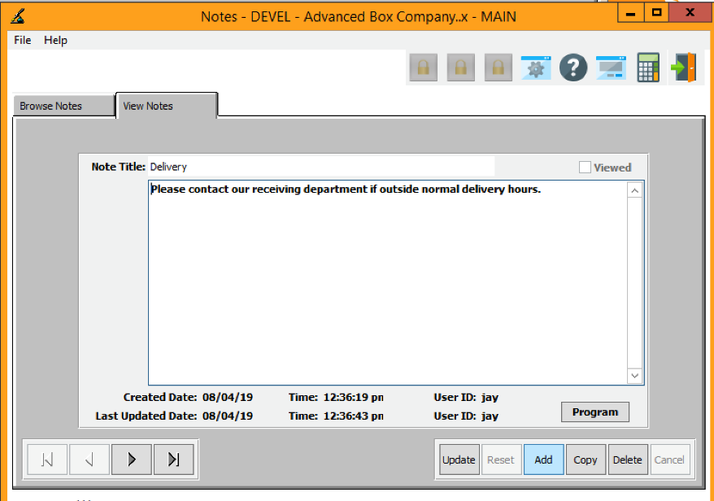

### Example Purchase Order

#### Page One

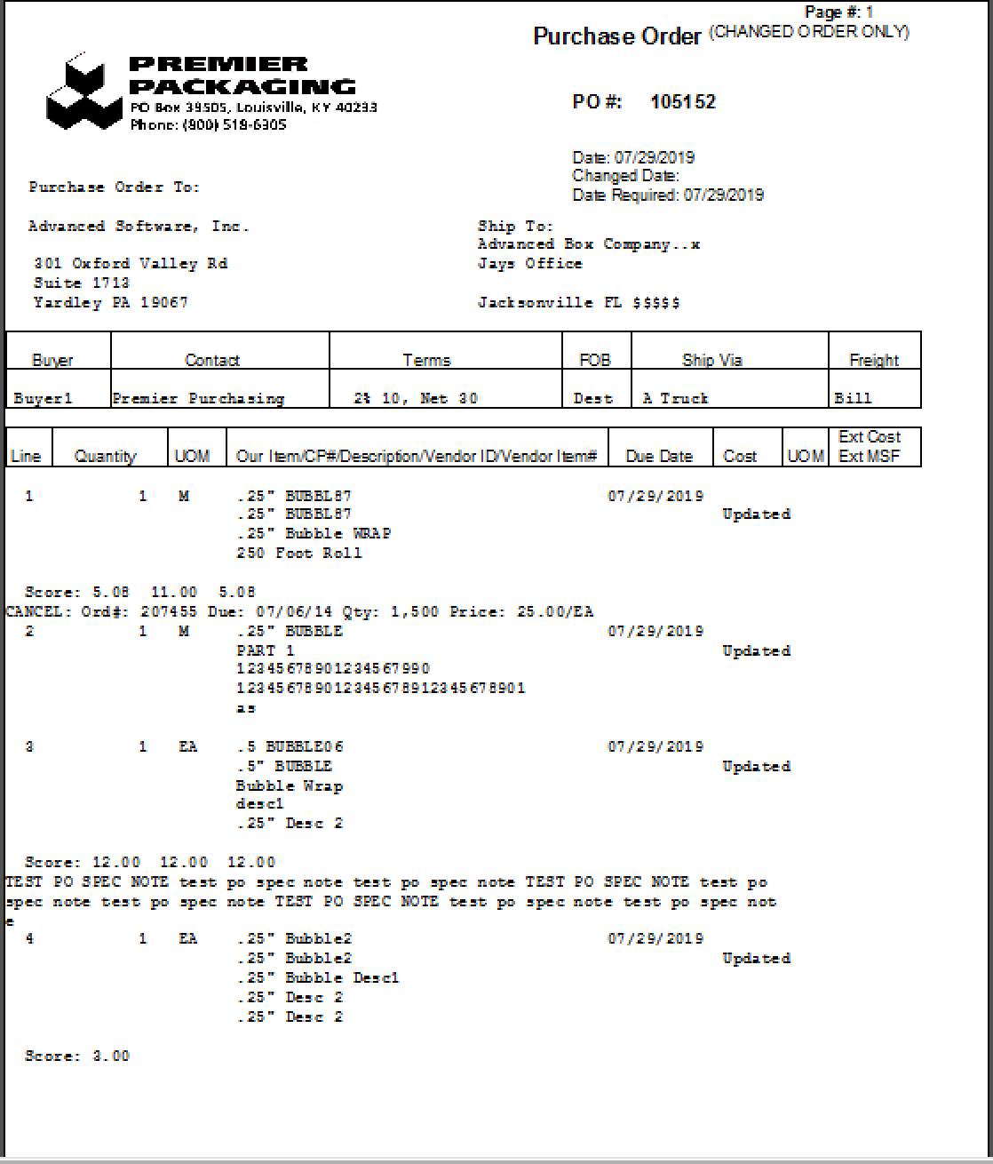

#### Page Two

